Slip Sliding Away at Ashton creek falls

When I heard there was a secret waterfall slide in the Enderby area I knew I had to find it. It took me a year of asking around until one day my good friend Jen Jones sent me a Facebook message saying her and some friends had found the slide. The following weekend she agreed to take me, my friend Carolyn Opp and her three kids for a day of watery fun.
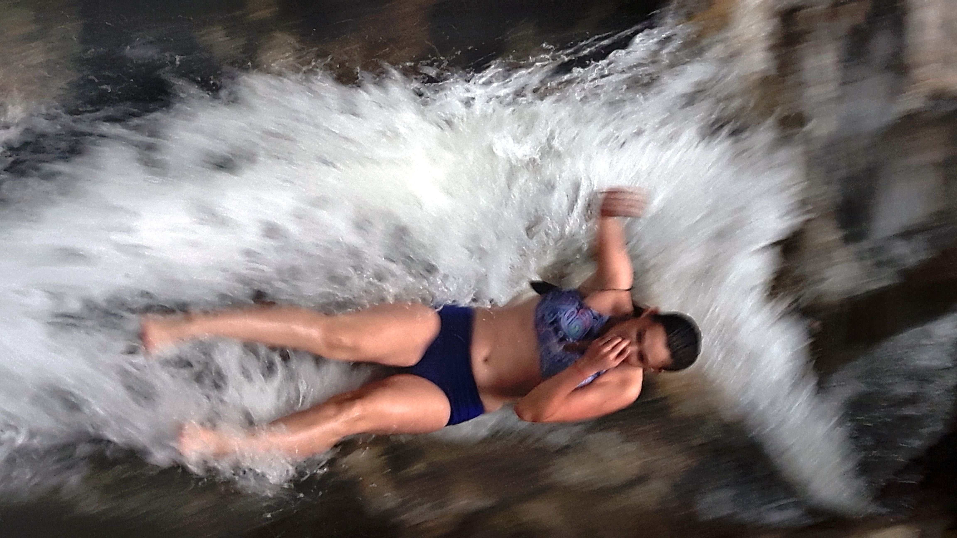
The Enderby area is a busy place in the summer. They host a large baseball tournament and it is a popular place to float down the Shuswap River. We visited in September when the crowds had died down.
The waterfall was a 10 minute walk from the parking area. When we arrived there were people enjoying the slide. Alissa, the eldest of the kids, followed two teenage boys to the up to the top of the first of four slides. After watching the boys take the plunge she gathered her courage and followed them down. The first was a smaller slide. No problem. But the second had a 6 foot drop into a deep pool. It took Alissa longer to gain the courage to slide down the second one, but she did it and I managed to take the picture on the right to prove it.
The third slide was a shorter one and the last slide was the most gentle of the four. After going down all four twice, Alissa encouraged her sibling Max and Samantha to join her on the last slide. Samantha did not require much encouragement as she is always eager to follow her big sister. The two of them took a few turns down the slide both alone and together before they coaxed Max to the top of the slide.
Getting Max to the top of the slide proved much easier than getting him to slide down. Despite all the encouragement from all of us Max just couldn’t get himself to slide down. We were starting to give up hope as max plotted how he would climb back down. Then Alissa got a brilliant idea. She offered Max a ride down the slide on her lap. He reluctantly agreed and Alissa slid down with him to a round of applause.

Alissa slides down the second and largest of the 4 slides.

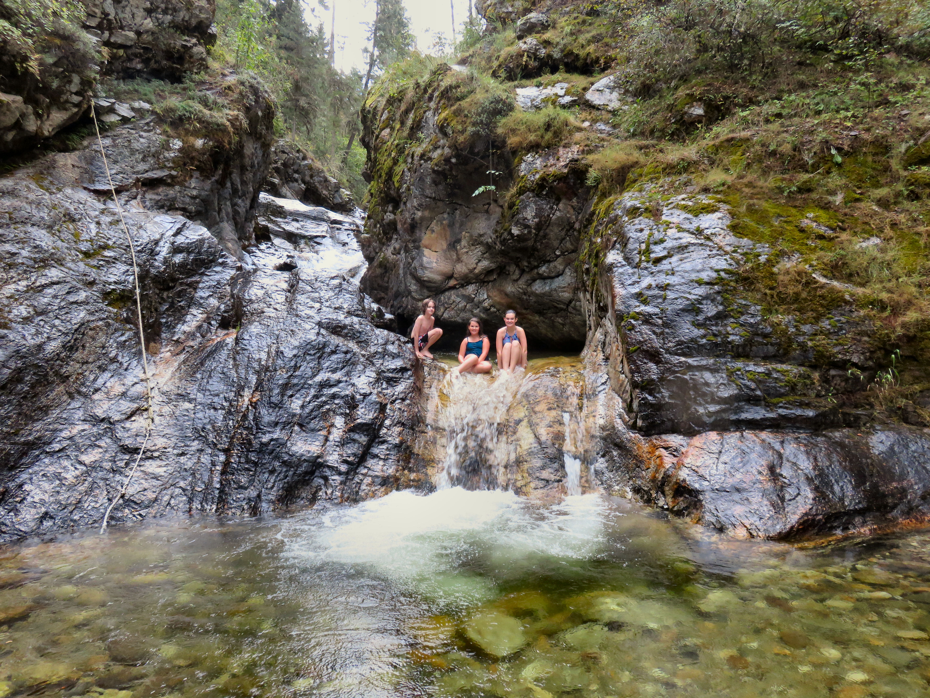

Siblings Max, Samantha and Alissa hang out on the bottom slide.

Unfortunately I could not get the courage to slide down. I used the excuse that I needed to stay dry to take pictures. A lame excuse but the best I could come up with on short notice.
Perhaps one day I will return with a full length Birkini bathing suit and some water wings and brave the slide...but probably not.

HOW TO GET THERE – From Kamloops, drive to Enderby and take a left on Cliff Avenue. Cross the bridge and follow the road as it turns into Enderby-Mable Lake Road. You will come to a small community with a general store. Just past the store take a left on Rand, a right on Novoting and a right on Olich. Park at the end of Olich and follow the trail upstream for about 10 minutes.

