A Deadly swimming hole in lynn Valley

Lynn Canyon Park was opened in 1912 and has been a popular destination ever since. Famous for its swimming holes, it is a great location for a picnic or a leisurely hike. It contains second growth forest with trees aged 80 to 100 years. The park has grown from 12 acres in its early years to 617 acres today. Due to its natural landscape many TV series such as Stargate SG-1 and Stargate Atlantis used the area for filming.
Some of the parks features include: a suspension bridge built in 1912 that sways 50 meters above the canyon, a selection of walking and hiking trails that connect to other parks in the region such as Lynn Headwaters, Rice Lake, and Inter River Park, and the Ecology Centre that is open daily. One of the biggest draws to the park is the swimming holes. The refreshing crystal clear water is a haven for people looking to beat the summer heat.
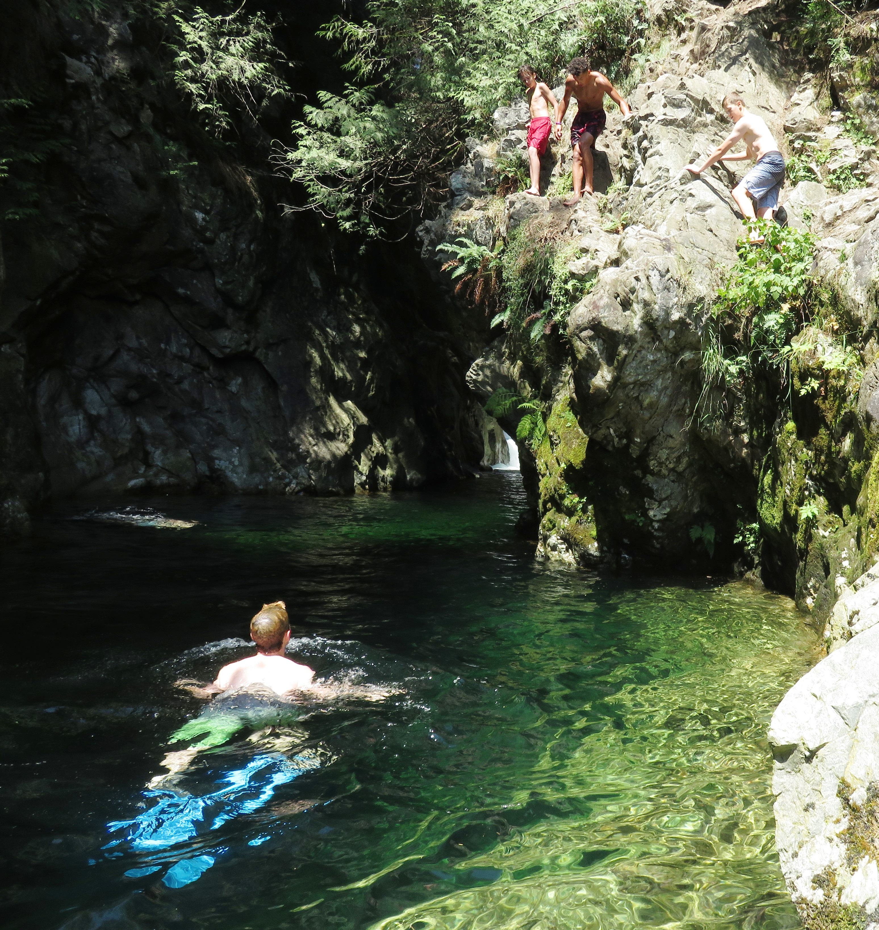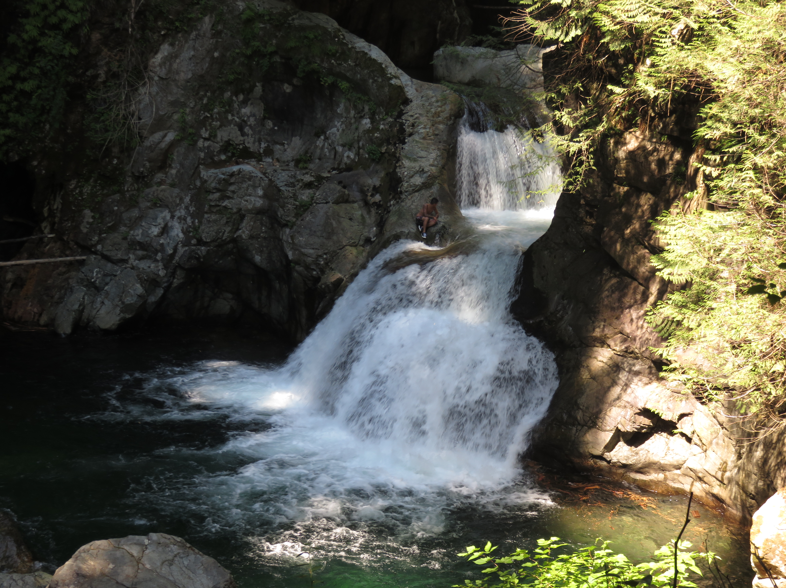

Left: Swimmers at the 30 foot pool. Right: The Twin Falls.

Daredevils are also attracted to this park for the natural waterslide and cliff jumping. The dangerous waters have caused 34 deaths and numerous injuries from 1985 to 2016. But despite warning signs people continue to jump off the bridge, cliff dive and slide down the waterfall.

HOW TO GET THERE – If you are driving, take upper levels Trans Canada Highway 1 until you reach exit 19. Follow Lynn Valley Road North East past the Mountain Highway intersection, and then continue to Lynn Valley Road. Watch for Lynn Canyon Ecology Centre sign on the right hand side of the road. Turn right onto Peters Road, and you will find the main entrance at the end. There is lots of parking at the entrance to Lynn Canyon Park however in the summer months it fills up extremely fast!

