Camp at Blanket Creek Near
Sutherland Falls

This summer, why not take a camping trip to Blanket Creek Provincial Park.. It is one of a system of four provincial parks on the Arrow Lake Reservoir. It has a warm man-made swimming lagoon, adventure playground, historic homestead site and is located near Sutherland Falls. This would make the perfect family summer escape.
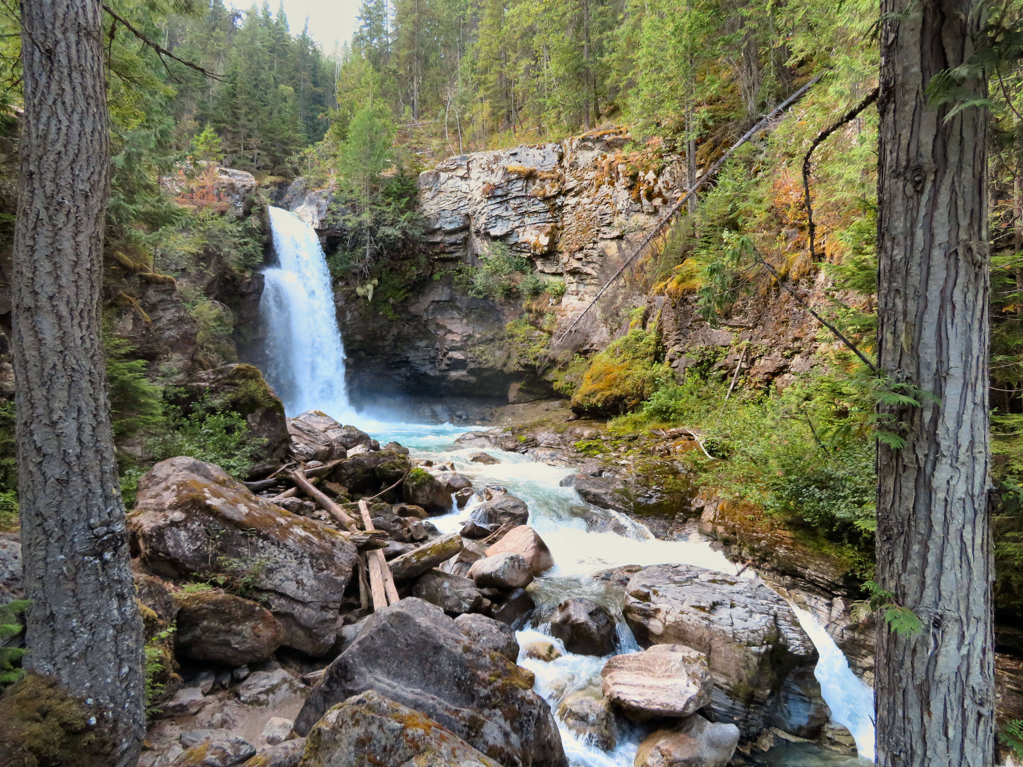

Sutherland Falls are a photographer’s dream.

HOW TO GET THERE – From Kamloops, drive south of Revelstoke on Highway 23. Turn off the highway at the Blanket Creek Provincial Park. Watch for the sign for Sutherland Falls. It is a short trail from the parking lot to get to the viewing platform. From there you can walk right to the foot of the falls. But be careful the rocks are slippery.

