TAKE A SEXY SELFIE AT IONE FALLS REST STOP

If you are looking for a great place to take a waterfall selfie or have a photo shoot, look no further than Ione Falls. It is conveniently located next to a rest stop with outhouses and picnic tables. The falls empty into a shallow pool.
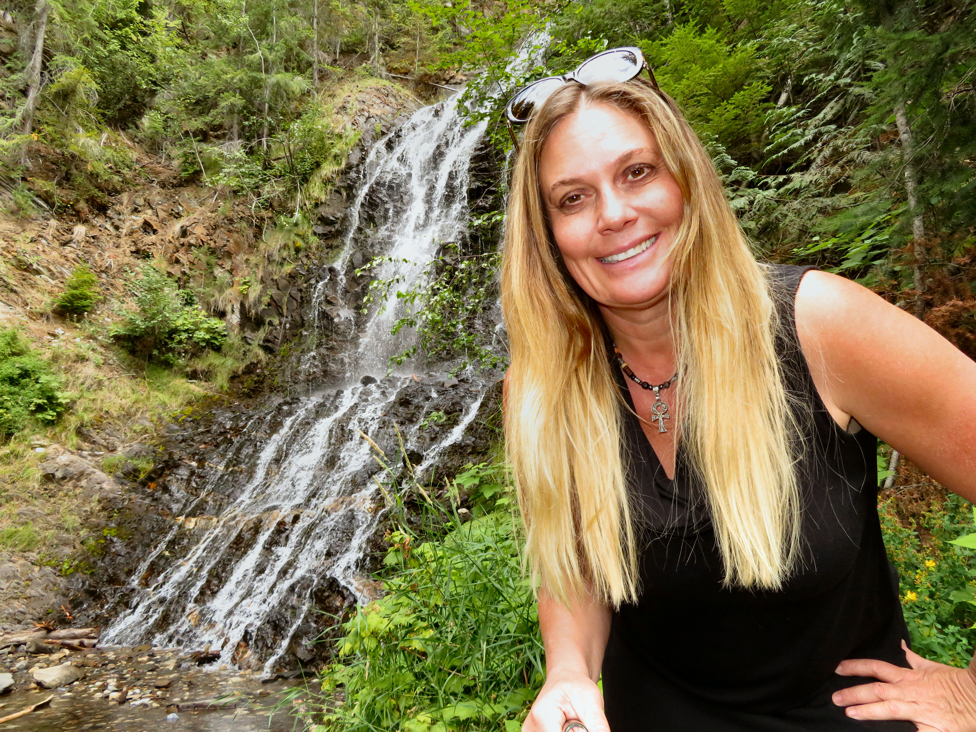

One Mile Lake is a popular locals swimming hole in the summer.

HOW TO GET THERE – From Revelstoke drive towards Nakusp. After you get off the ferry at Shelter Bay keep an eye out for a rest stop on the left hand side of the highway. The waterfall is located right by the parking area.

