SWIMSUITS ARE OPTIONAL
AT halfway hot springs

I remembered visiting this hot spring almost 25 years ago with a boyfriend but I forgot where it was. I was surprised to see many of the bathers wearing only their birthday suits. Apparently nothing has changed. This natural hot spring located by a river in the forest is still swimsuit optional. Fortunately I had it to myself so I did not have to make any awkward decisions.
There are three pools to soak in more pools located along the river. Unfortunately I was not able to find them.
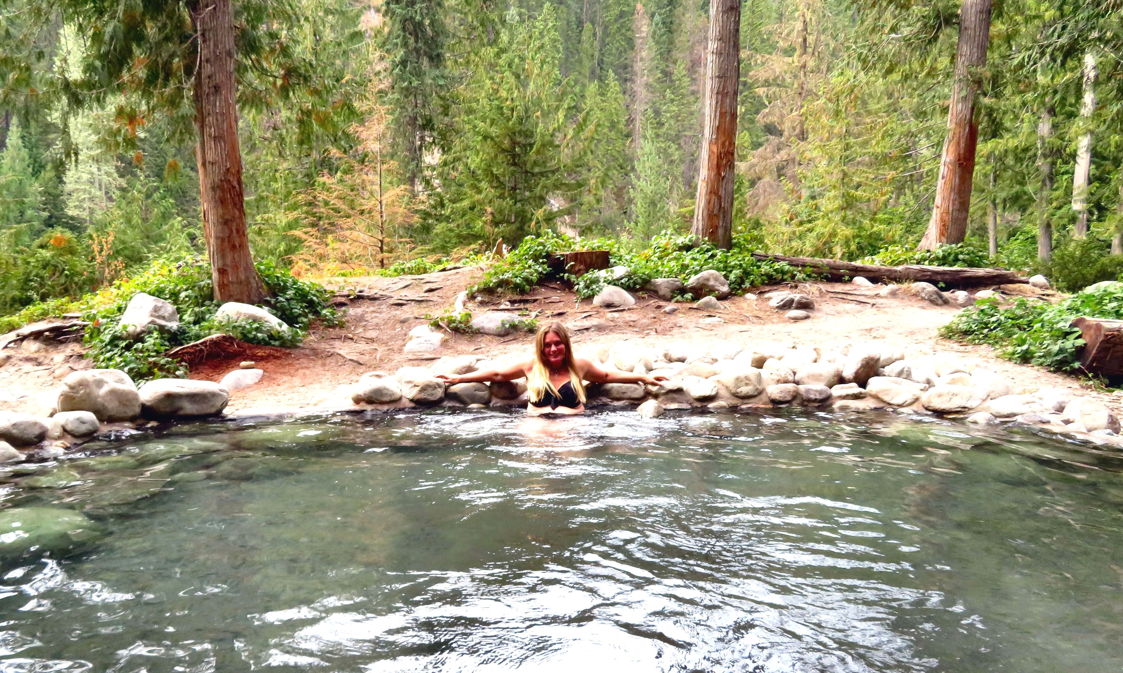

I visited the springs on a Monday afternoon in late August and got them all to myself for 30 minutes.

HOW TO GET THERE – From Nakusp drive North on Highway 6 towards Revelstoke, around 25km you will come to the St. Leon bridge. Cross it and look for the turn off to Halfway Road on your right. If you cross the Halfway River Bridge you have gone too far. Drive 11km up this rough dirt road (muddy in the spring). Stay on the main road; do not take any of the forks. At the 11km mark you will see signs pointing you towards the day parking area for the springs. Park there and take a steep trail with steps down to the springs.

