TRY COLD WATER THERAPY in gardner creek falls

Cold water therapy has numerous benefits for health conditions, including colds, insomnia, and high blood pressure. It can boost immune function, decrease inflammation and pain, and increase blood flow and metabolism. Take a dip in the falls and see for yourself.
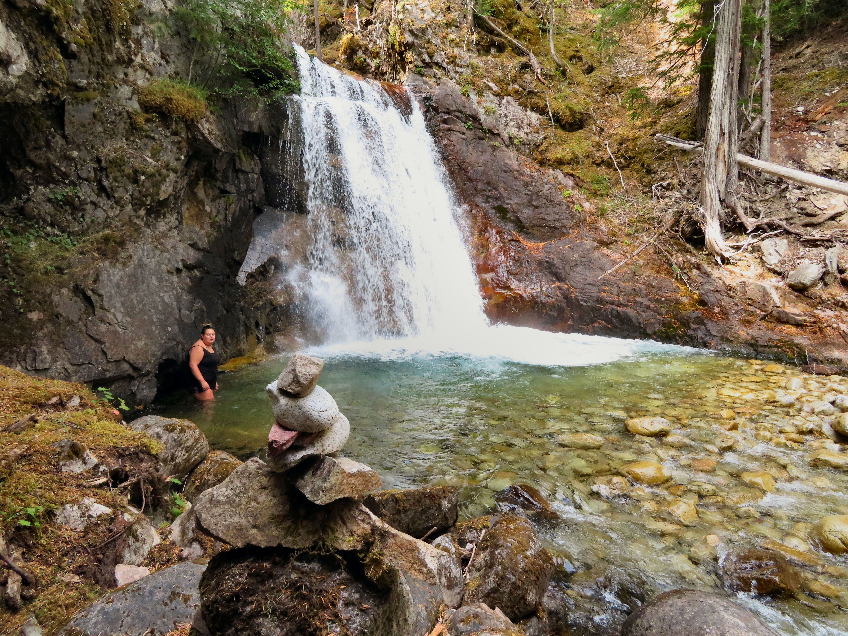

.

A swimmer braves the cool waters in the pool at the foot of Gardner Creek Falls.

HOW TO GET THERE – From Nakusp, drive towards Nakusp Hot Springs. The road is well marked. You will see Gardner Creek Falls from the road on the left hand side 8.2 km up the road. There is parking on both sides of the creek.

