Healing HOT SPRINGs AT kUSHANAX fALLS

People throughout the ages have believed in the healing powers of hot spring. The Nakusp Hot Springs offers 11 different therapeutic components. It has sulphates to support liver and gastrointestinal conditions, and respiratory conditions; and chlorides to help rheumatic conditions, arthritis, central nervous system conditions, posttraumatic and postoperative disorders. It is believed that soaking in water containing calcium supports bone health, arthritis, insomnia, menstrual concerns and cardiovascular health. Copper supports brain function, arthritis, skin care and immunity.
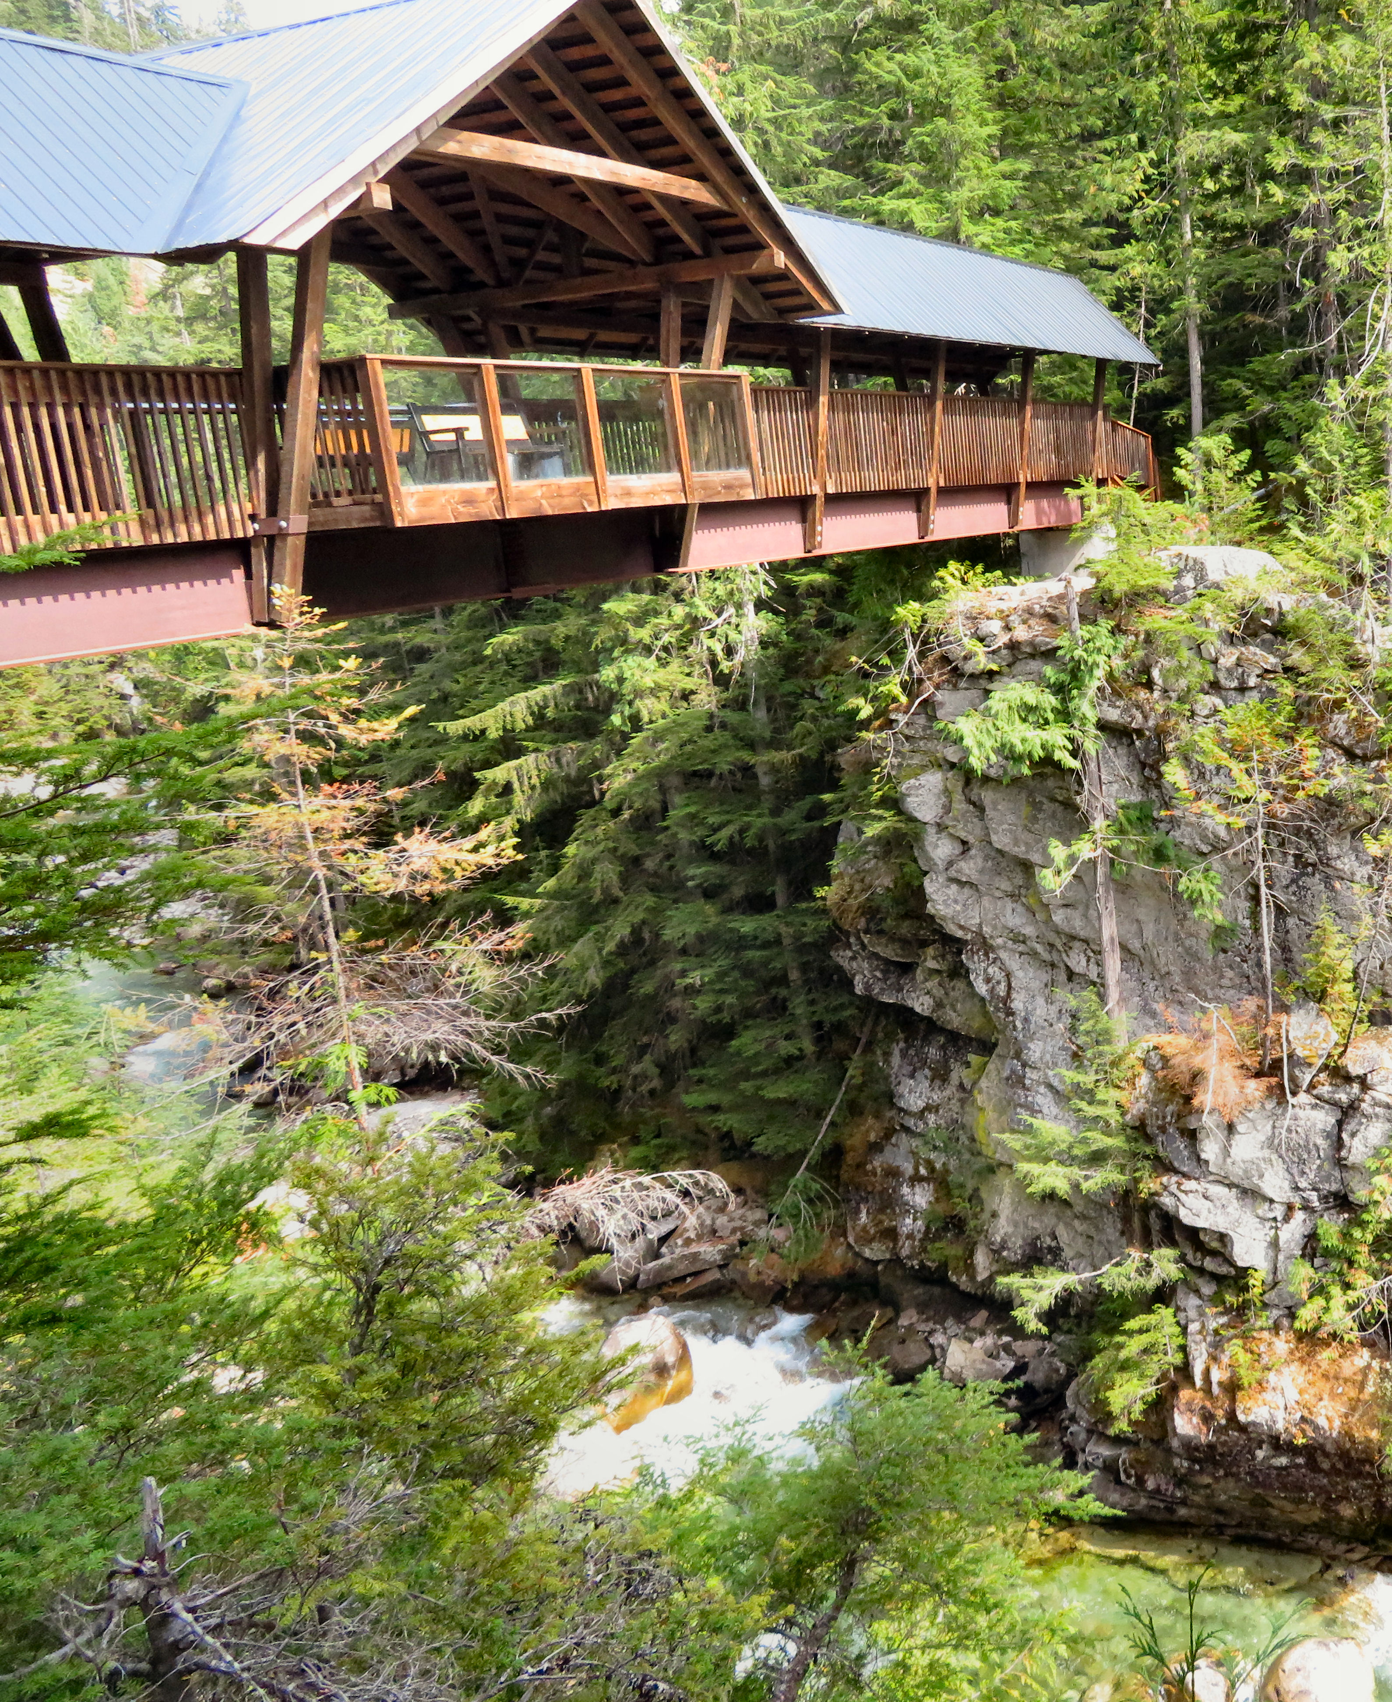

The covered bridge has benches where you can enjoy the view of the river.

Magnesium supports energy production and heart health. Potassium supports the heart and eliminates toxins. Phosphorus improves bone health, brain function and metabolism. Silica helps bones, skin, hair and nails. Sodium and natural salts alleviate arthritic symptoms, and stimulates the body’s lymphatic system.

HOW TO GET THERE – From Nakusp drive towards Revelstoke and take a right onto the Nakusp Hot Springs Road. Park at the hot springs and look for the trailhead. Cross the bridge and stay along the river to find the falls or take the trail to the old hot spring source.

