wilson creek falls at the end of the rainbow

Plunging 207 feet, Wilson Creek Falls is one of the most spectacular waterfalls in the Kootenays. It is located in Goat Range Provincial Park which is home to fish of legendary size and rare white hued grizzly bears. This is the only place in BC where grizzlies of this unusual coloration are found. The 195,086 acres of the park include not only important interior wet belt old growth and expansive high country but also a variety of sparkling lakes, untamed rivers and fast flowing creeks.
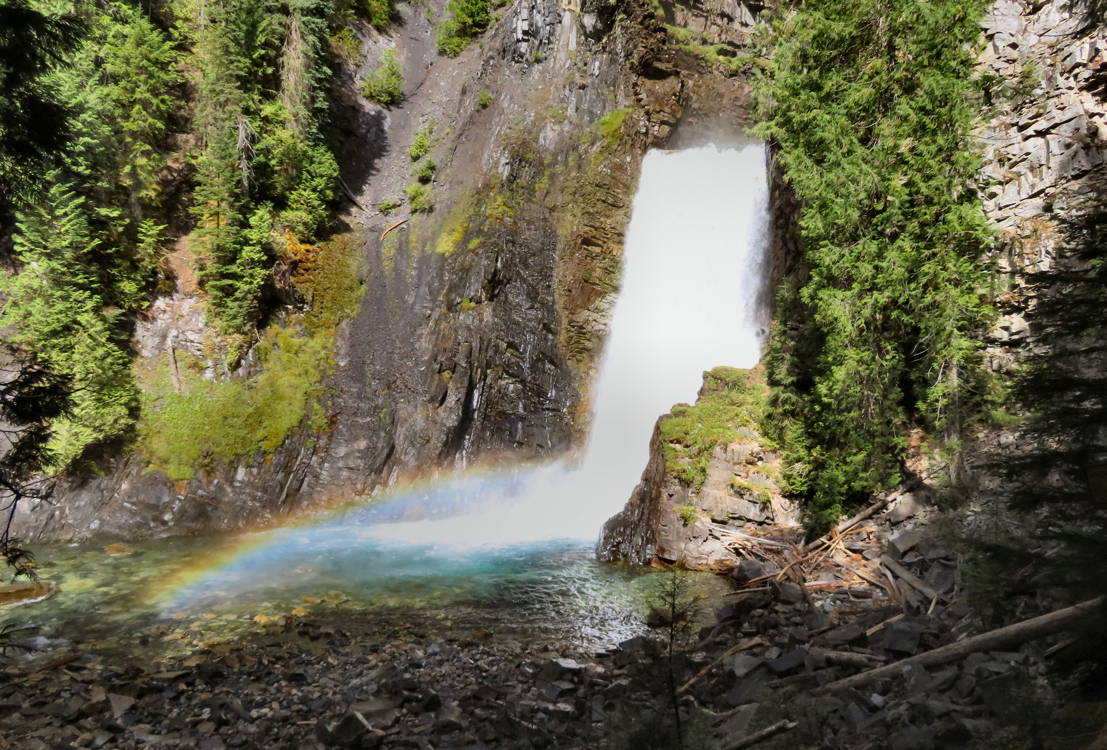

A rainbow formed at the base of Wilson Falls

HOW TO GET THERE – Head 5.3 km north of New Denver on Highway 6. Turn right on East Wilson Creek FSR 11.5 km and then turn right just before bridge over Wilson Creek at turnoff signed for Wilson Creek Falls. Drive 1km to trailhead. The road is gravel and rough in parts, a high clearance vehicle is recommended. A 2.2 km round trip hike down a hill brings you to the base of the waterfall. The rocks at the base are slippery use caution.

