PLAY FETCH WITH FIDO AT FLETCHER FALLS

Kaslo is a tiny gem of a city well worth visiting. It was originally incorporated as a city on August 14, 1893, making it the oldest incorporated community in the Kootenays. It was an important center for shipping and silver ore mining. After the silver rush Kaslo's fortunes faded but it was re-incorporated as a village on January 1, 1959. Kaslo is home to two National Historic Sites of Canada: The SS Moyie, which worked on Kootenay Lake from 1889 until 1957. It is located on Front Street. Also Village Hal, which was built in 1898, and is one of only two intact wooden municipal buildings still in use in Canada.
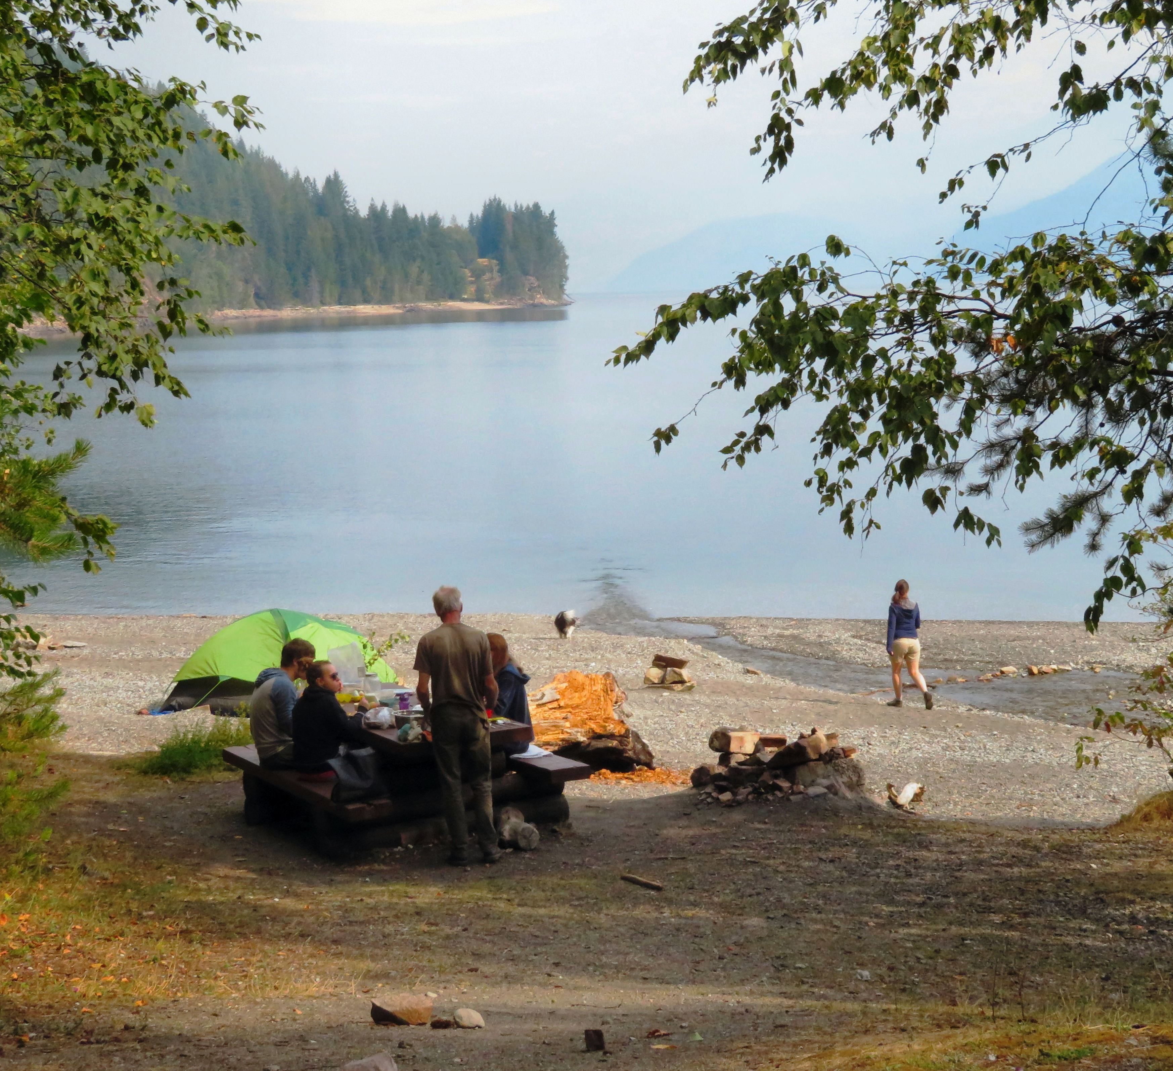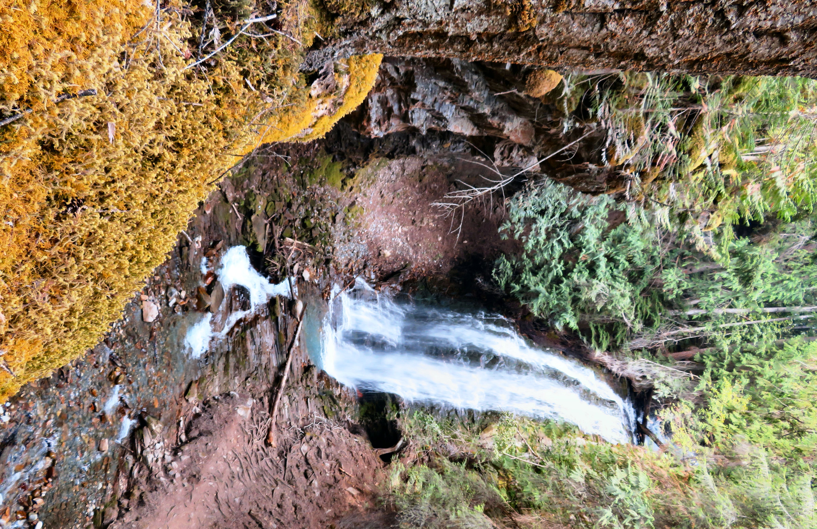

Fletcher Falls is located on the shores of beautiful Koonenay Lake.

Little shops and restaurants line the main street making it a great place to do a little shopping and stop for a bite to eat while admiring the gorgeous view of Kootenay Lake.
If you are looking for a great place to take the dog for a walk, check out nearby Fletcher Falls.

HOW TO GET THERE – From Kaslo travel on Hwy #31 towards Nelson. In 5 km turn left onto the Fletcher Frontage Road. Park at the end of the road and follow the short trail down to the falls. The falls are located near a day use area on the shores of Kootenay Lake.

