WATCH THE SALMON SPAWN THEN HIKE TO CANYON FALLS

Kokanee Creek Provincial Park is a provincial park in British Columbia, Canada. The park is situated on the shores of Kootenay Lake and is bisected by Highway 3A 19 km east of Nelson, British Columbia. Established as a BC Provincial Park in 1955, it encompasses 260 hectares of sandy beaches, deltas, and coniferous forest. The park also has important man-made and some natural spawning channels for kokanee salmon, which spawn in the late summer.
There are 9.5 km of easy hiking and walking trails within the park. The majority of these trails are located around the campground, visitor centre, spawning channel, and shoreline and through the delta. A walking bridge across Kokanee Creek can link you to roads and trails to Redfish campground.
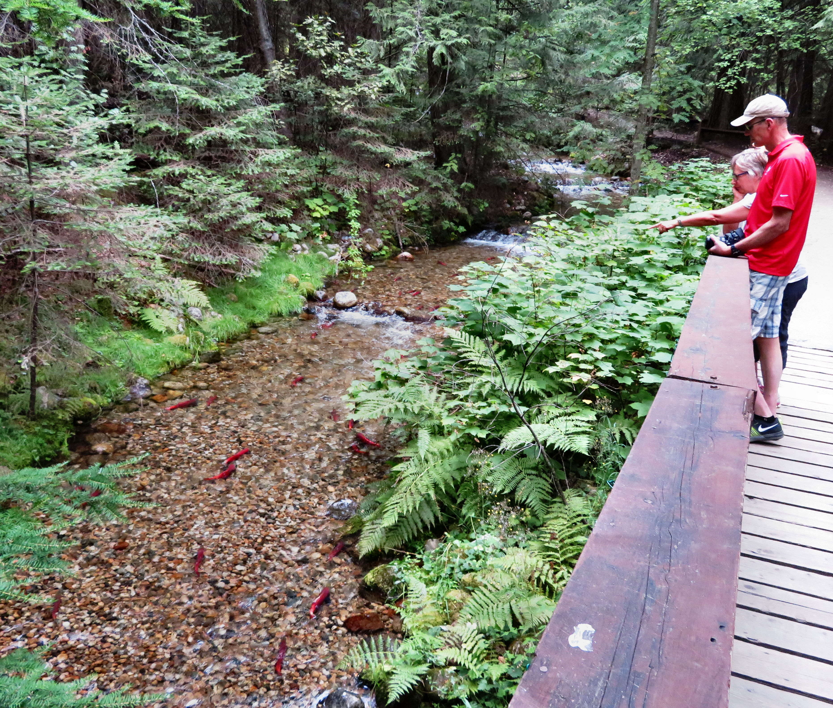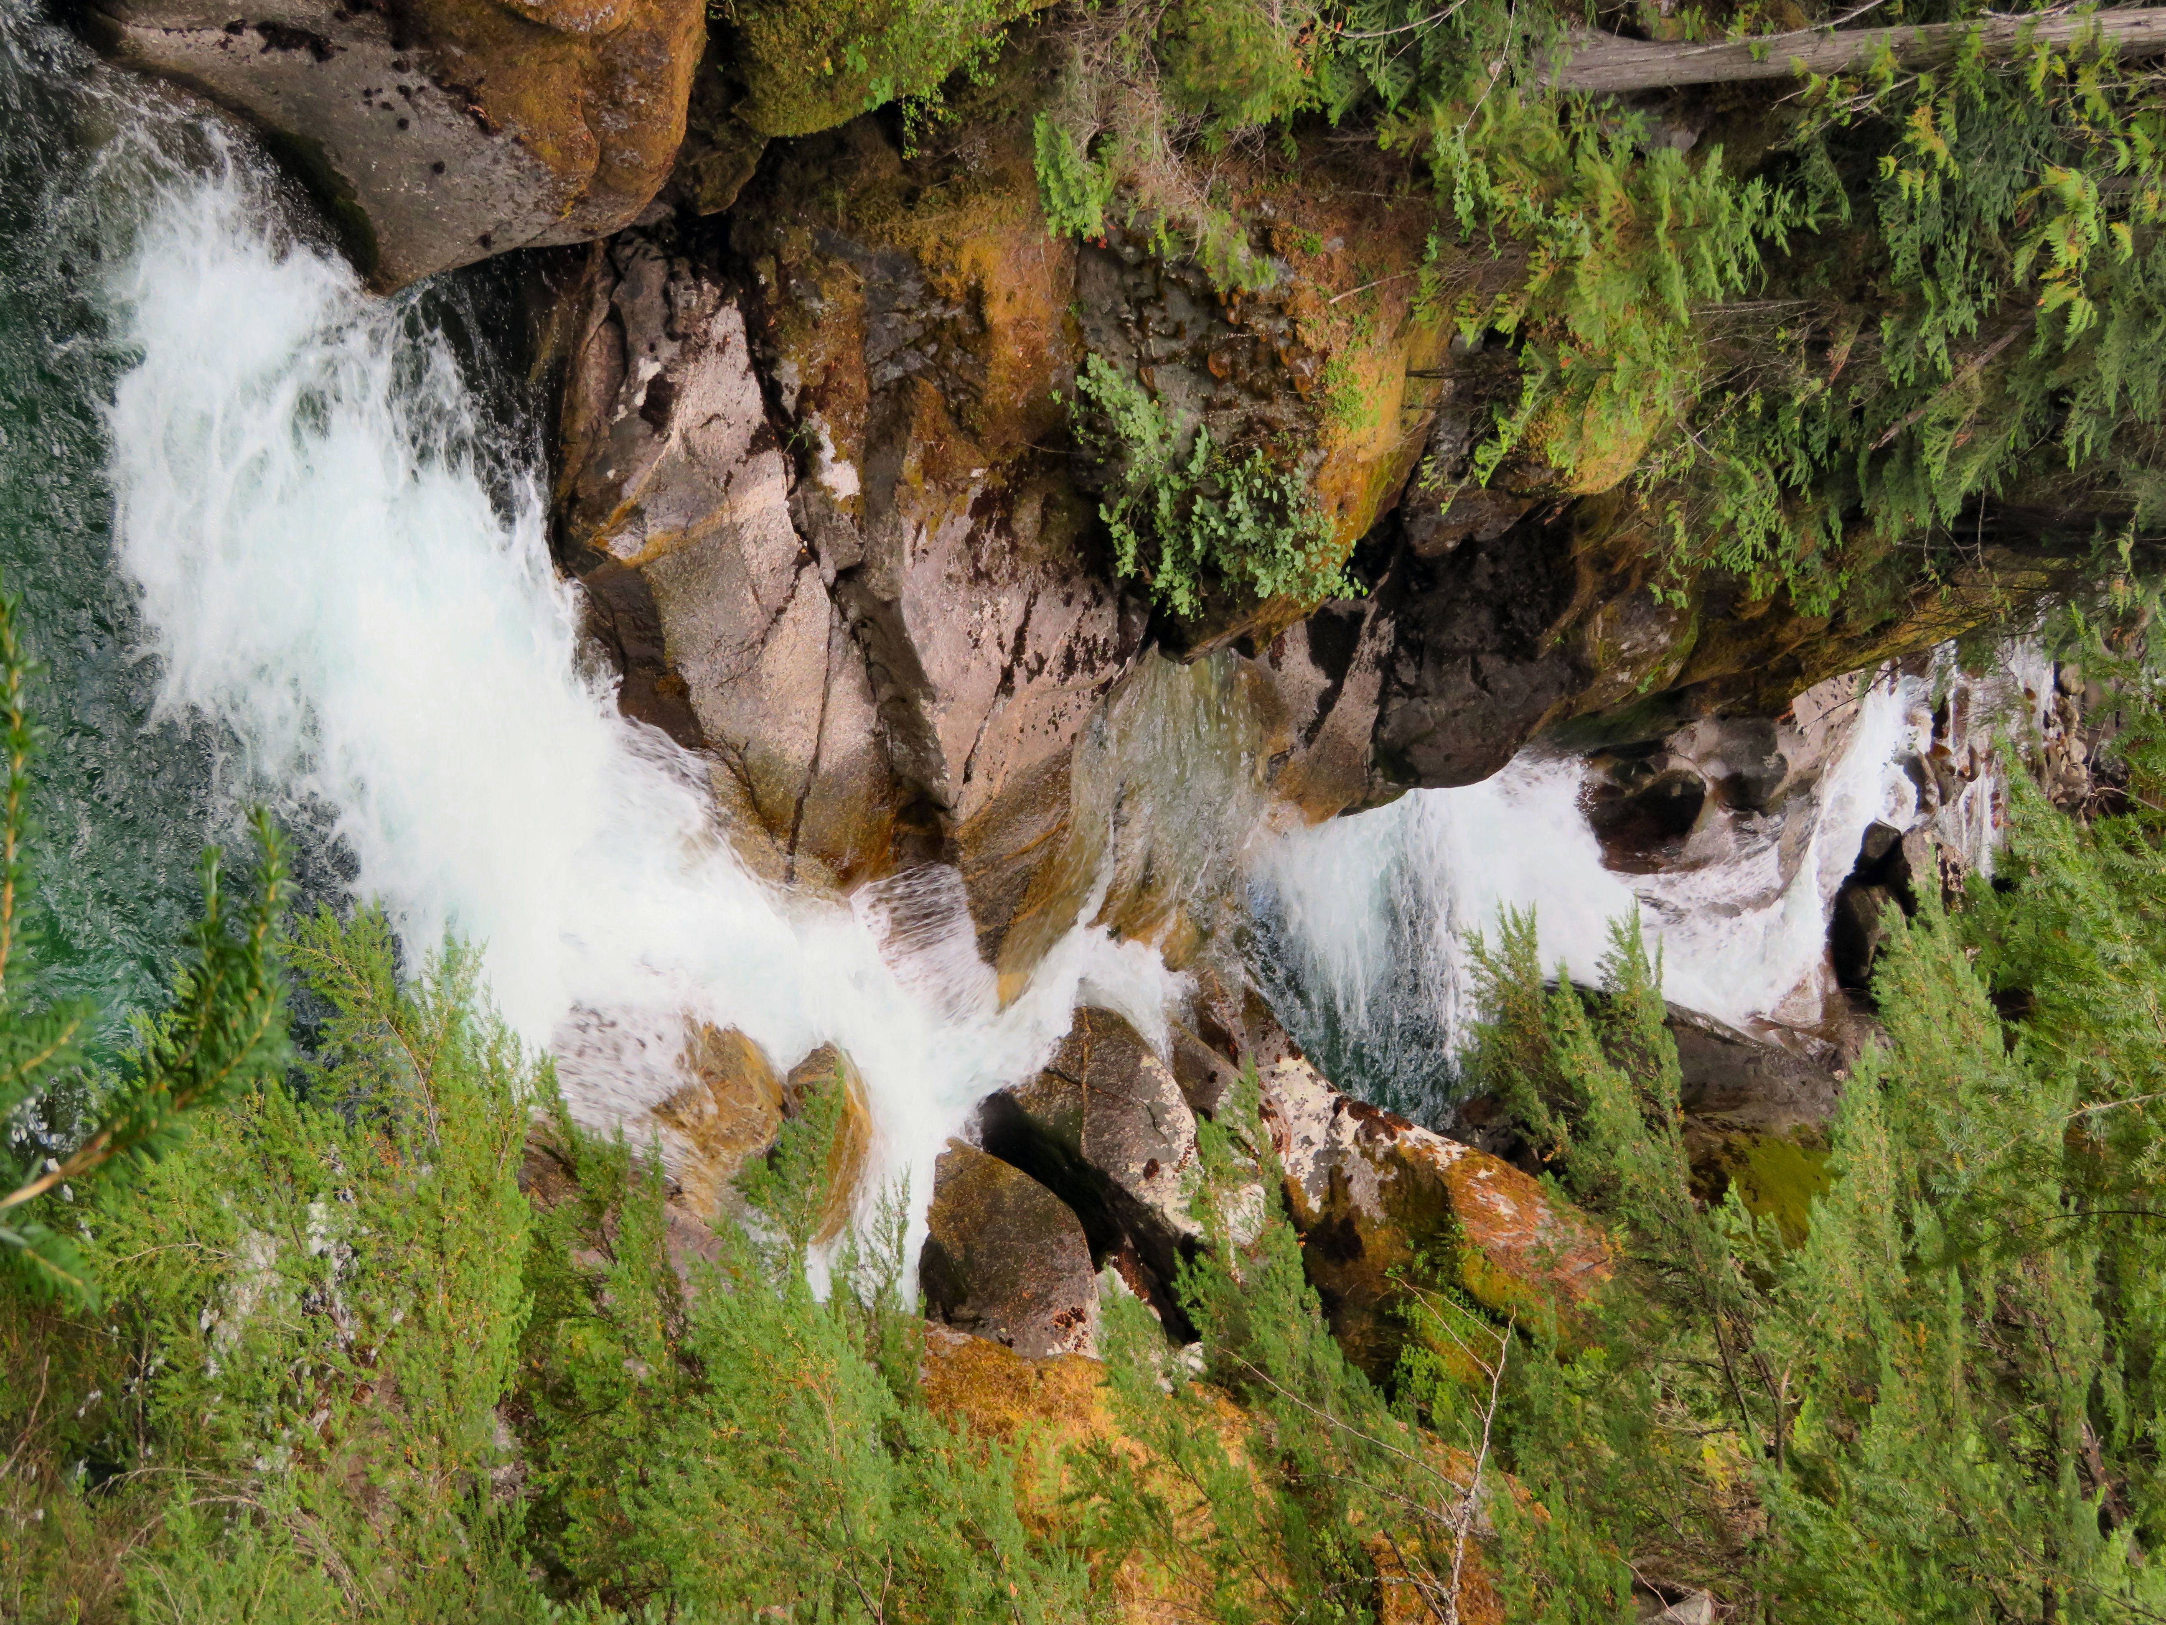

After watching the salmon spawn, take a hike up to Canyon Falls.

Canyon Trail follows the east side of Kokanee Creek, passes through mature cedar/hemlock trees and leads you to a set of stairs and terraced viewing platform overlooking a canyon. The connecting Pine and Woodland trails take you through a forest of yellow pine and birch. The trails combine to make a circle route. All the trails are considered easy to moderate. Hiking times range from 30 to 60 min.

HOW TO GET THERE – Canyon Falls is located in Kokanee Creek Provincial Park between Nelson and Kaslo on Highway 3A. Follow the signs for the visitor centre and park there. Follow the trail to the spawning beds. To get to the falls, follow the Canyon Trail across the highway and along the river and up some stairs.

