Jump off a cliff into The silver spring

When I went to visit my cousin Brenda for the first time in ages, I asked her and her husband Sean if we could do a fun family hike on their favorite trail. It didn’t take them long to think of the best place to visit during the July heat wave we were experiencing.
The next day we packed up the family van along with their kids Katie and Rylan made our way to the Silver Springs trailhead where we parked the van. Then we climbed for about 10 minutes to the power line and then hiked up a steep washed-out gravel road. In about 20 minutes we reached the shore of the first lake.
Most people stop in this area and hang out for the day basking in the sun and jumping off the cliffs into the refreshing turquoise blue waters but we wanted to explore the rest of the trail. The three kilometer one-way trail cuts through the bedrock slopes of the surrounding mountains and goes through boulder fields on its way to the other two smaller lakes in the chain.
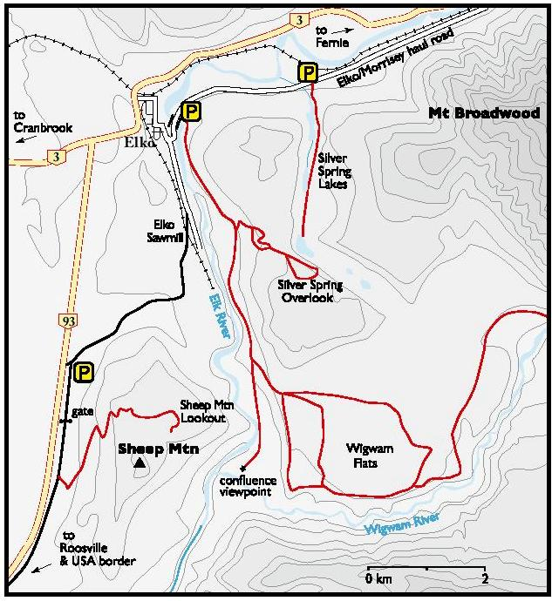
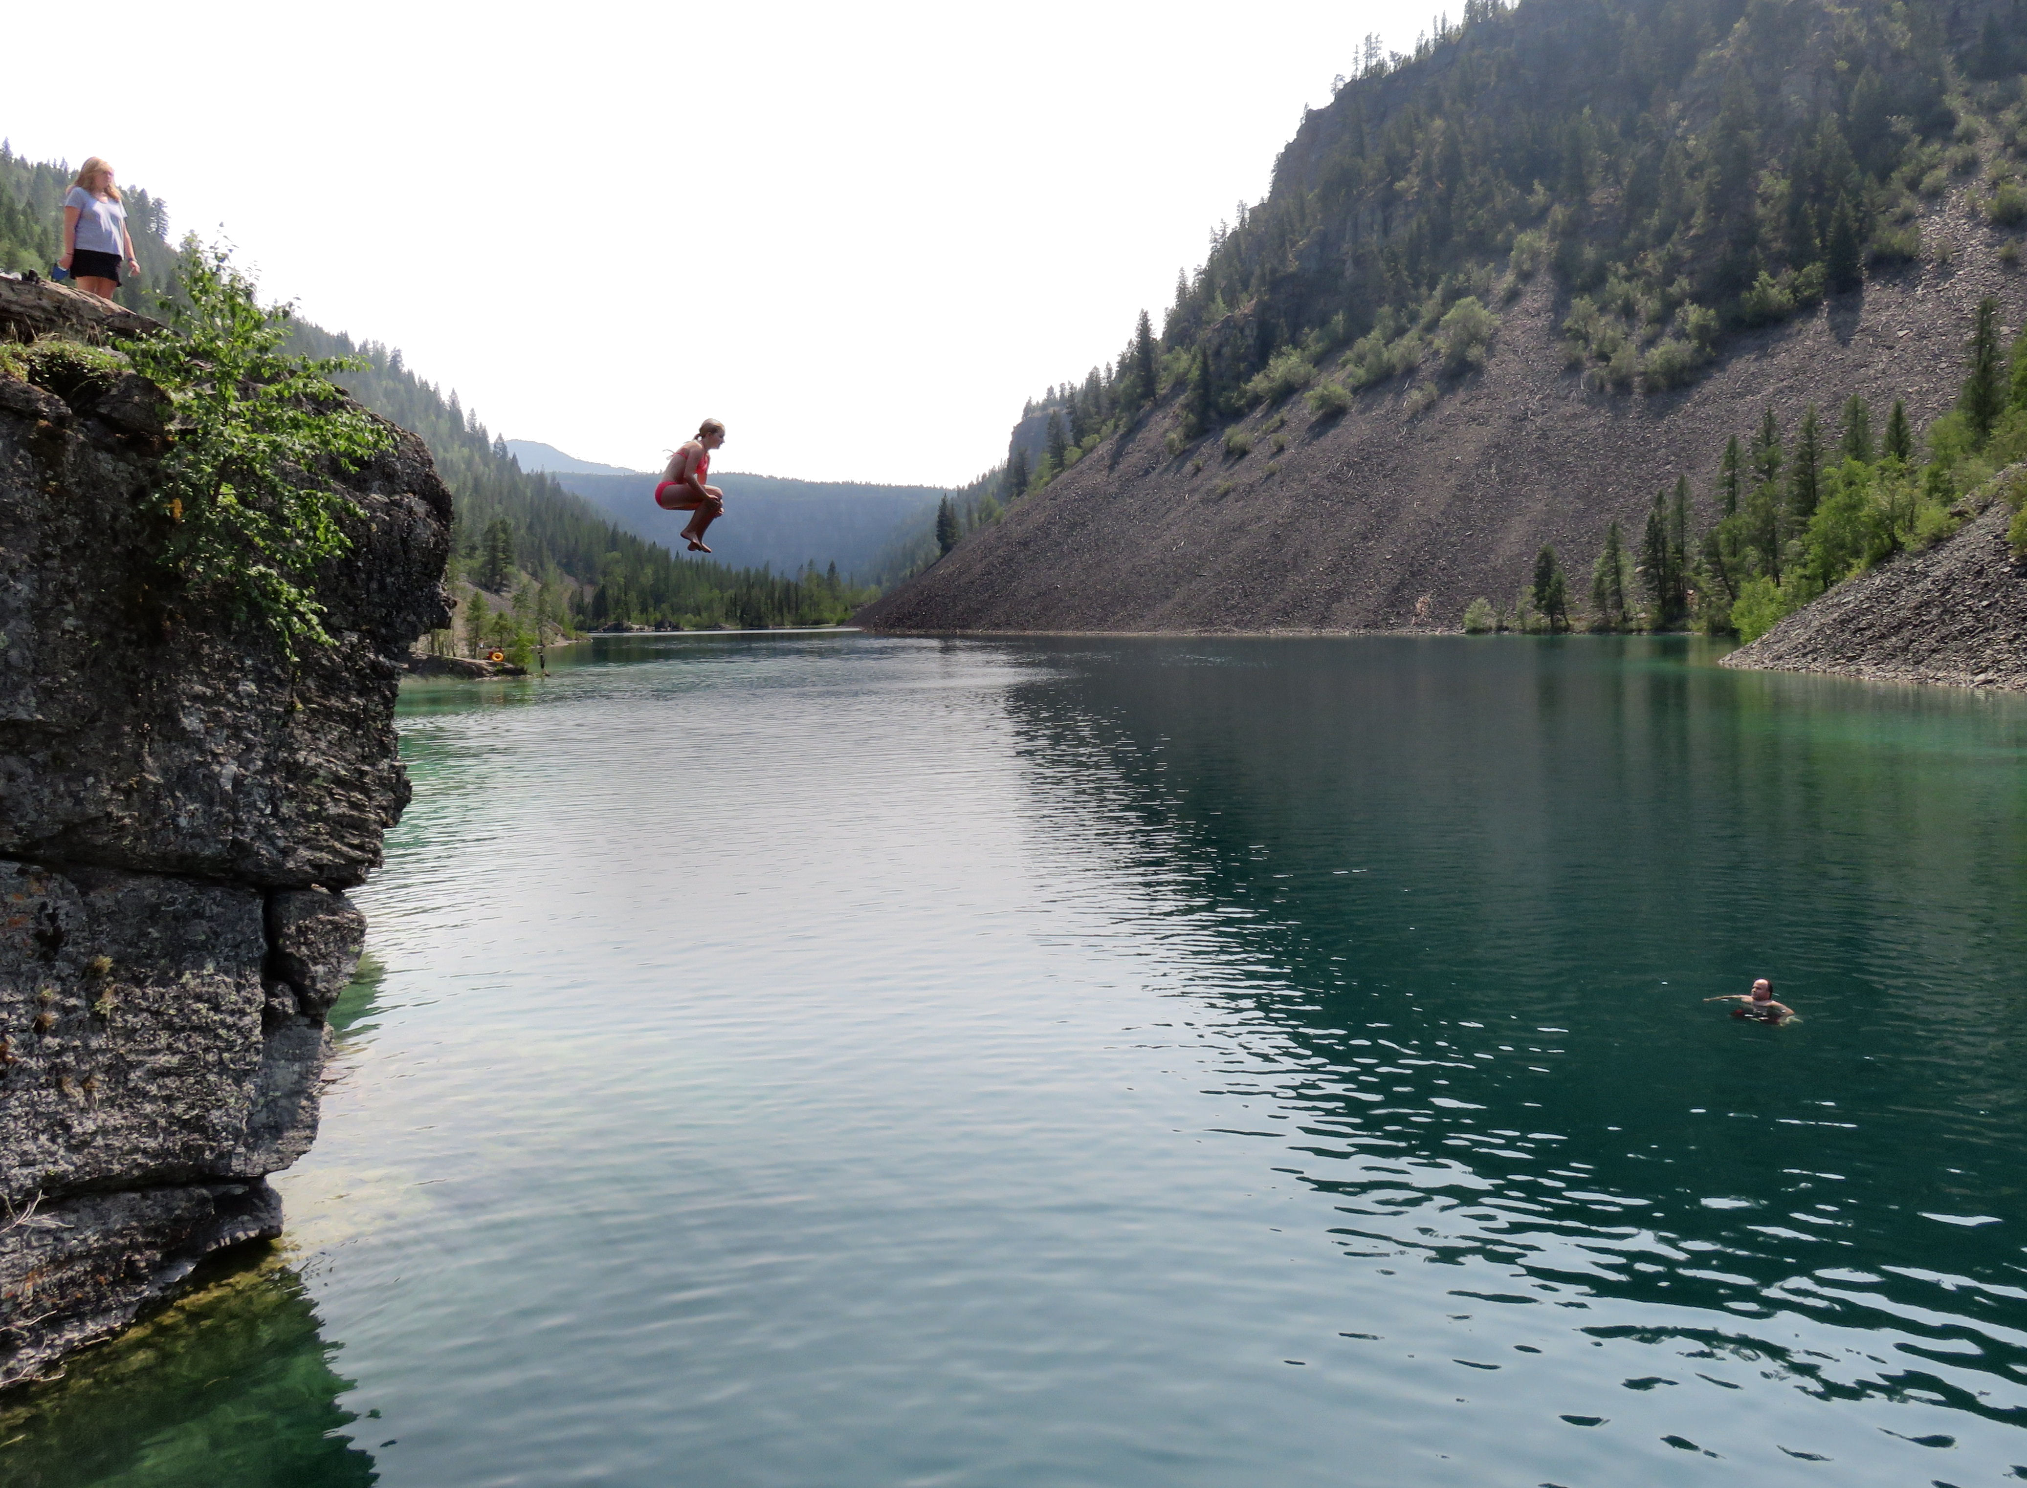

Left: This map shows the Silver Springs Lake trail and other trails in the area. Right: Katie Miller jumps off the cliff into the water as her parents watch on either end.

The second lake is one of Sean’s favorite fishing holes and a quiet place to chill and enjoy nature. Since most people don’t venture farther than the cliff jumping area of the first lake
For all the years the Miller family has visited this gorgeous chain of lakes, the one thing they never tried was the one thing that draws most people to the lake: cliff jumping. On our way back we stopped at the first lake to change this.
There are higher and lower cliffs to jump from. While Brenda, Sean and Katie braved the tall cliff, myself and Rylan played it safe by jumping off the lower cliff.
Even from the lower cliff the jump was exhilarating leaving me with an adrenaline rush. It was also a relief to cool down from our hike in the over 30 degree Celsius weather. It was the perfect end to a perfect day.

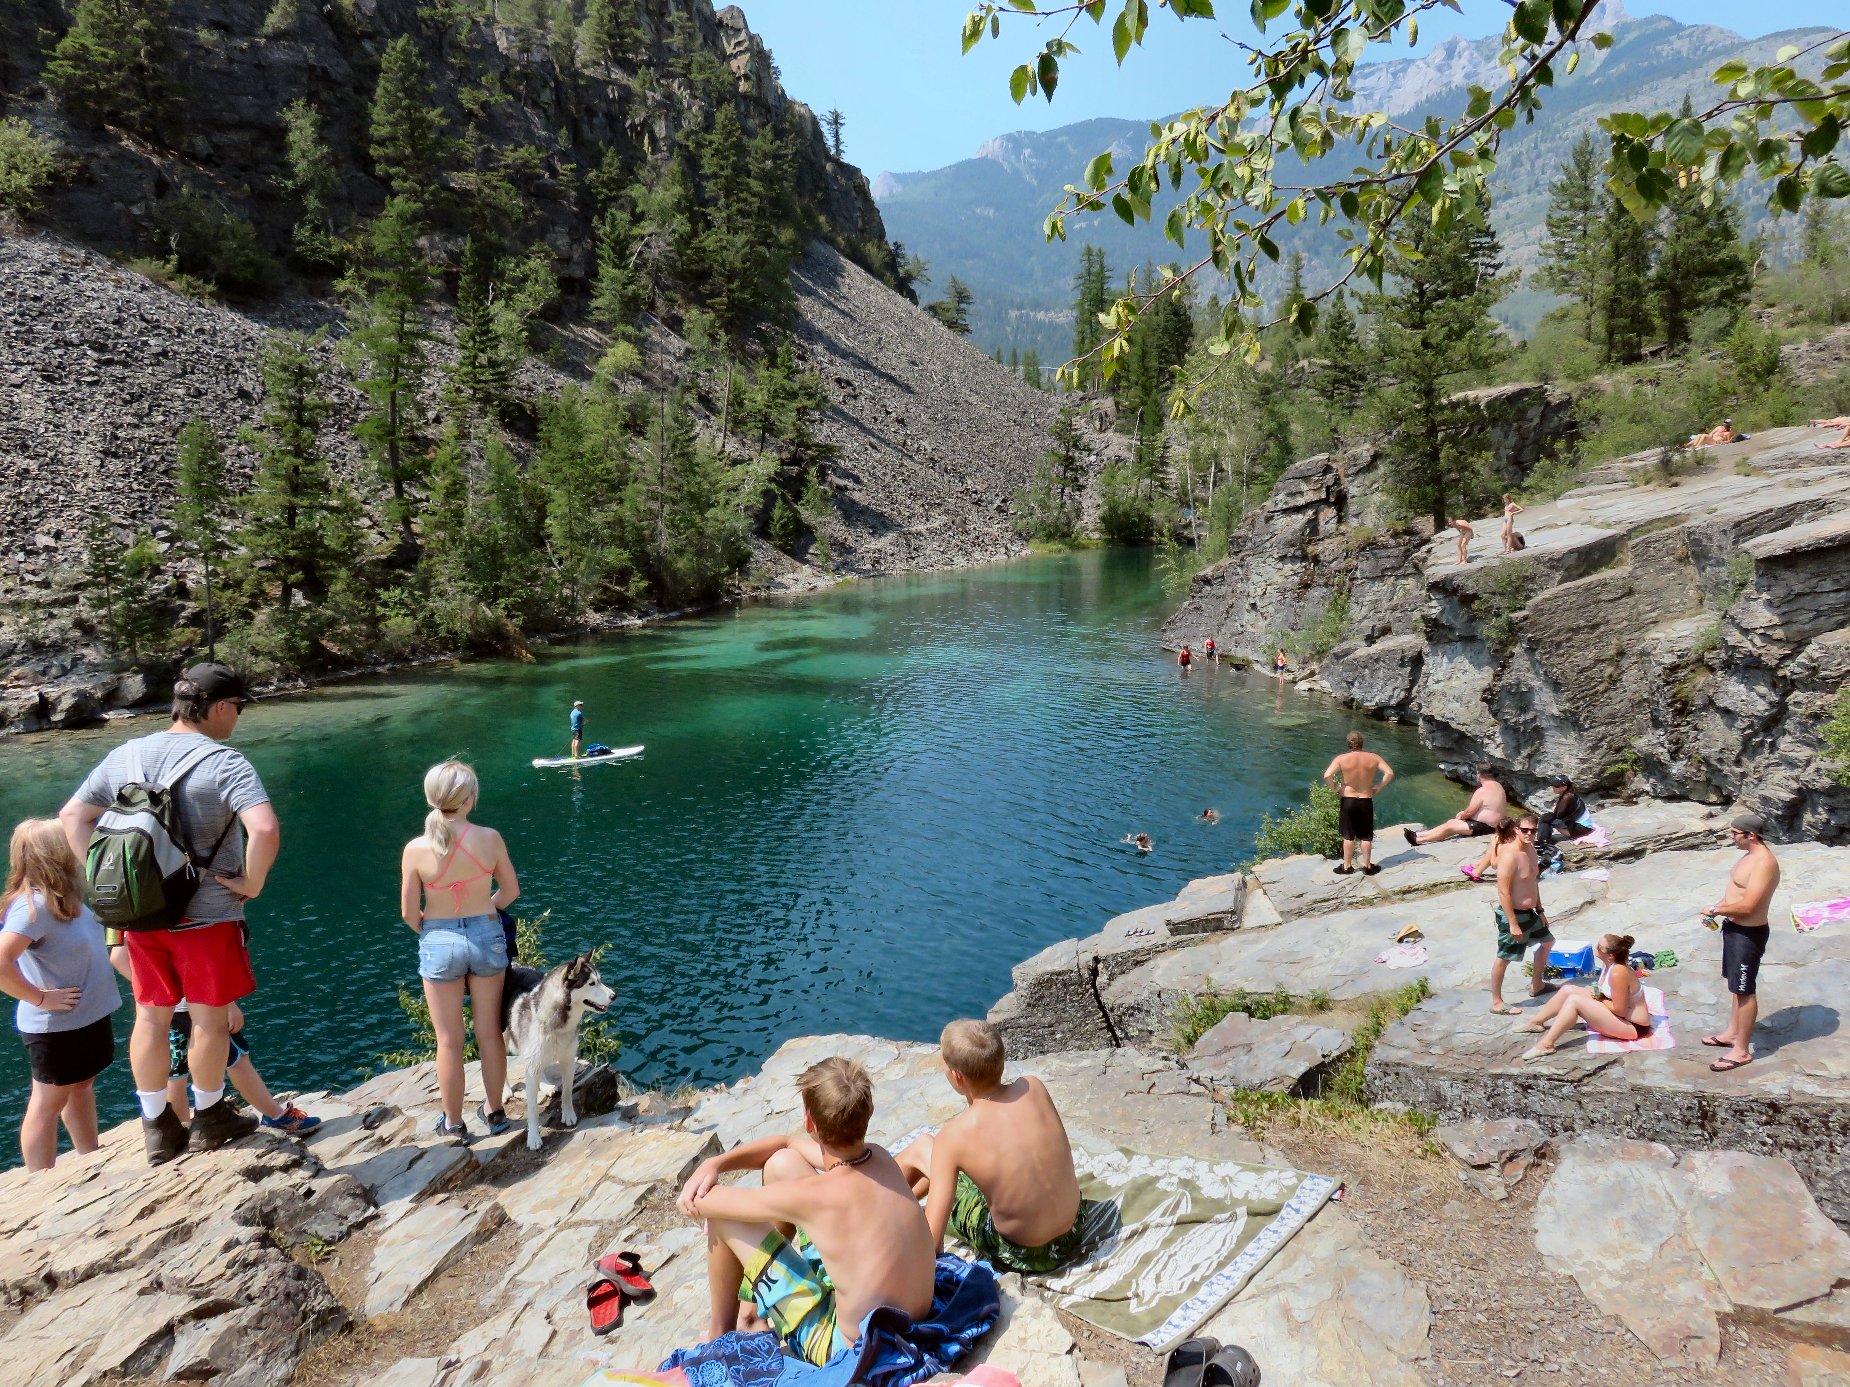

A crowd basks in the sun on the rock bench overlooking the first Silver Spring Lake

HOW TO GET THERE – From Highway 3 turn east into Elko. The turnoff is south from the gas station/restaurant along Highway 3, I believe it is called Store. At this point zero your odometer and turn east from Highway 3 into Elko and follow the paved road around several corners through the small town. After 1 km turn left downhill to the river and then at 1.5 km cross the bridge on to the Elko/Morrissey haul road.

Follow this gravel road 2.3 km east from the bridge. The river bends away from the road for a couple of kilometres. At 3.8 km when the river flows alongside the road again, drive another 500 m and look uphill on the right side for a small well-worn footpath. Parking is available about 200 m past of the trailhead, at a wider spot along the busy roadway.

