Take a Soak in the Lussier River Hot springs

I firmly believe that if it is located at the end of a dusty gravel road, it is probably worth seeing. This is no doubt true for one of the Kootenay’s most precious gems. To get to Lussier River Hot Springs one must drive 17 km down a dusty and in places narrow and scary logging road. But the reward at the end is well worth the white knuckles. Warm water flows from the rocks along the bank and is collected into manmade rock pools creating a little piece of heaven on earth.
The springs are located a short distance from the parking area but for those wanting to also enjoy a nice hike, the North Shore Trail located further up the road at the east end of Alces Lake provides a 2km hike through a Douglas Fir forest and provides views of Whiteswan Lake and the surrounding mountains.
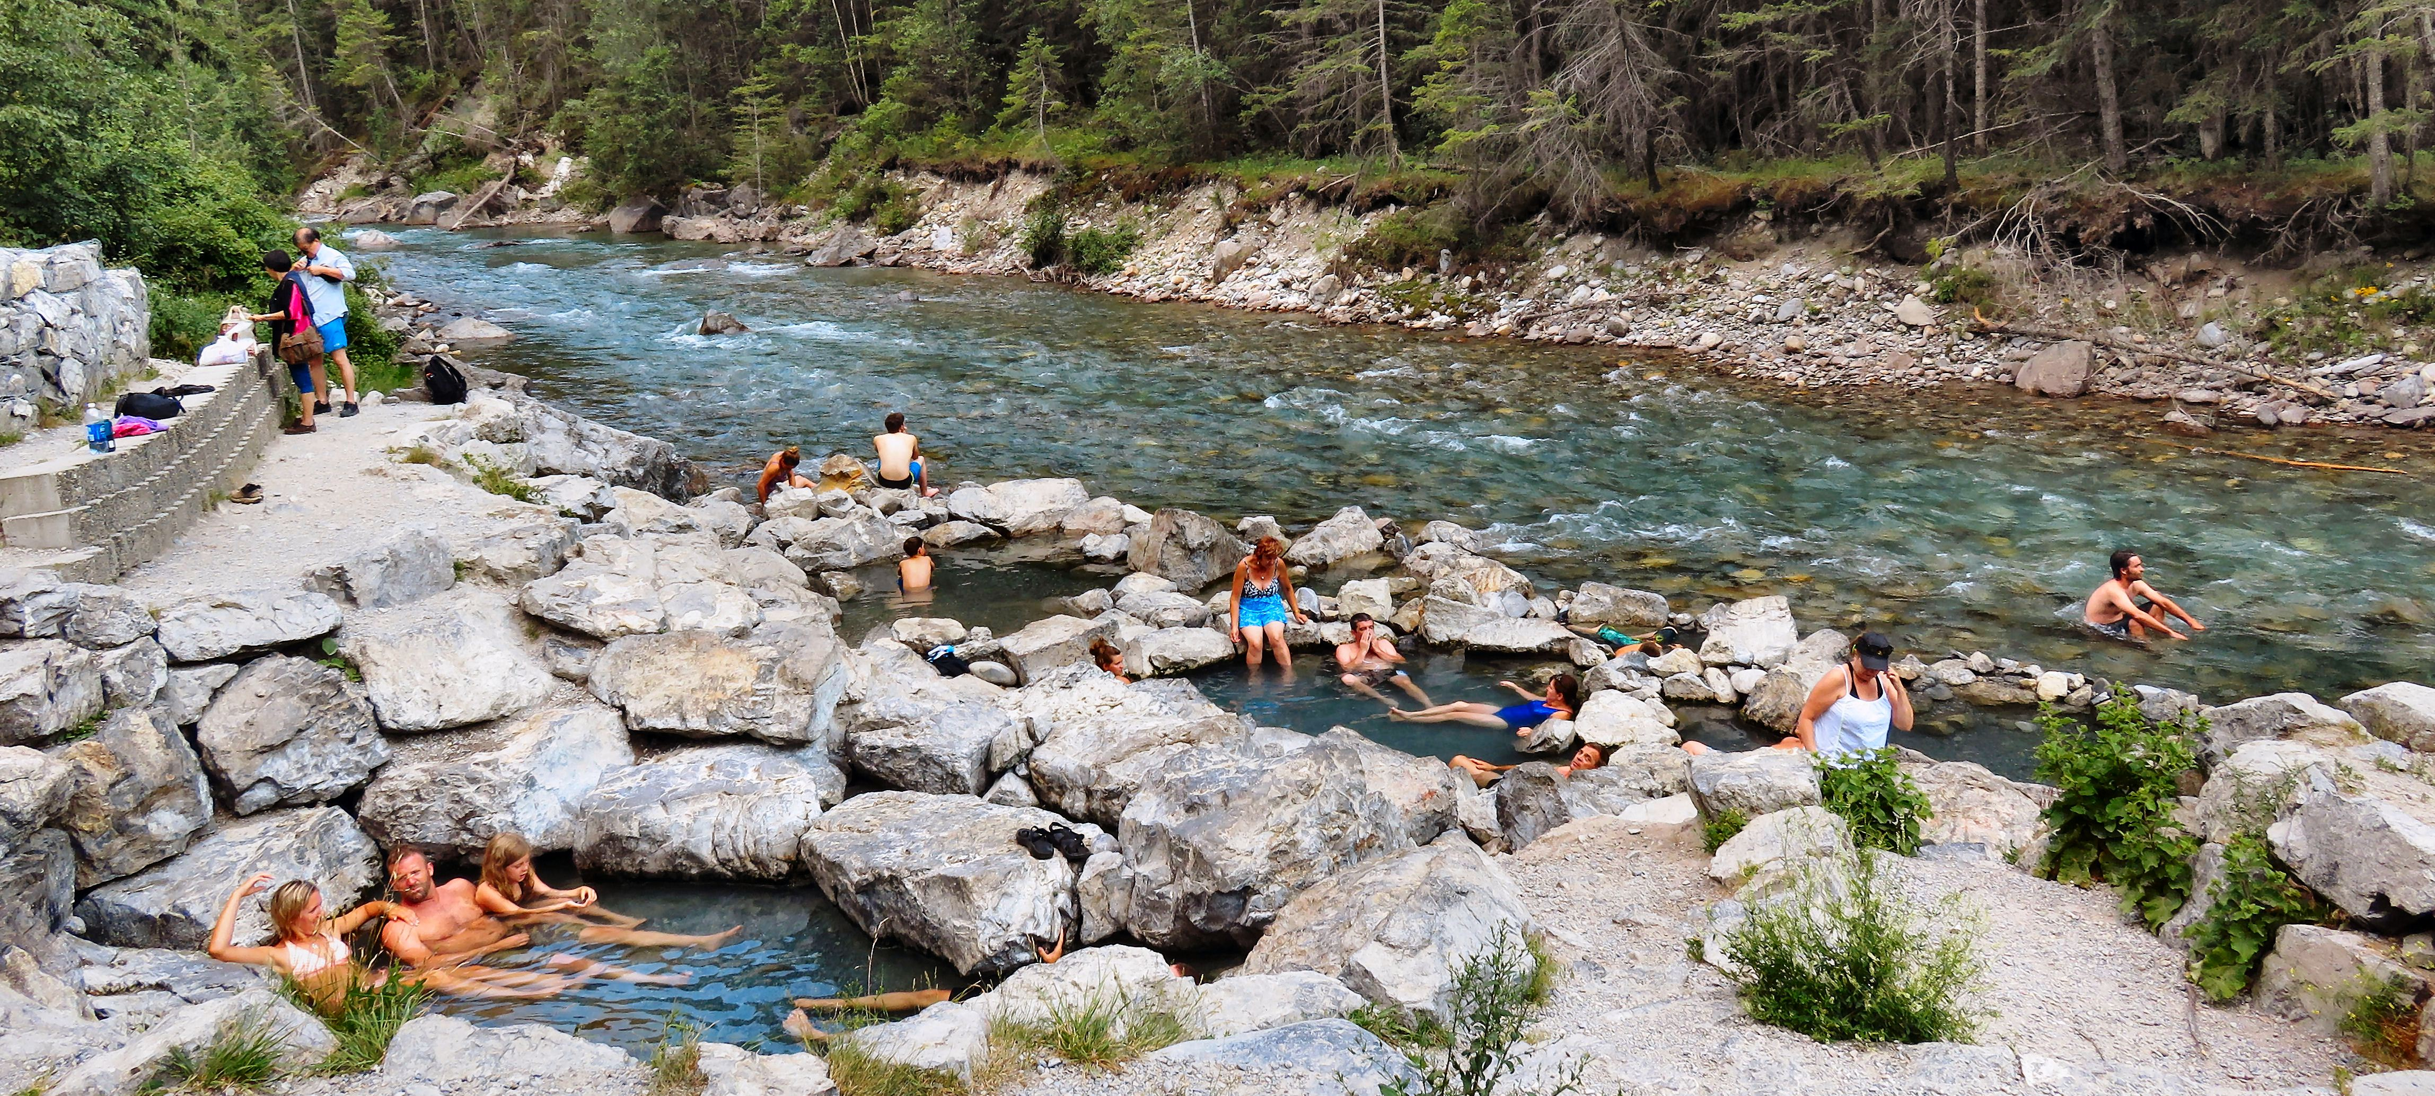

After warming up in the hot springs many visitors love to cool down in the shallow river.

For those wanting to stay overnight, there are 5 campgrounds in Whiteswan Lake Provincial Park that offer campsites on a first come first serve basis. This is a popular park in the summer. It is best to come in the off-season to increase your chances of getting a campsite.

HOW TO GET THERE – Whiteswan Lake Provincial Park is located, 22km southeast of the Village of Canal Flats, the nearest community. Access is from Highway 93/95; turn east 4.5 kilometres south of Canal Flats onto the gravel Whiteswan Forest Service Road. Whiteswan Lake is about 25 km from the highway; the hot springs are located near the west boundary of the park at kilometre 17.5.

