make a Relaxing pit stop at rearguard falls

Rearguard Falls is one of only two waterfalls on the 1,375 km long Fraser River; the other is a few kilometres upstream at Overlander Falls. It is located just above its emergence into the Rocky Mountain Trench near the community of Tete Jaune Cache and marks the upper limit of the 800 mile migration of salmon from the Pacific Ocean. In the late summer, look for the few largest and strongest of the Chinook that made it this far.
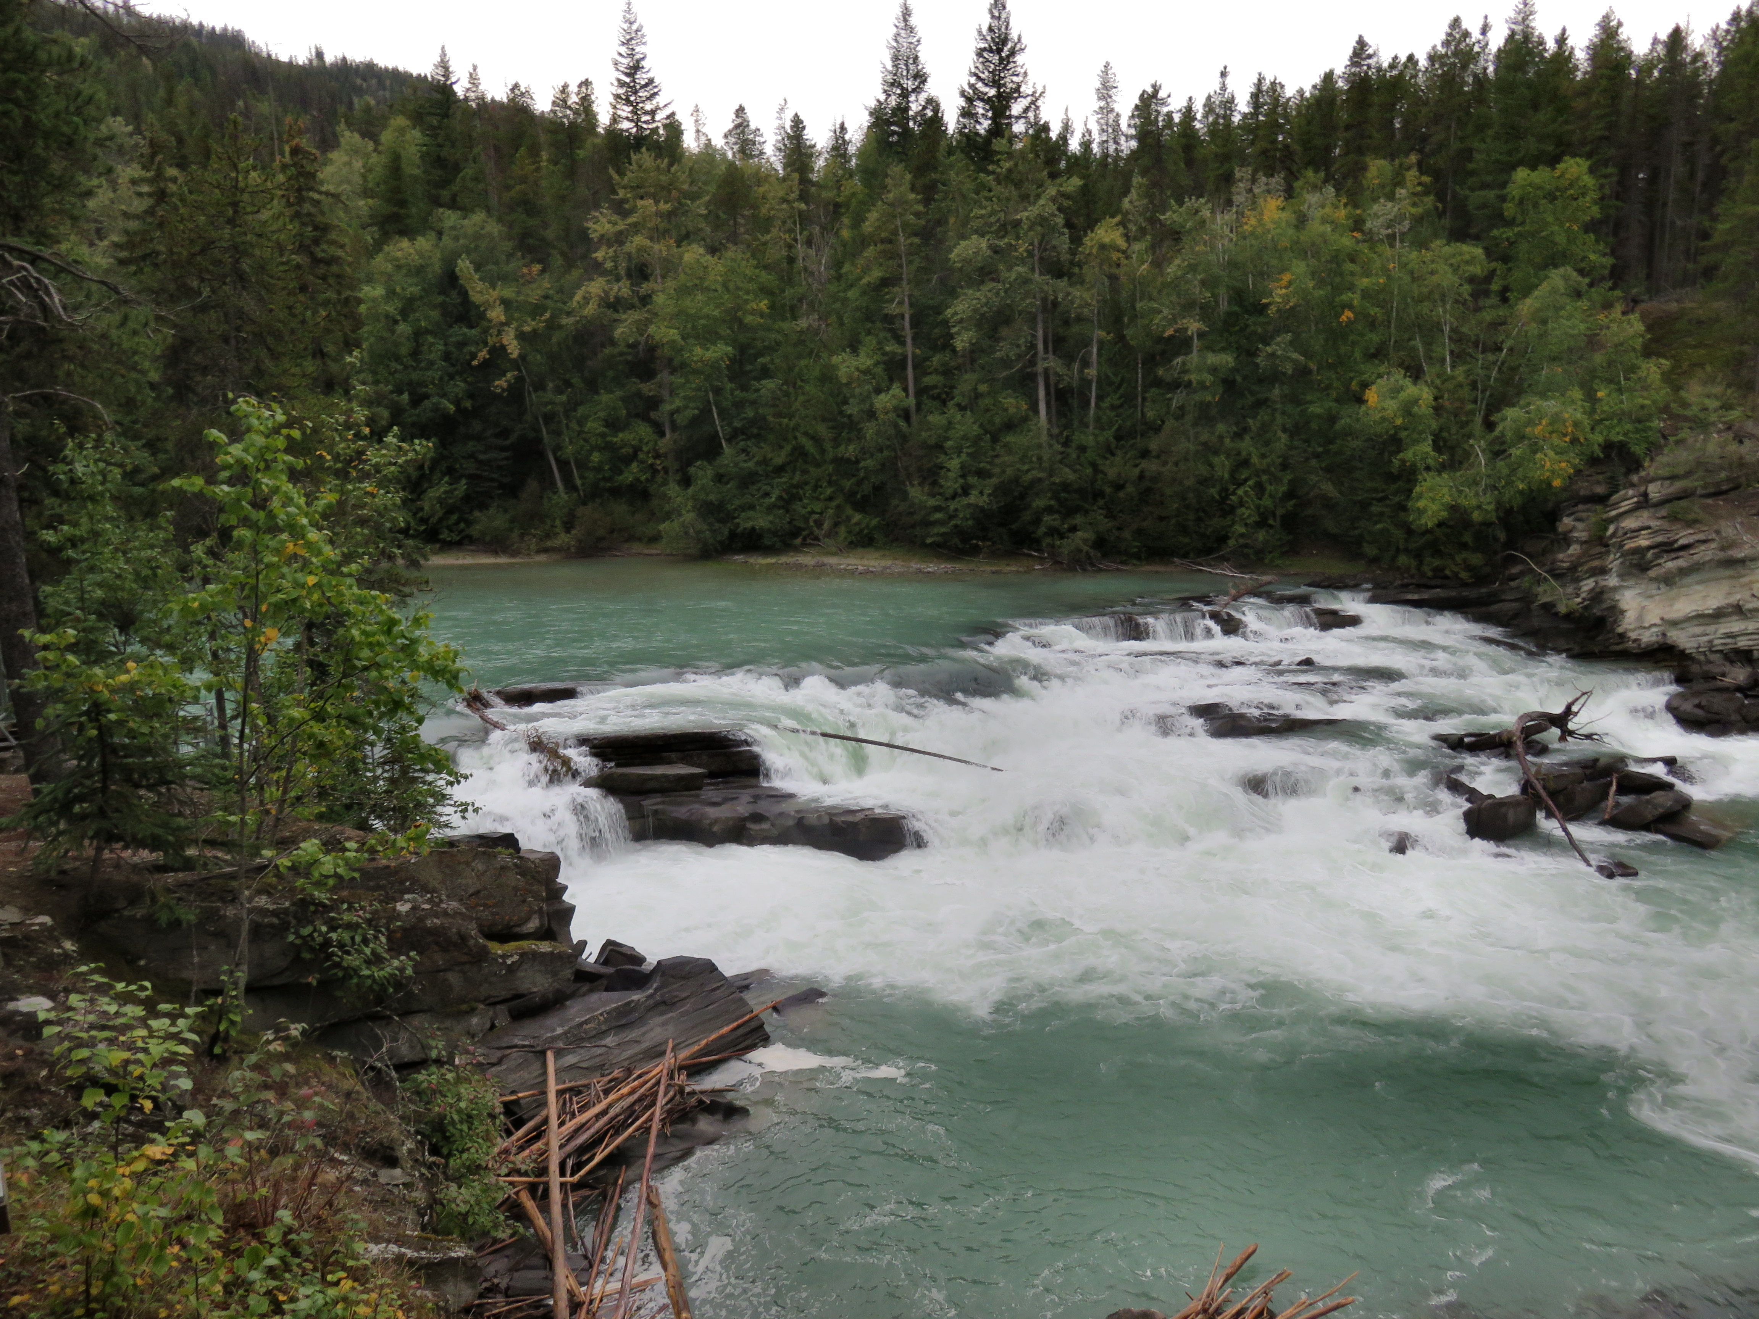

Rearguard Falls marks the upper limit of the salmon migration on the Fraser River.

HOW TO GET THERE – From Kamloops head North on the Yellowhead Highway towards Jasper and you will see the turnoff for the falls 285 km east of Prince George on Highway 16. From the parking lots the falls are a short 10-15 minute hike down a hill where you will come to a wooden viewing platform. If you continue down from the platform you can gain another view of the falls from the riverbank.

