Set your aperture on the Amazing Athabasca falls

Athabasca Falls is not known so much for the height of the falls (23 metres), as it is known for its force due to the large quantity of water falling into the gorge. It is a Class 5 waterfall, with a drop of 24 m and a width of18 m.
White water rafting often starts below the falls to travel downstream on the Athabasca River to Jasper.
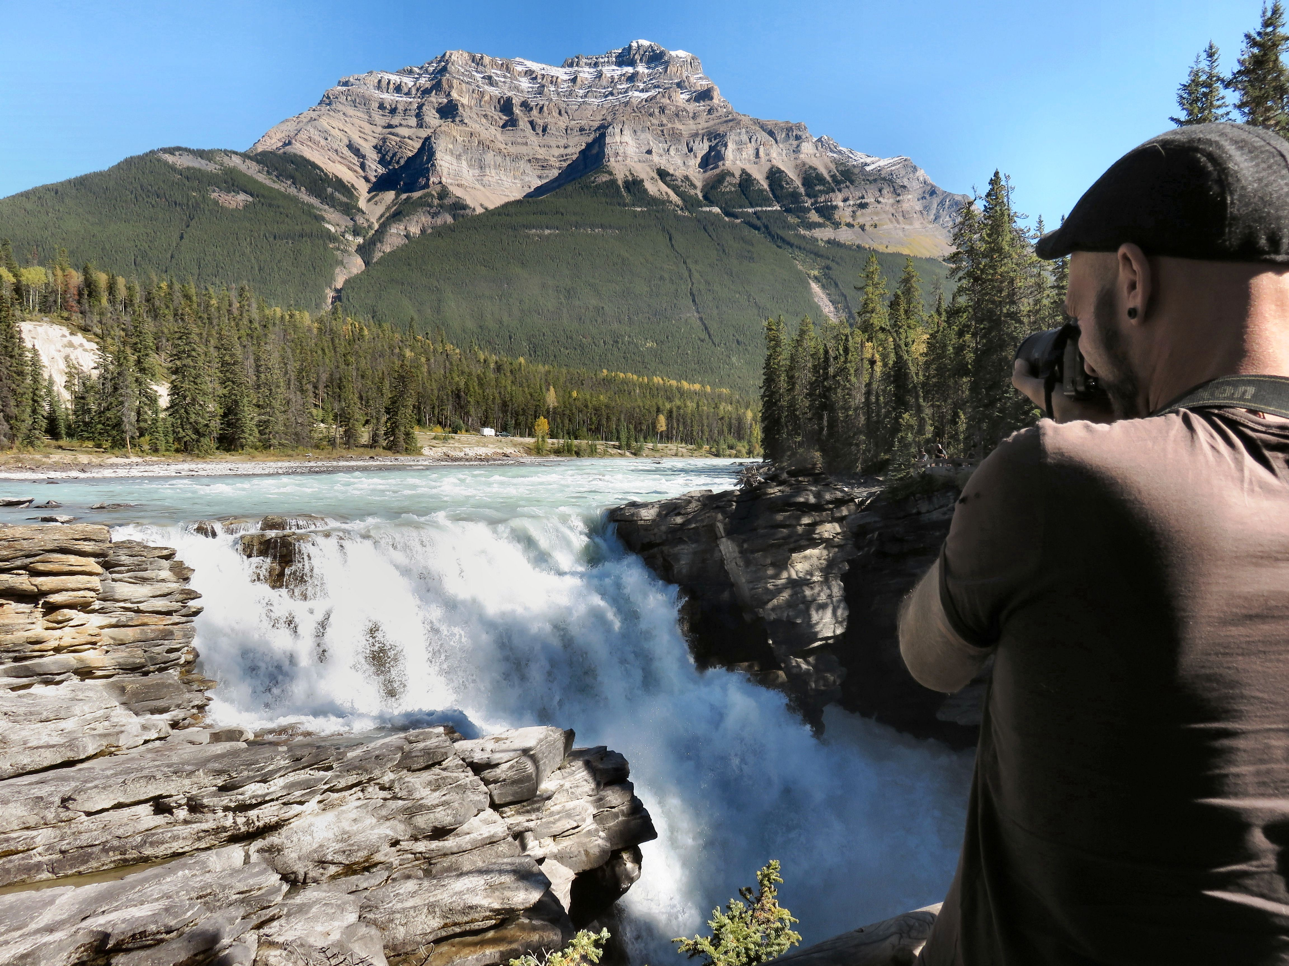

World traveler David Dhaen photographs the falls from the viewing platform.

The falls can be safely viewed and photographed from various viewing platforms.

HOW TO GET THERE – The falls are located just off Highway 93A which takes off from the nearby Icefields Parkway, and crosses the falls on the way north to the town of Jasper.

