Climb to the top of Tangle Creek falls

One of my favorite waterfalls in Jasper National Park is Tangle Creek Falls. The waterfall drops about 114 feet, with an array of separate braids that consolidate into a single fall that plunges and additional 3 consecutive tiers of about 14, 18 and 13 feet each.
Located along the Icefields Parkway, this waterfall is not only incredibly beautiful, it is also fun to climb.
As cascades down the side of the mountain it creates a number of different waterfalls that are fun to get up close to. The hill beside the falls is an easy climb prompting many visitors to scramble up to the upper falls where what appears to be four side by side columns of water tumble into a pool below.
The coordinates are N 52° 16.035 W 117° 17.197. There are restroom facilities and some parking.
HOW TO GET THERE – To get to the falls from the south, head just past the Icefields Centre on Hwy 93. Watch for Tangle Creek on the east side of the road while descending a large mountain to the Kitchener Mountain Area. The falls are located 96 kms from Jasper.

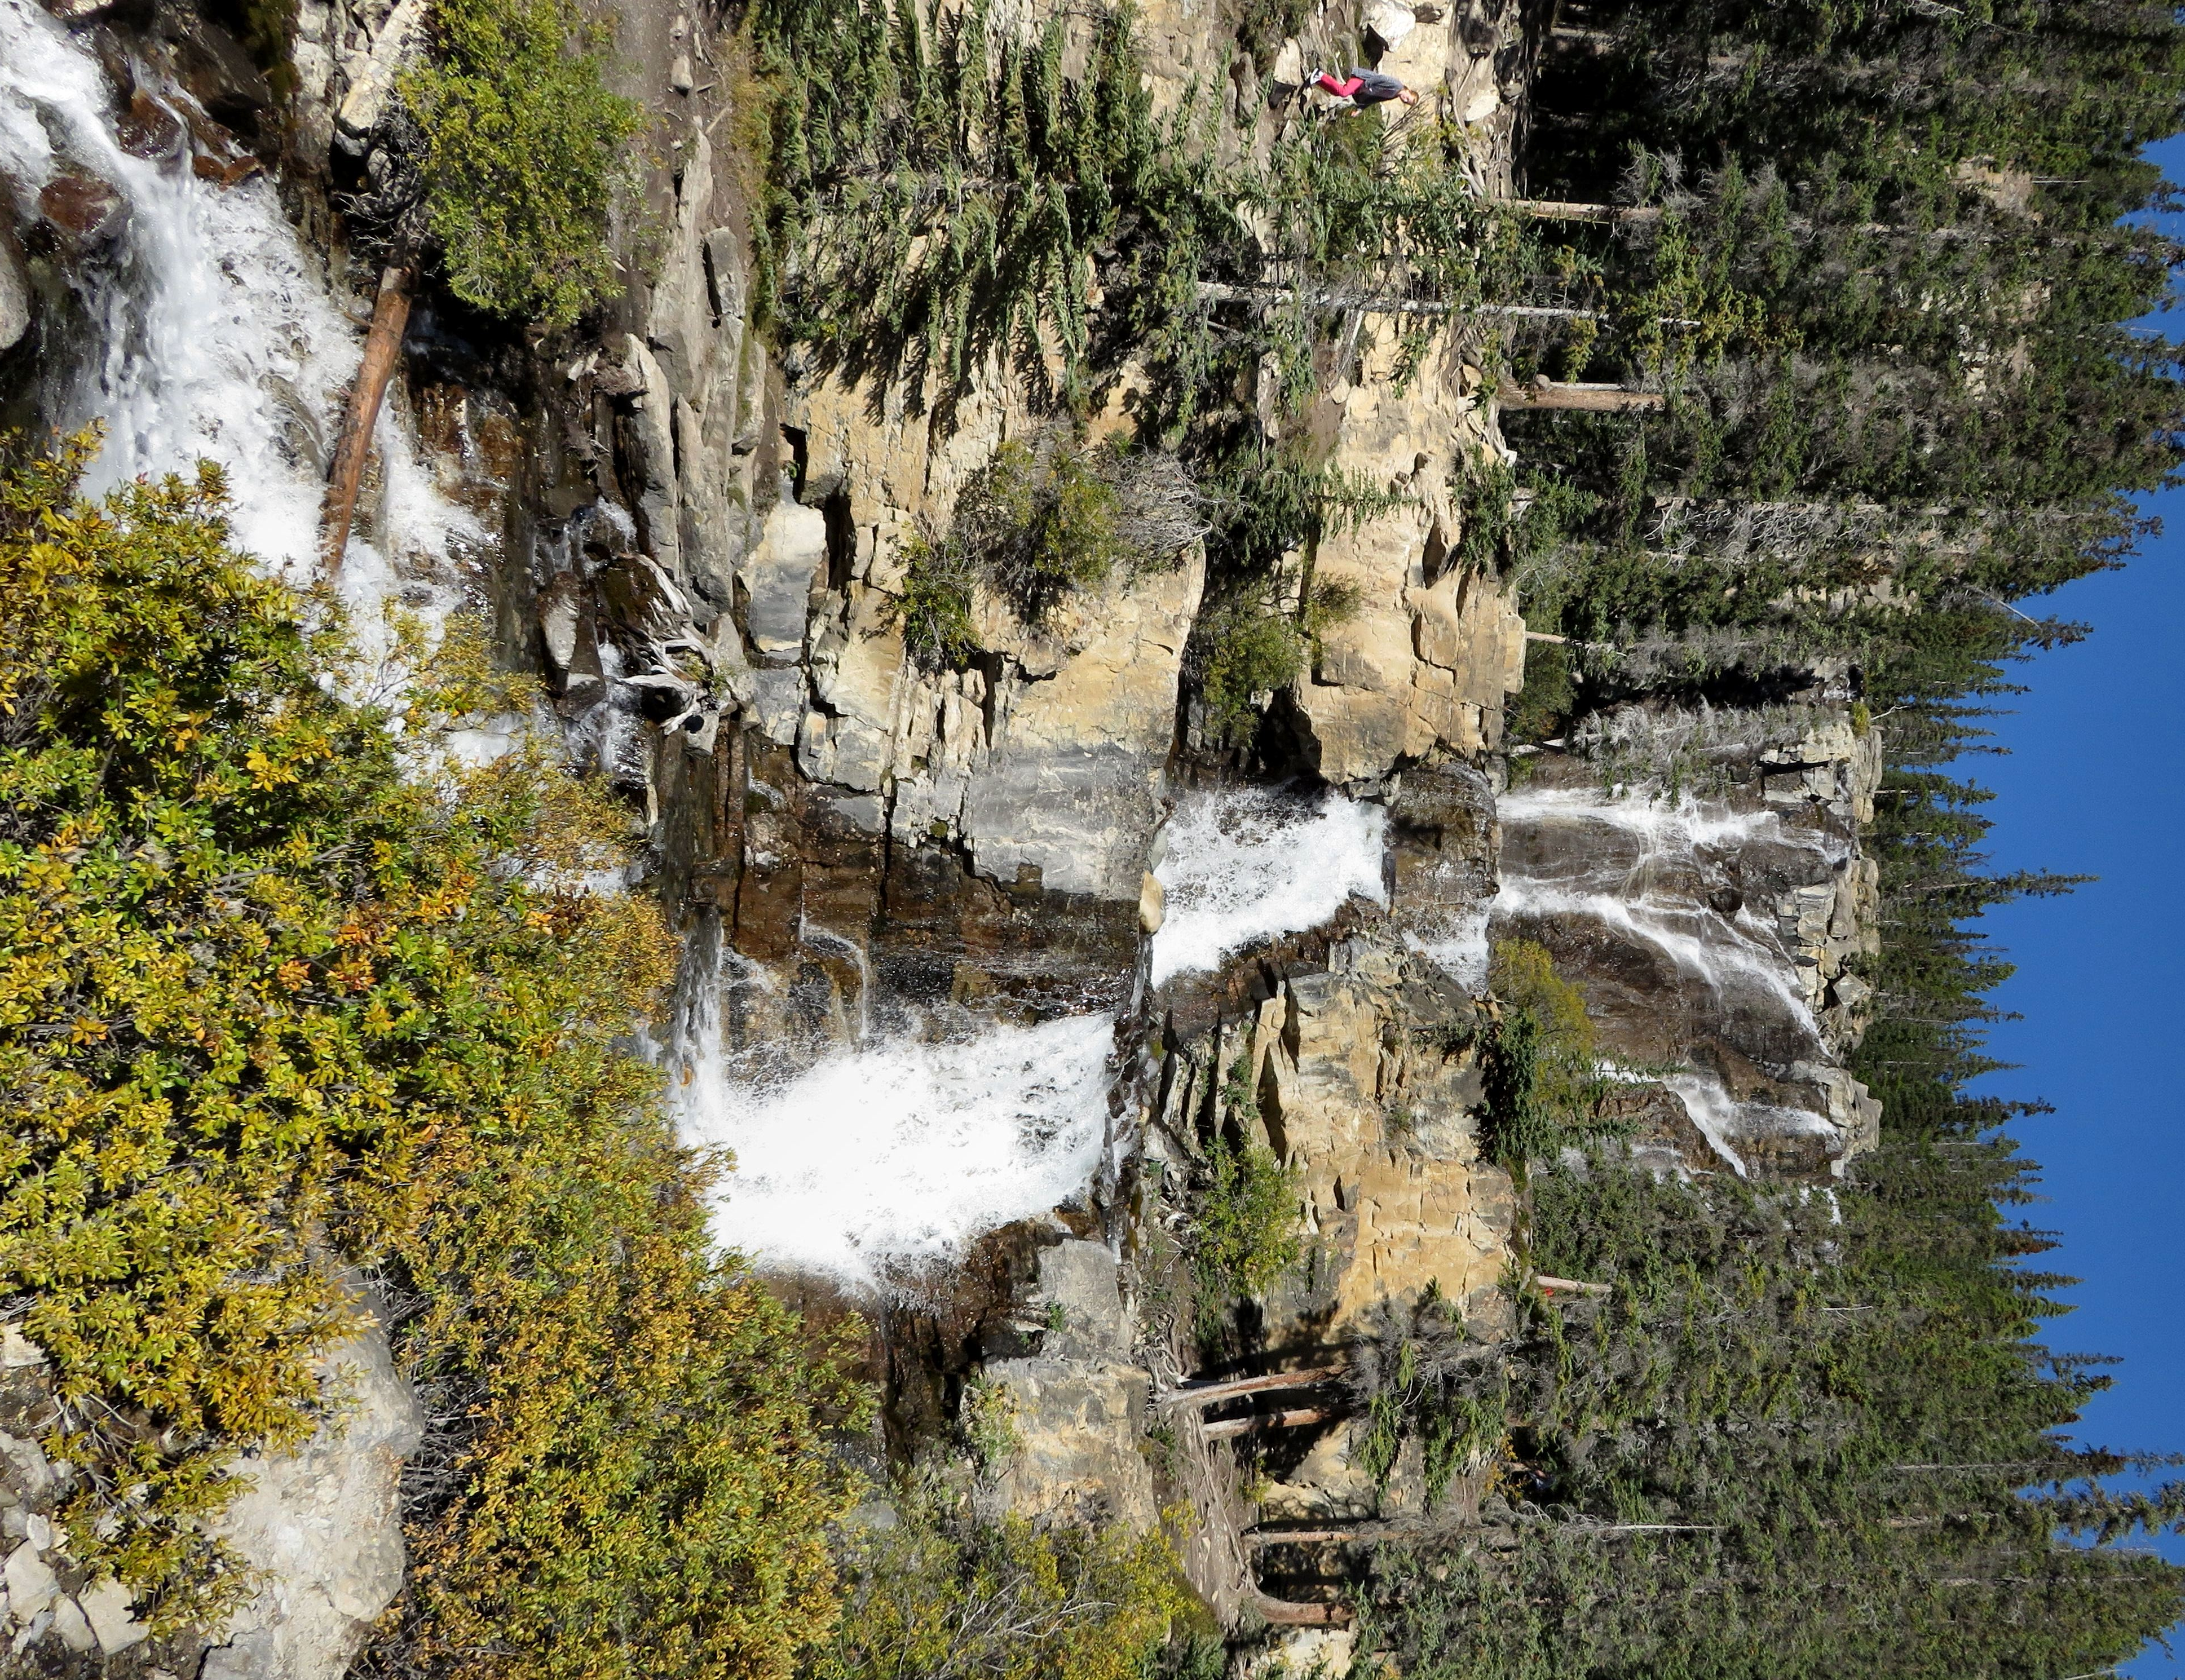

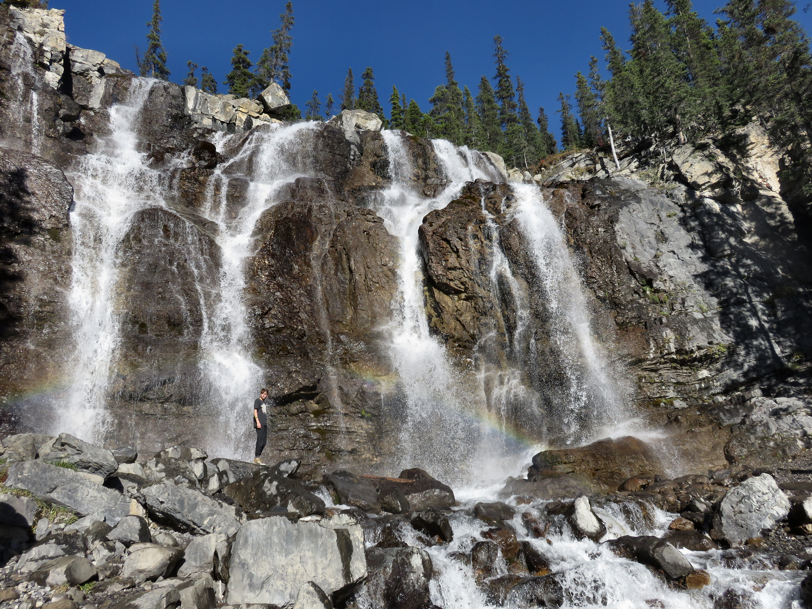

Top: Tangle Creek Falls as seen from the top tier. Bottom: Tangle Creek Falls as seen from the road.

aaaaaaaaaaaaaaaaaaaaaaaaaaaaaaaaaaaaaaaaaaaaaaaaaaa

