Soak in the serenity of Sunwapta falls

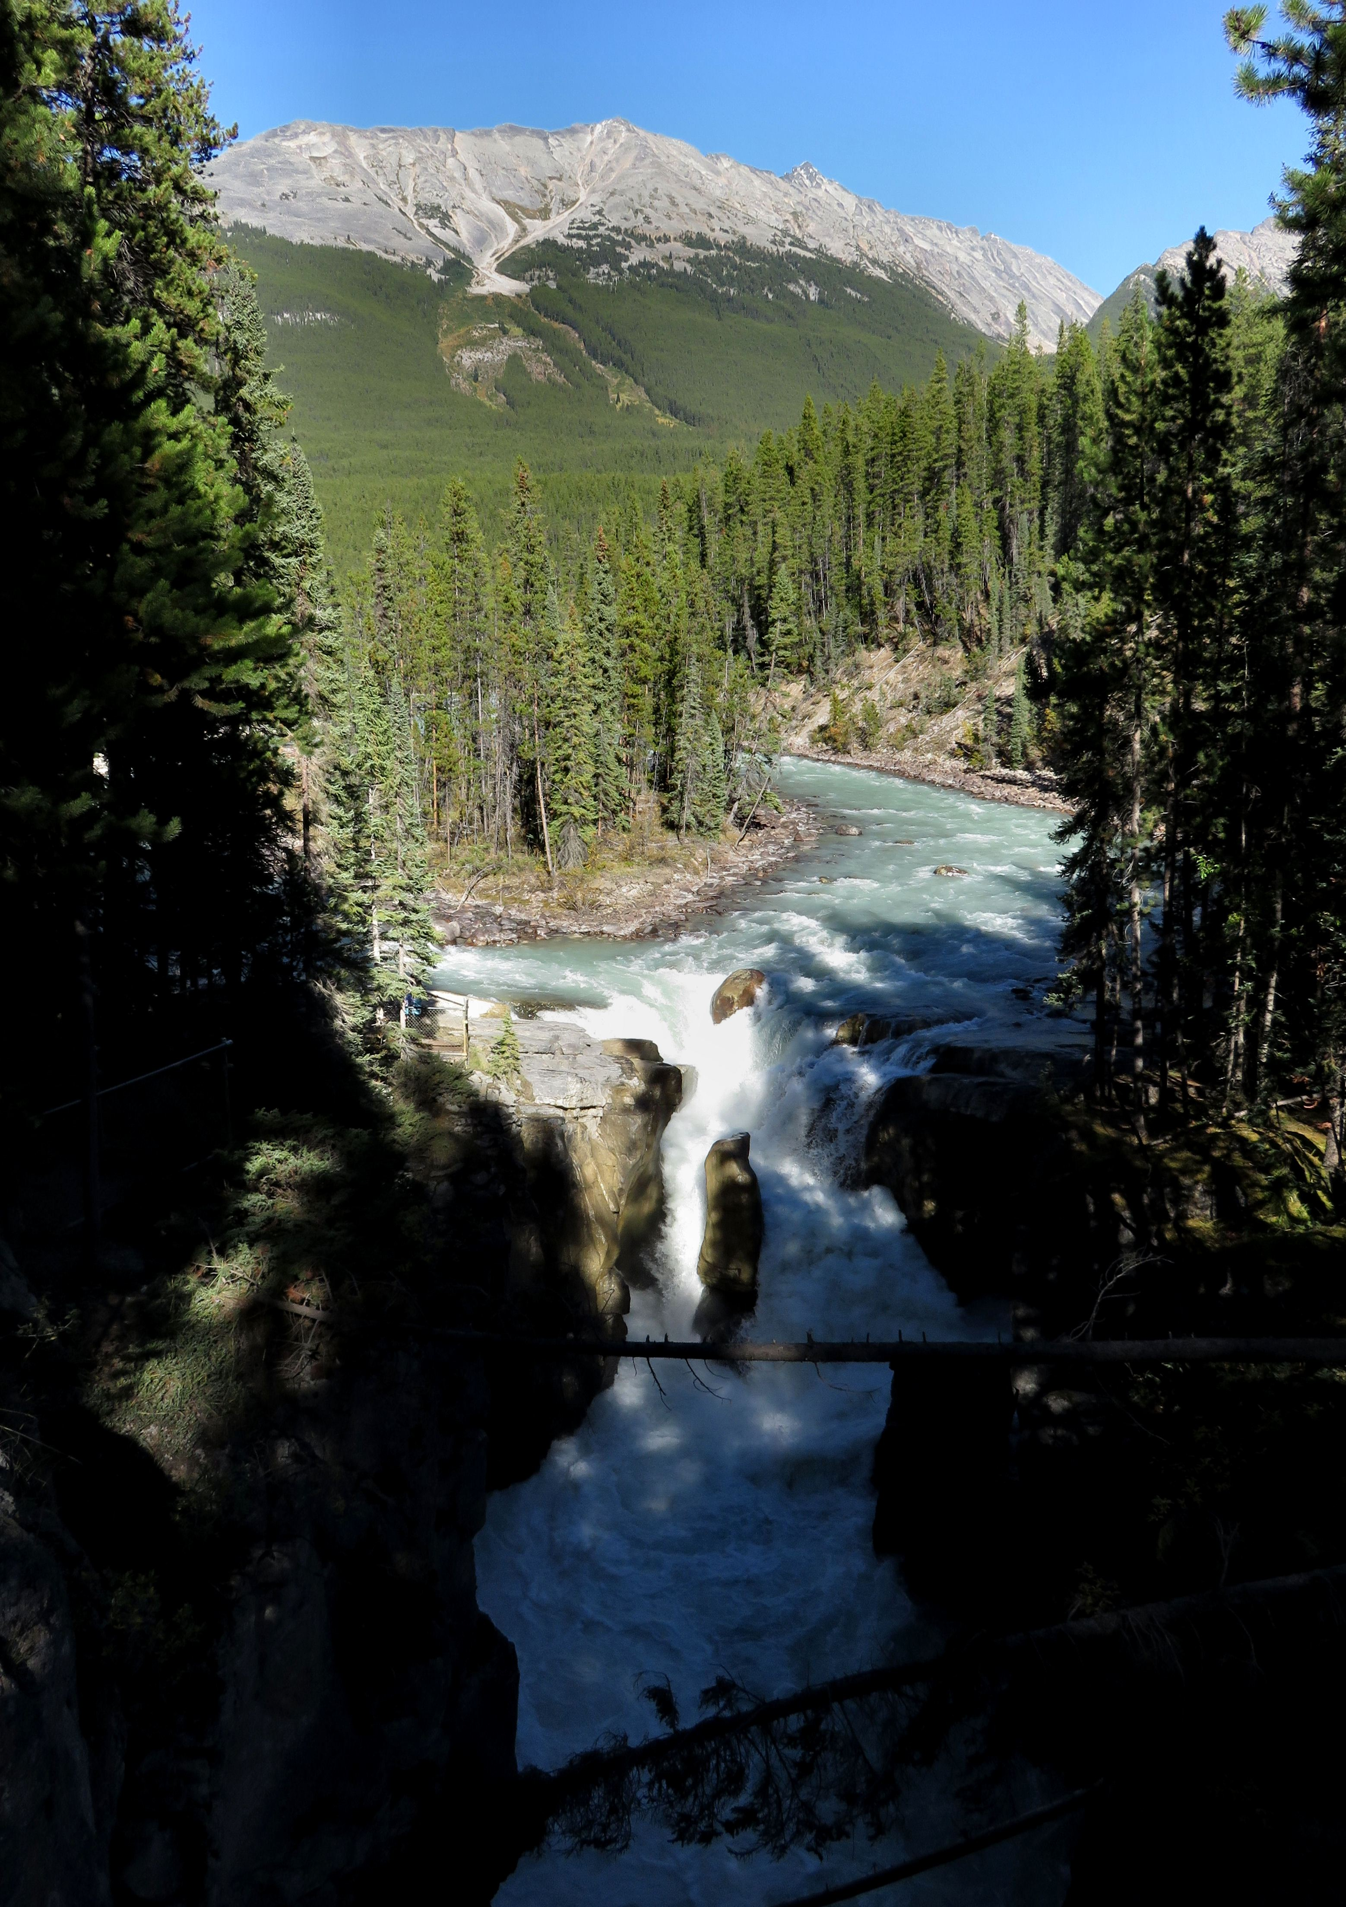
Accessible via a short drive off the Icefields Parkway that connects Jasper and Banff National Parks, Sunwapta Falls (Stoney word meaning turbulent water) drops about 18.5 metres. The water originates from the Athabasca Glacier, and volumes are higher in early summer, caused by glacial meltdown.
While it is the most spectacular in the late spring when the spring melt is at its peak, it’s a beautiful set of waterfalls to visit anytime of year.
Yes you read that correctly, unbeknownst to most people, there are actually two falls, a lower and an upper one. The one most people see is the upper falls as access is easy. It is a class 6 waterfall with a drop of 60 ft (18 m) and a width of 30 ft (9.1 m).
The Lower Sunwapta Falls are actually a series of three waterfalls locate further downstream and reached via a trail that starts from the same parking area as the upper falls.
The trail to the lower waterfalls starts beyond the picnic and viewing areas where most of the attention would be towards the main waterfall and the mountain backdrop.
If you walk gently downhill for roughly 2km (in one direction) along the well-forested path, the commotion from the upper waterfall gives way to the subtle sounds of Nature. At the end of the walk, you will reach a fenced overlooks where you can view the lower three waterfalls.
There is a bench and plaque just above the uppermost of these waterfalls in commemoration of someone that died young here

HOW TO GET THERE – The well-signed turnoff for the falls is roughly 45 minutes north of the Columbia Icefields along the Icefields Parkway (aka Hwy 93). Heading south of Jasper, it's about an hour's drive on Hwy 93 (or 25 minutes south of Athabasca Falls).

Upper Sunwapta Falls on a sunny September day

