Feel the rush of water in maligne canyon

There is just something about the rush of water that lifts the spirits and awakens the soul. My visit to the magical Maligne Canyon one hot September day had that exact effect on me as I witnessed the surge of water making its way over waterfalls and through narrow parts of the canyon to reach the calm pools at the end.
Originating in Medicine Lake, the Maligne River flows about 15 km upstream as a full river, before disappearing into seeps in the ground and then completely vanishing for most of the year.
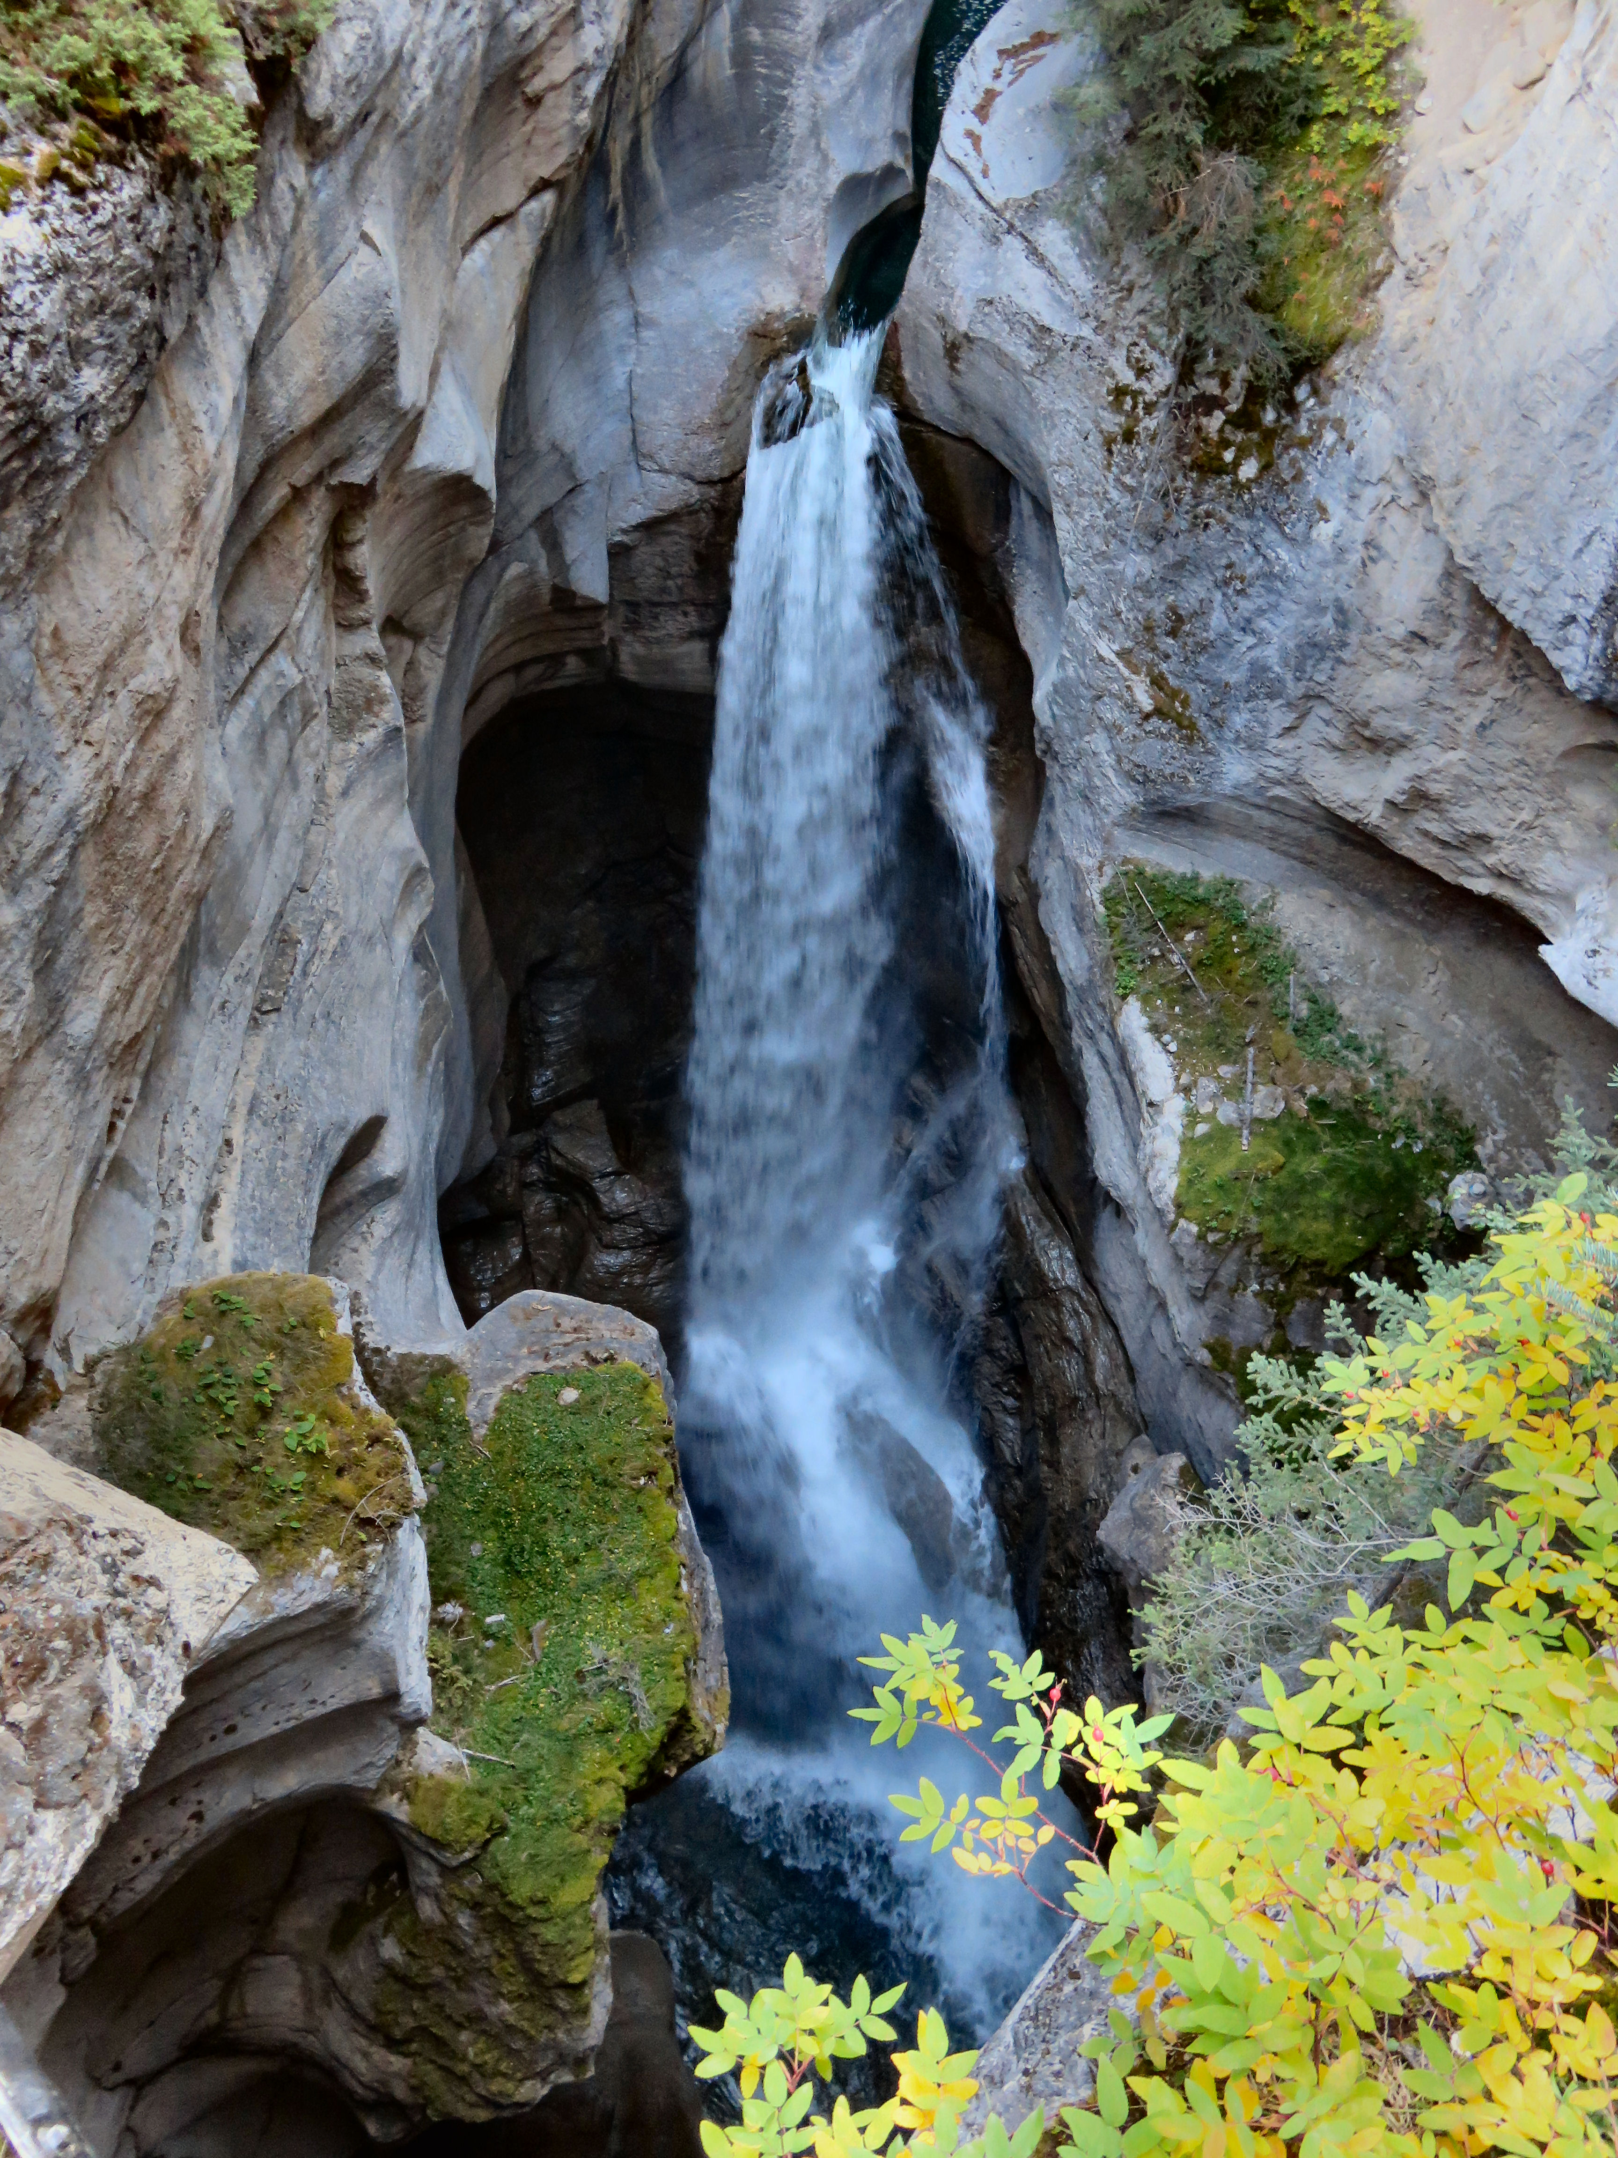

One of a number of waterfalls in the canyon

The smaller streams that feed the valley below that point rebuild the river by the time it reaches the top of the canyon.
Maligne Canyon is carved into the Palliser Formation, a layer of limestone deposited in a shallow tropical sea by lime-secreting plankton about 365-million years ago. Some geologists speculate that parts of the canyon were originally deep caves that have since been uncovered by glacial scraping and water erosion.
Parks Canada has developed a self-guided interpretative trail along the canyon with signs describing the geological history of the area There are six bridges that cross the canyon and depending on how long you want to walk there are a number of options.
For a short easy walk of 20-40 minutes you can choose to do a loop that includes the crossing the first two foot bridges. Here you will see the teahouse which is also a souvenir shop as well as the fossils that remain in the walkway near the teahouse.
For a 30-minute return walk you can head to the third bridge and for a one-hour return carry on to the fourth bridge. If you have more time, you may want to do the longer 2-hour return walk to the fifth bridge of the 3-hour return walk to the sixth bridge.

For an added rush, visit the canyon in the winter and walk along the frozen river and under the sheets of ice.

HOW TO GET THERE – To get to the Maligne Canyon Trailhead, follow Highway 16 towards Edmonton; go 1.8 km past the east Jasper exit to the Maligne Road and look for the sign for Maligne Canyon parking.

