watch The weeping wall of waterfalls

The Weeping Wall is a set of cliffs, approximately 1000 feet high, located alongside the Icefields Parkway in northern Banff National Park in Alberta, Canada, just south of the boundary with Jasper National Park.
In spring and summer, the faces of the cliffs are usually covered with a series of cascading waterfalls. In winter, the waterfalls freeze into towering pillars of ice and become a well-known site for ice climbing.

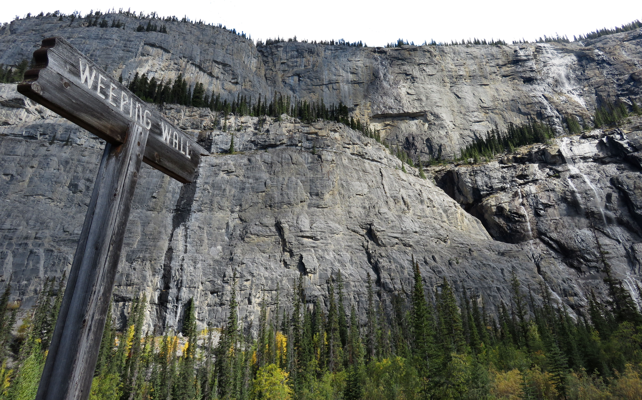

In the summer water trickles down the face of the Weeping Wall hence the name.

I visited the wall in mid-September and there was not a lot of water falling down the cliffs however during the spring in June and early July with a heavy snow melt the volume of water would be much more prominent.

HOW TO GET THERE – The Weeping Wall is located on the Icefields Parkway between Jasper and Banff and is visible along the road. There is parking across the street. The coordinates are 52°9′23″N 117°0′24″W.

