explore the cascading pools of sukunka falls

I firmly believe that most of British Columbia’s most precious gems are hidden at the end of a dusty gravel road. Sukunka Falls is no exception. At the end of a long dusty drive you are rewarded with a little piece of paradise. With a backdrop of the Rocky Mountains, the Sukunka River over vertical bands of bedrock layers in a series of 10 waterfalls complete with rapids. The falls are spread out over a distance of 300 meters.
Sikanni and Beaver First Nations are known to have occupied the Sukunka Valley during the time of European exploration in the Peace River region. Prescott Fay, in 1914 wrote: “At this point the river goes through a rocky canyon, above which are a series of very pretty cascades and small, symmetrical falls, so much so as to be almost artificial.”
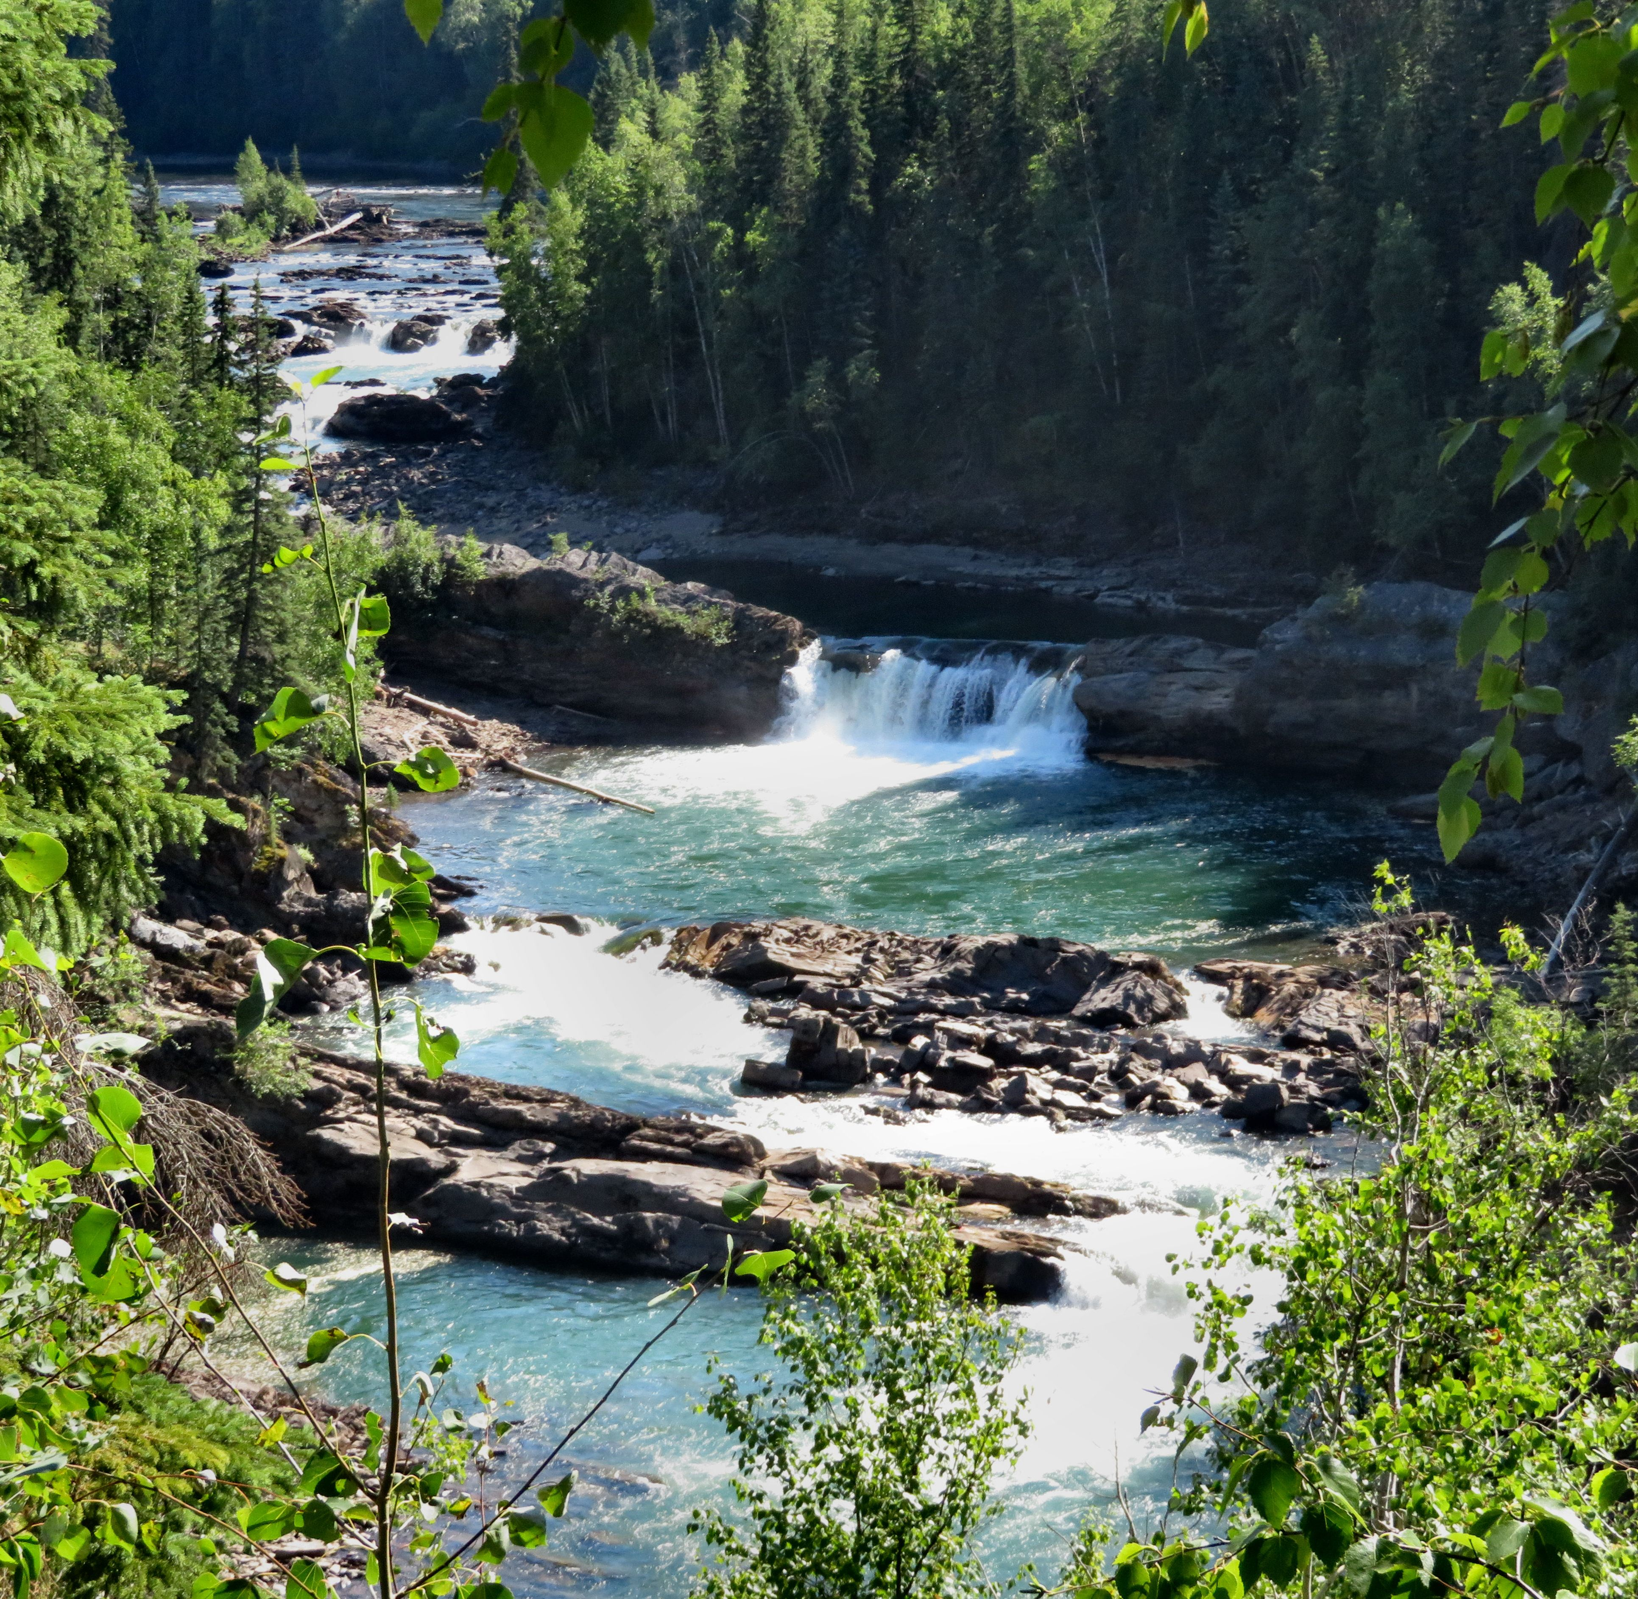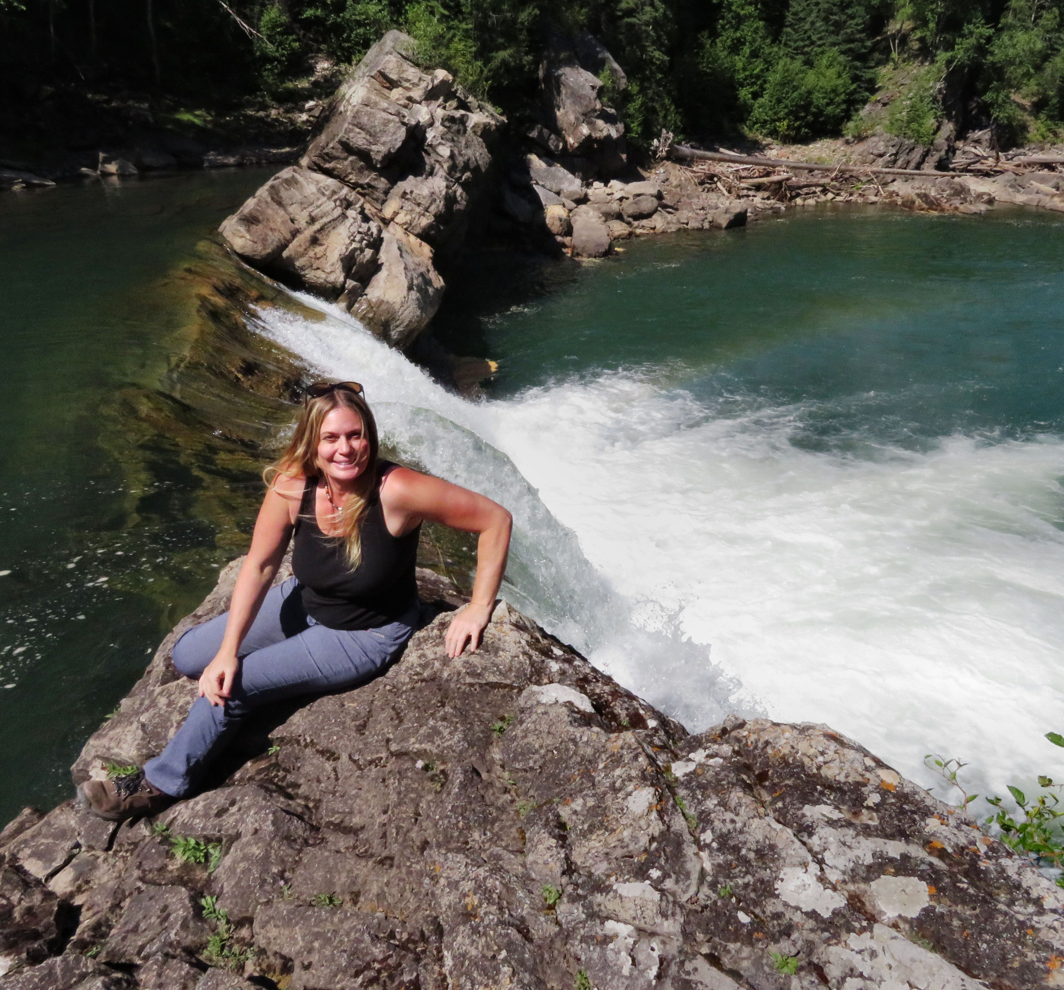

Right: The falls from the viewpoint. Left: Me sitting on a rock next to the largest of the falls. (Photo taken by Dariusz Slowik)

A steep trail leads down to the rocky shoreline where you can get up close to the falls. As you make your way along the path you are rewarded with beautiful vistas and refreshing pools where you can take a dip in the chilly mountain water.
At the largest waterfall you can climb right out onto the rocks and watch the water flow over the brink into an emerald green pool.

HOW TO GET THERE – From Chetwynd drive 3km towards Dawson Creek on Highway 97then take a right onto Highway 29 to Tumbler Ridge. In 22.6 km turn right onto the Sukanka Forest Service Road. You will see the sign for the falls to your right in 21.5 kilometres. There is a circular pullout where you can view the falls and just up the road is the trail leading down to the falls.

