Discover Two of the Four falls on martin creek

Martin Falls are located in Martin Canyon along Martin Creek. On its descent to the Sukunka River, Martin Creek flows over four waterfalls and through multiple rapids. The first and second falls are located along a one kilometre well marked trail while the others are located downstream and would require some bush whacking to get to.
The trail descends to the creek between the first and second falls. From there you can climb the rocks up to the first falls and take a refreshing dip in the pool. You can and even walk underneath the falls for a chilly shower. This is also a great place to find leaf fossils in the large rocks. But be sure to leave the fossils behind for future generations.
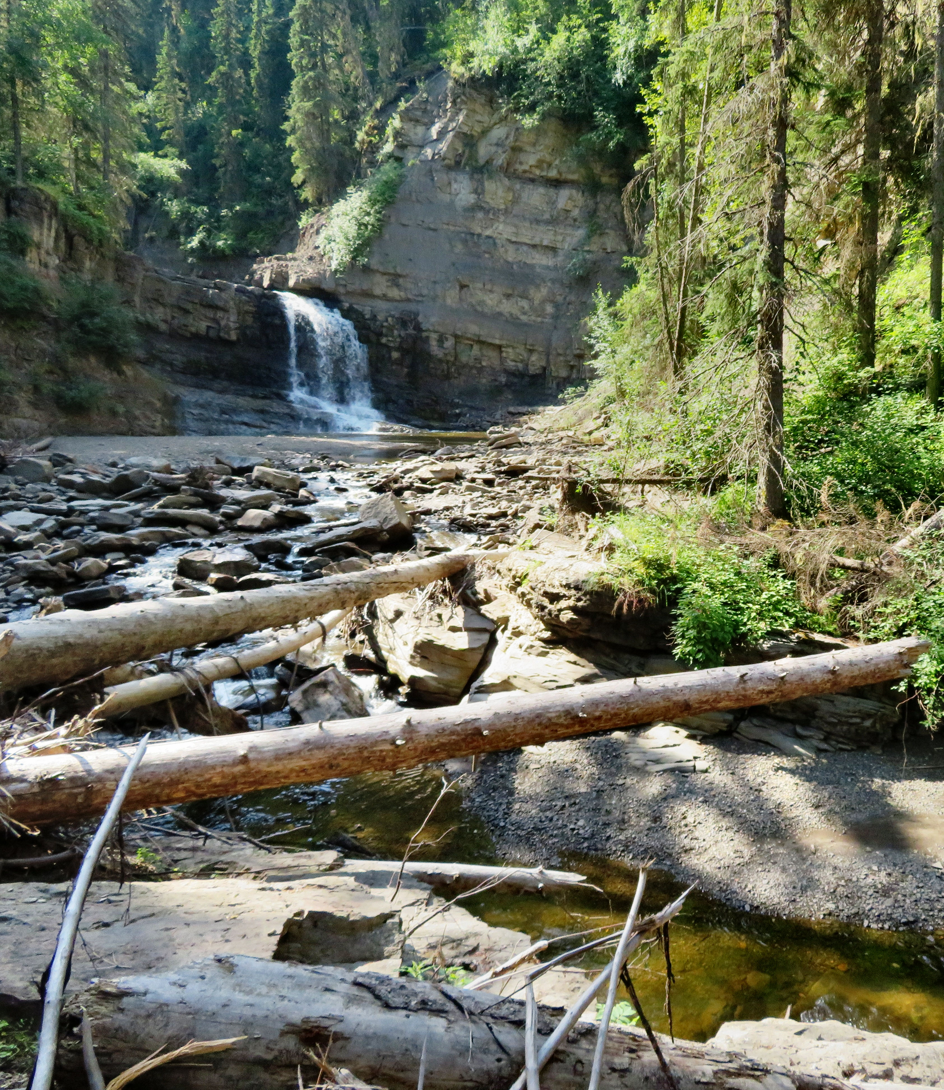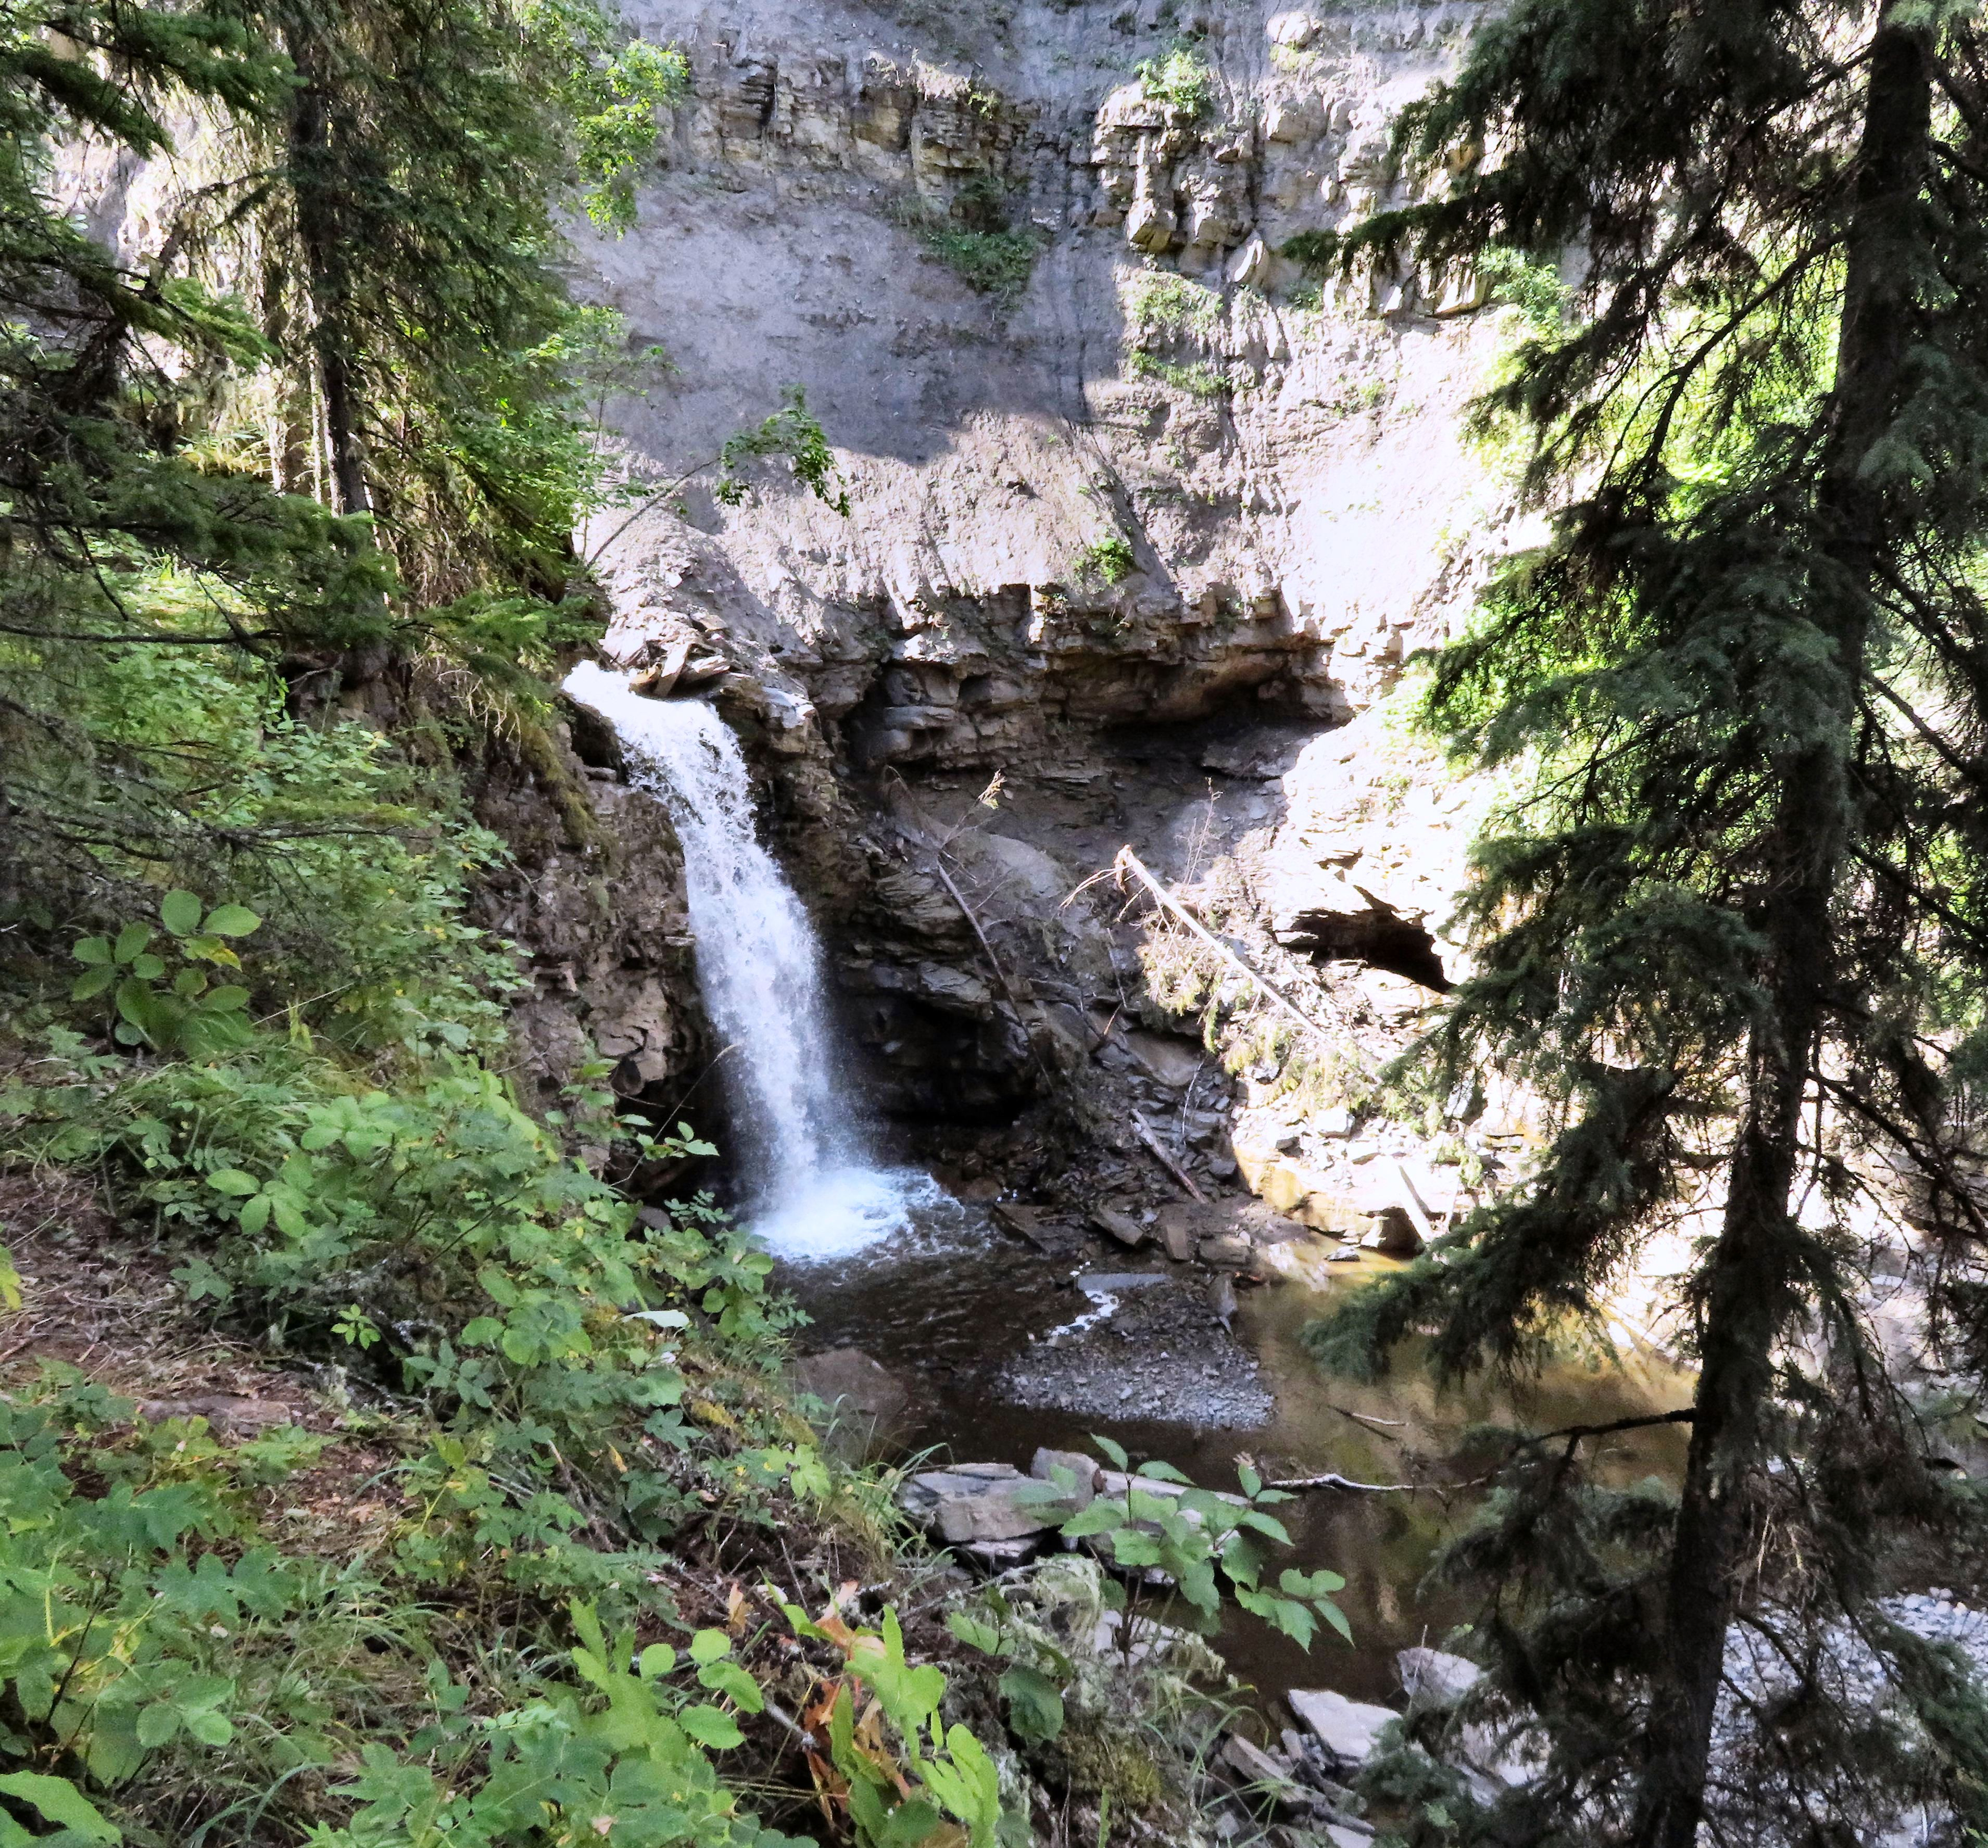

Left: The middle falls. Right: The bottom falls.

The decent to the second falls is dangerous. They are better observed from the trail. Many of the pictures of the second falls shows them fanned out along the cliff forming multiple waterfalls. This is how they appear in the spring during high water. In the summer when the water is low they look like the picture below. The canyon that surrounds them is very high and picturesque giving you a sense of the grandeur of Mother Nature.

HOW TO GET THERE – Martin Falls is located 66 km north of Tumbler Ridge and 29 km south of Chetwynd. You will see a sign on the highway marking the trailhead parking lot.

