Hike Way up the Mountain to Weyman Falls

One of the little known waterfalls in our area is Weyman Falls on the Douglas Lake Road. It is a short yet steep climb up a hill to get to but well worth it. The trail takes you to a lookout point and then continues to the creek above the waterfall where you can cool off in one of the pools.
You may be able to bushwhack your way down to the foot of the falls or walk up the creek to the base. The falls are best seen in the spring when the water is high. I visited in the middle of summer and there was only a trickle of water.
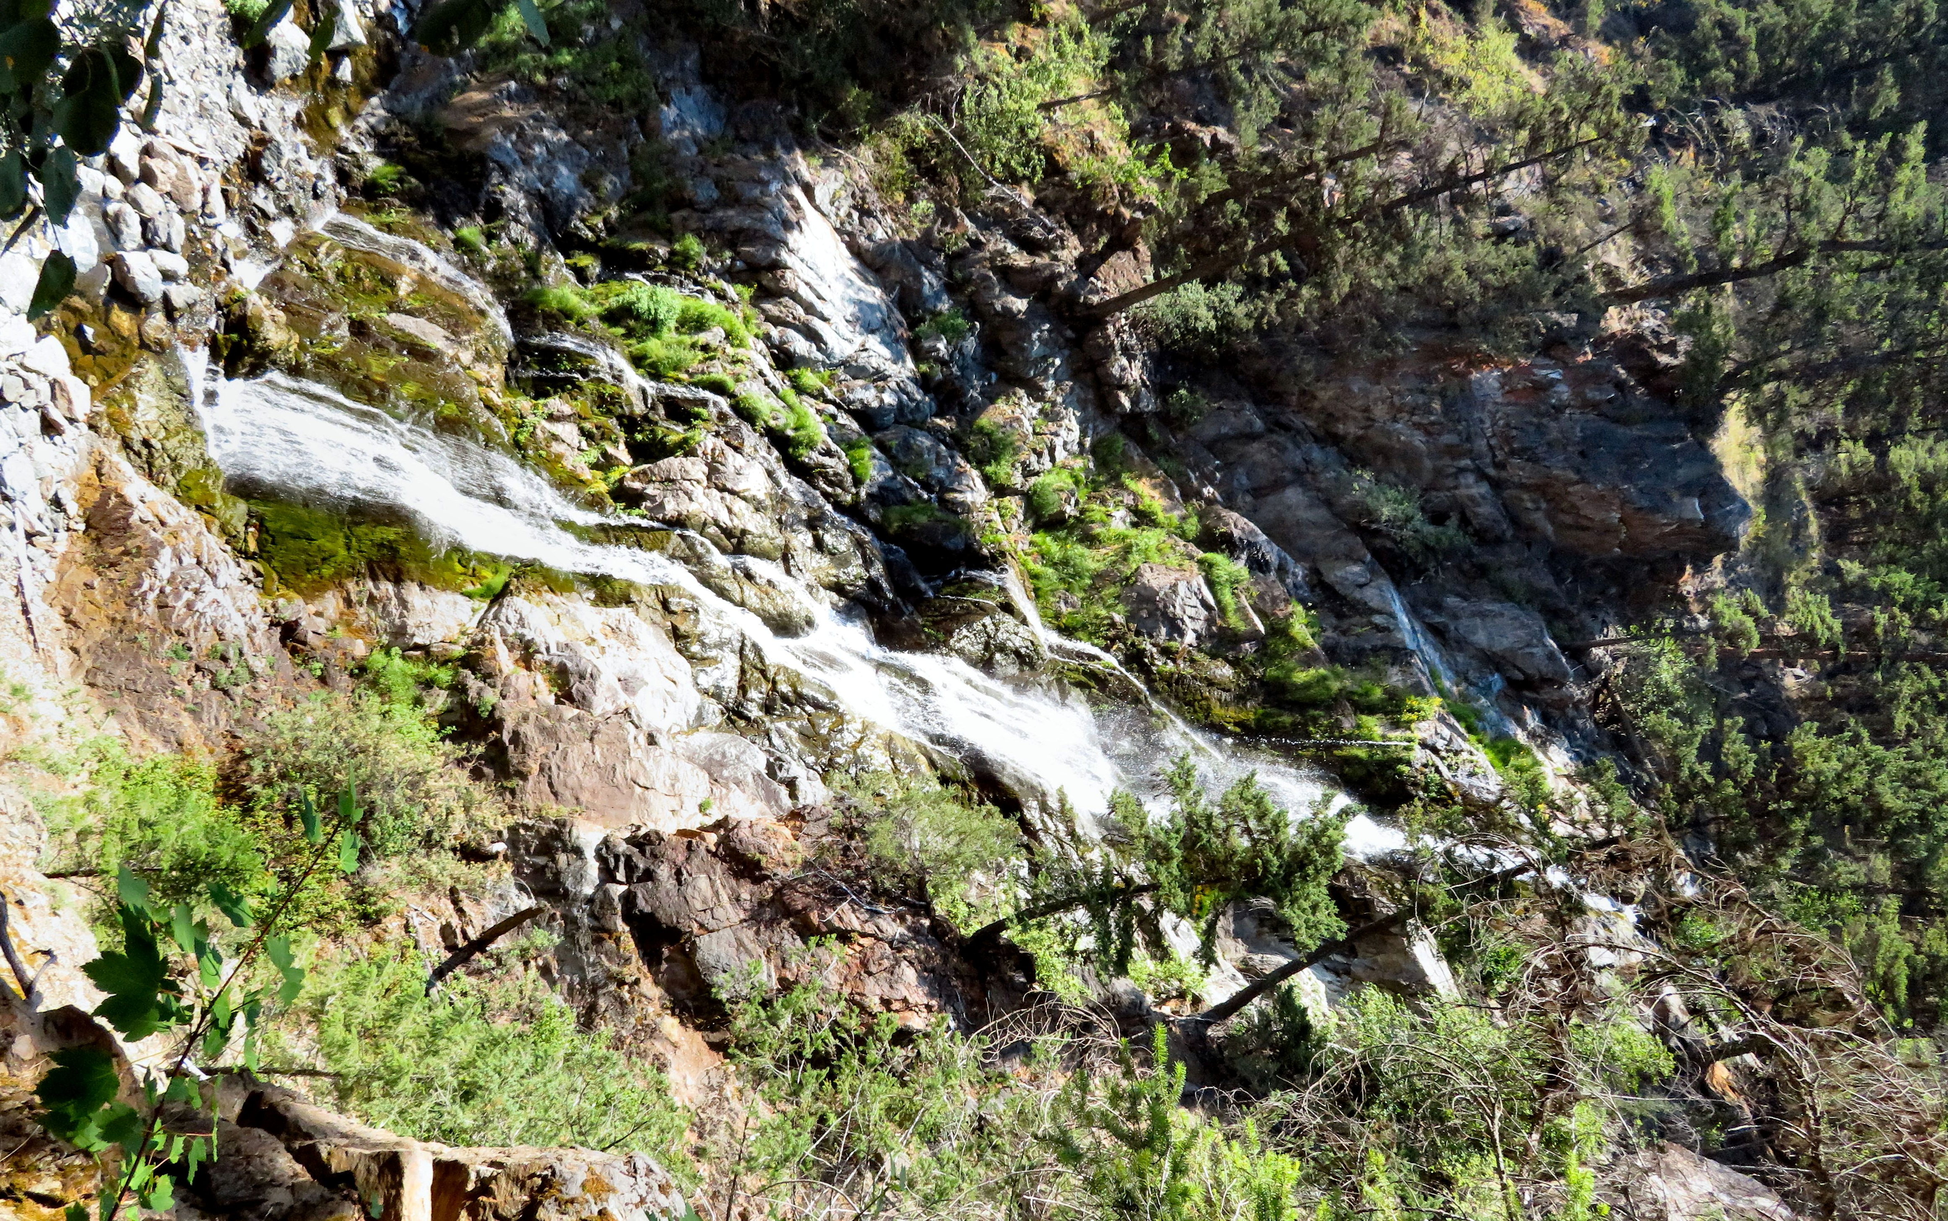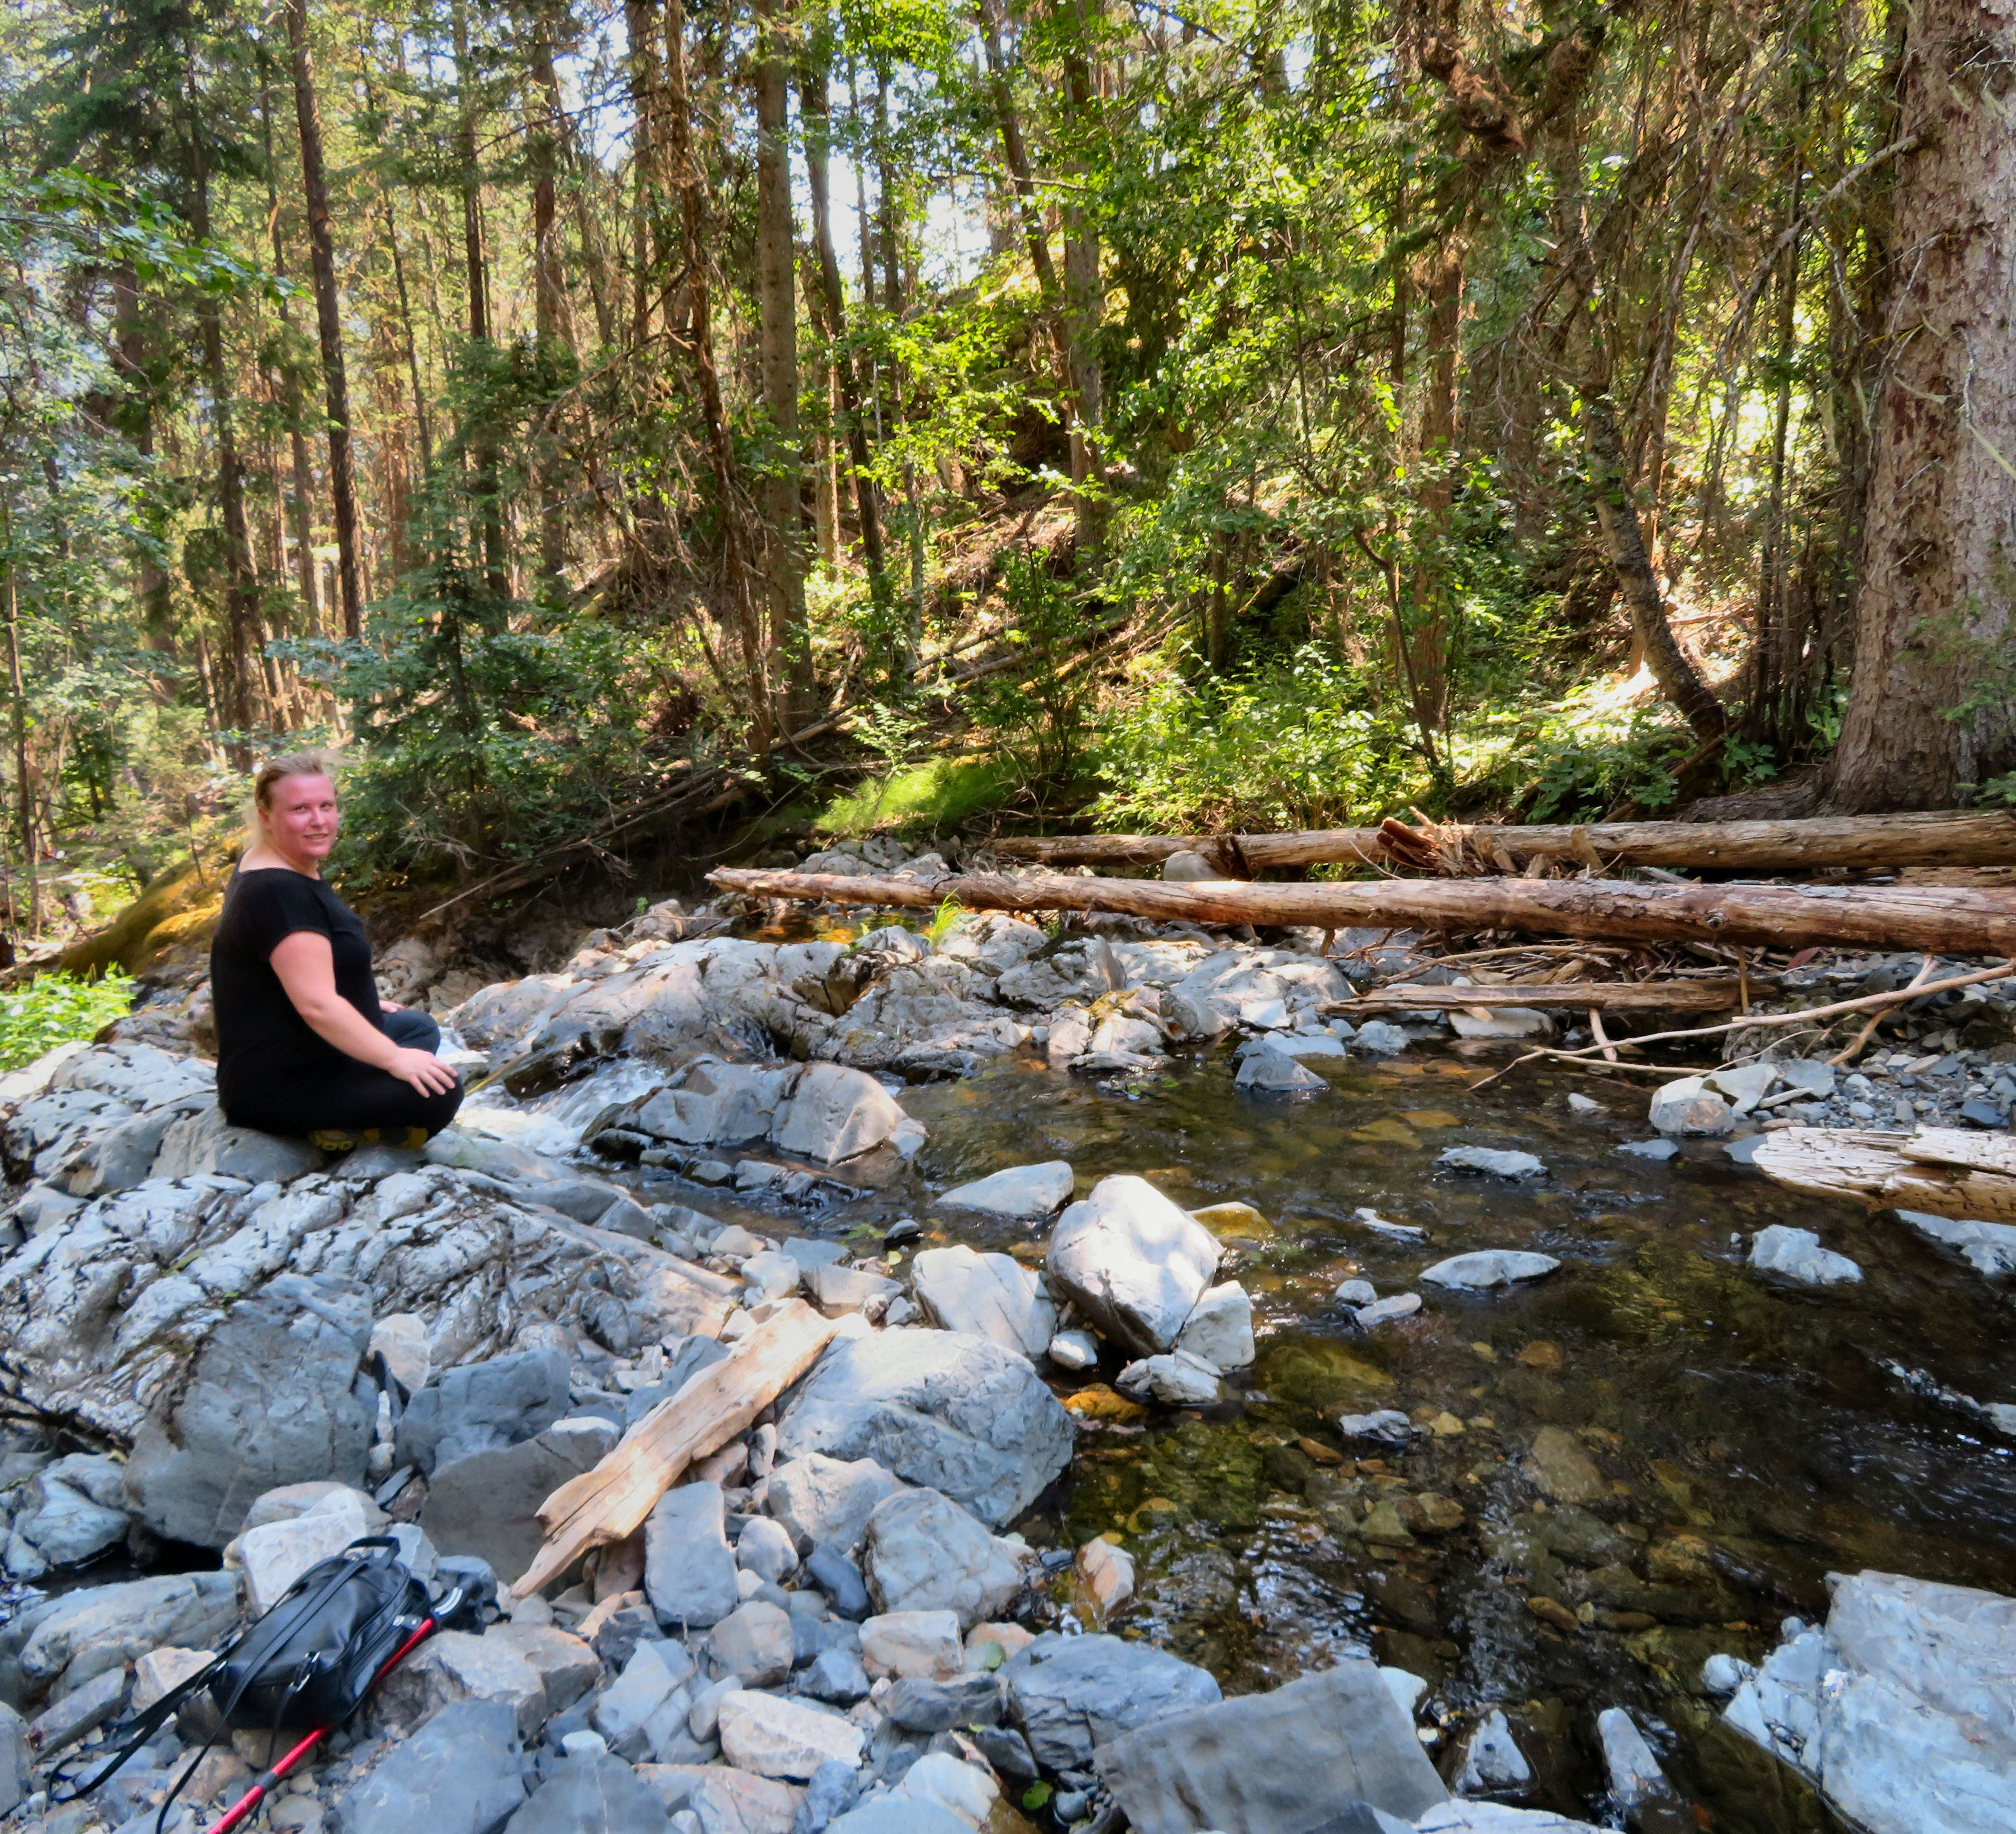

Left: Weyman Falls from the lookout area. Right: Nikki McCormack sitting at a pool above the falls.

The pools above the falls have tiny waterfalls and make a great place to cool down and put your feet in the water.

HOW TO GET THERE – From Kamloops drive towards Merritt on Highway 5A. Drive past Nicola Lake and take a left onto Douglas Lake Road. From here drive 59 kilometres along the gravel road. You will cross 2 bridges around 57 kilometres. Park at the 3rd bridge and you will see the trail on the left hand side of the road.

