Step Back in time at
fossil falls

Of all the waterfalls I visited in researching this book, this was my favourite. It wasn’t the biggest or most spectacular waterfall but it was unique in that the rocks at the base of the falls were covered with shell fossils. The falls are unmarked and only unknown to even many of the locals in the area. They are located up a dusty forest service road near the Halfway River First Nations Community. When you get near the Mile 97 mark you will see junction to a quad trail on your right. This is where people unload their ATV’s for the 1.5 hour jaunt to the better known Charlie Falls. Another quad trail on the left just past it will bring you to these unnamed falls. I call them Fossil Falls.
A viewpoint from the top gives you a view of the tiny canyon they trickle down into. From there take the steep trail down to the base of the falls.
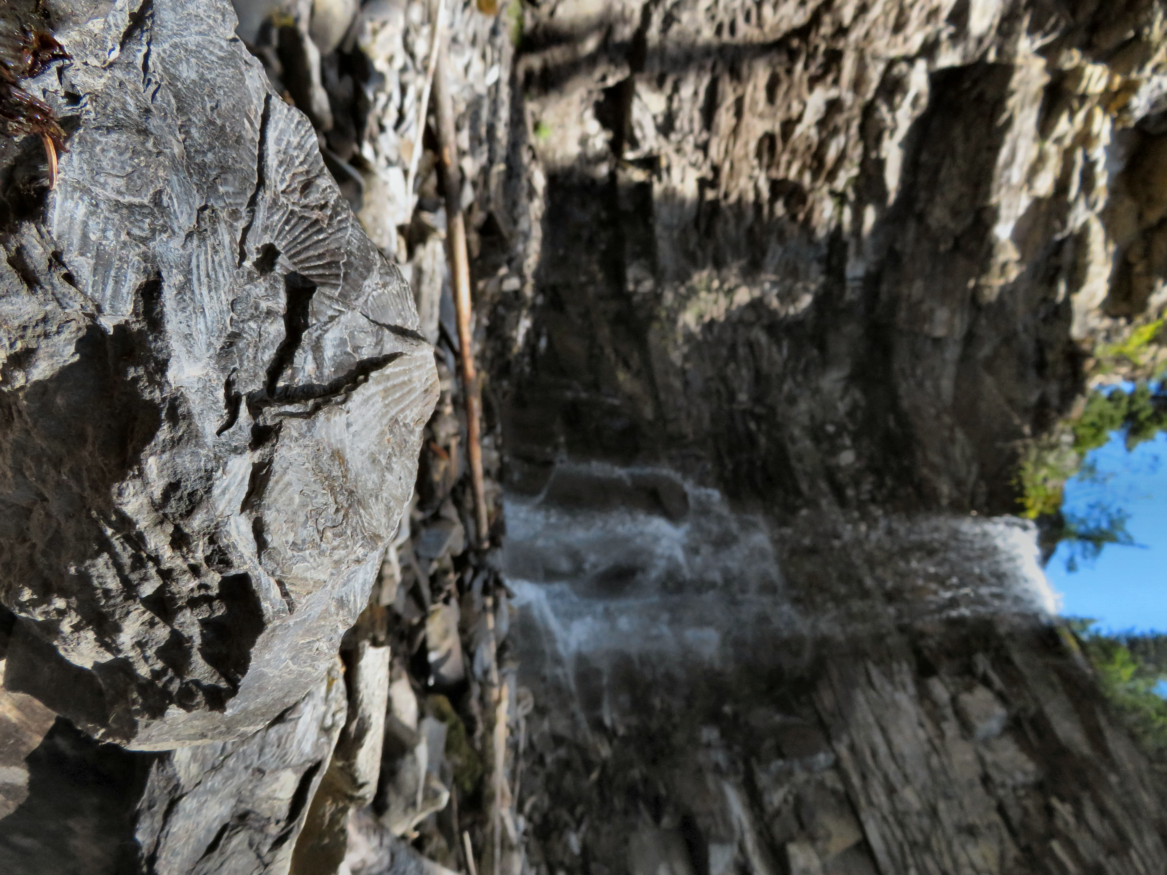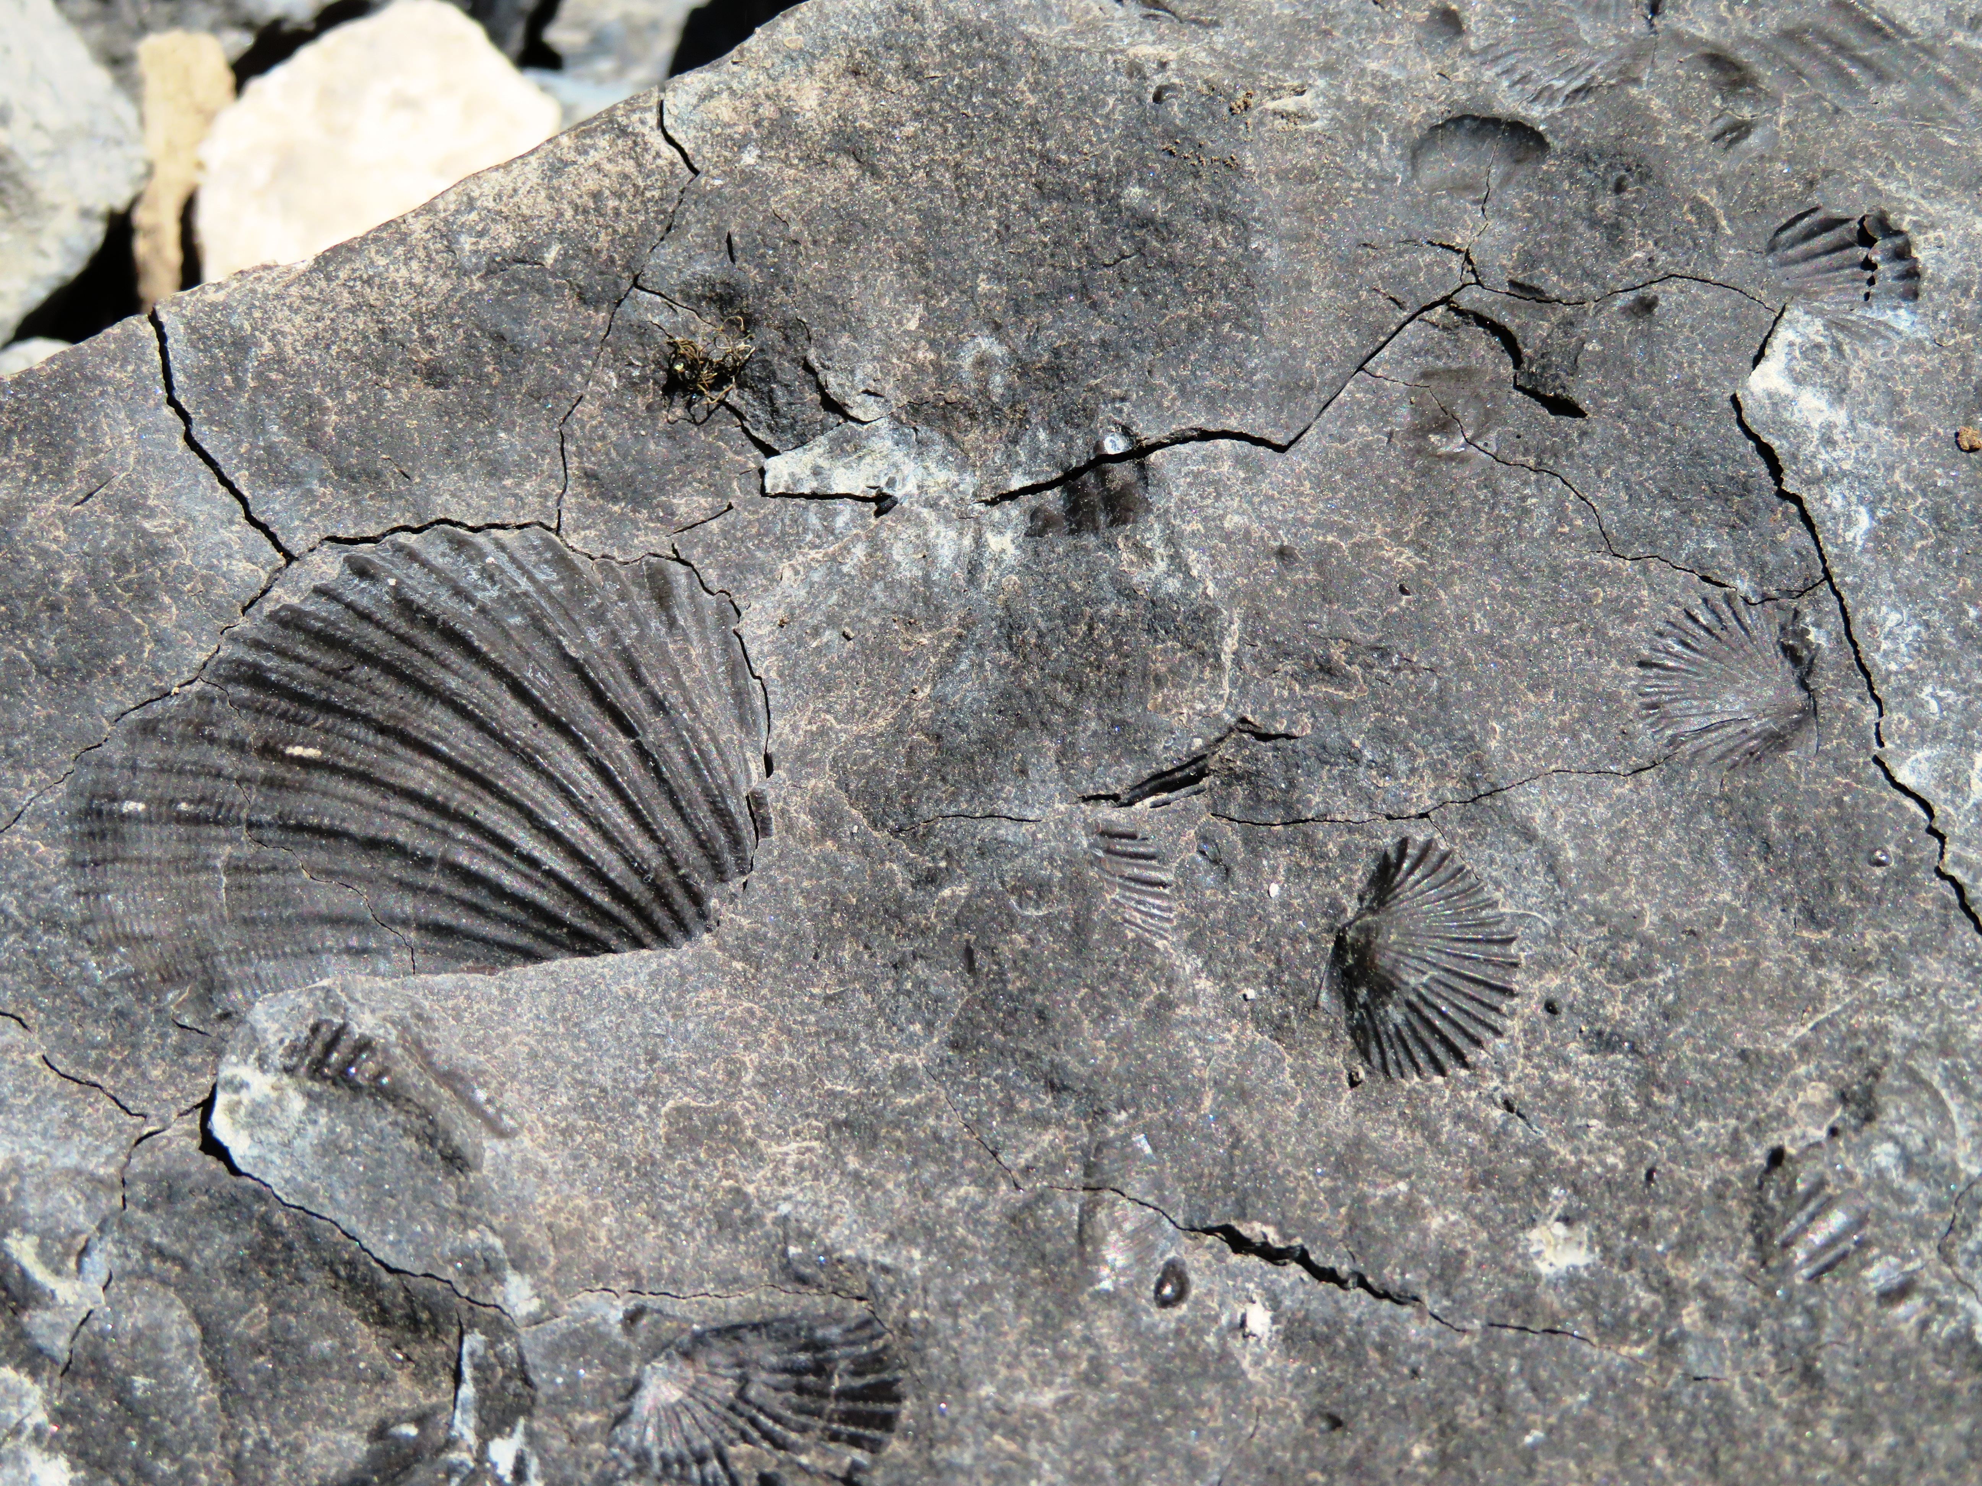

The rocks surrounding the base of this waterfall are covered with shell fossils.

As you look closely at the rocks it feels like you are stepping back in time. Many of the rocks are covered in fossils. Most of them are shell shaped fossils and others are plants.
To preserve this beautiful spot, please leave the fossils where you find them and don’t post directions or videos online. Let’s keep this our secret!

HOW TO GET THERE – From Fort St. John take Highway 97 (the Alaska Highway) towards Fort Nelson. Just past Kobes take a left onto Upper Halfway Road. You will drive past the Halfway River First Nation Community. Between Mile 97 and 98 look to your left for a quad trail. Follow the trail for about 300 meters to the waterfall. It takes about 2.5 hours from Fort St. John to get to the falls.

