JUMP OFF THE ROCKS INTO FLATBED FALLS

Flatbed Falls is a popular swimming hole for the people of Tumbler Ridge. When the water is high enough, people can jump from the rock in between the two falls into the pool below. Just above the falls there is a covered picnic log shack and outhouses.
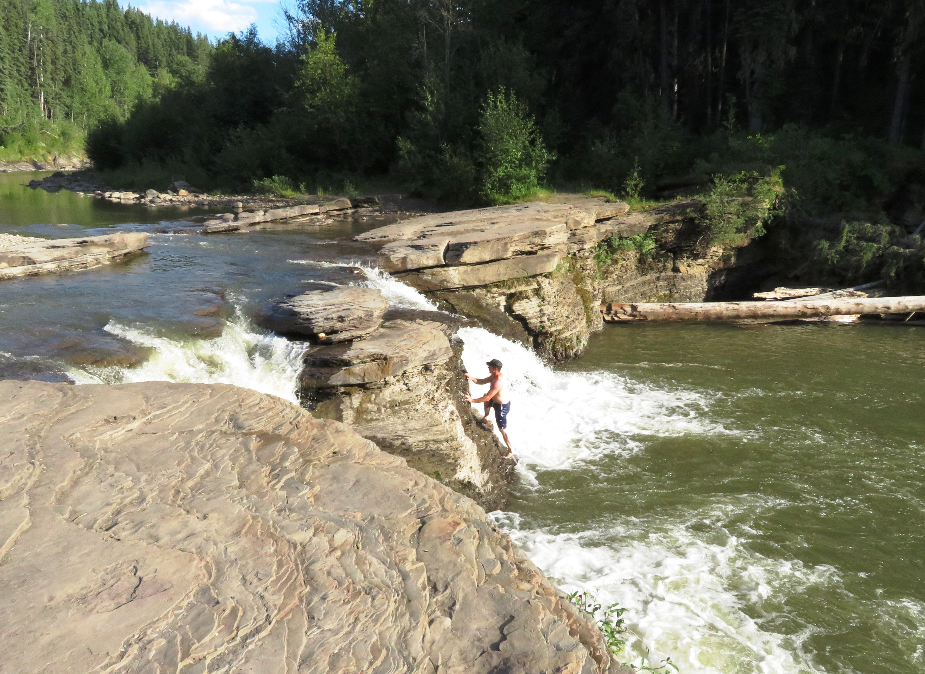

A swimmer hikes up the rocks to jump into the pool.

HOW TO GET THERE – From the Tumbler Ridge Visitor’s Center, take Mackenzie Way and turn left onto Highway 29. Go 400 metres along the highway, and the parking lot is on the right. Take the right fork in the trail to Flatbed Falls. It’s 2km round trip.

