Dinosaur print on the trail to Nesbitt’s knee Falls?

The drive to Kinuseo Falls is a long one, but the good news is that there are three waterfalls you can visit along the way. Nesbitt’s Knee is one of them.
A short 3 kilometre return trail takes you to a beautiful waterfall that pours into a serene pool. The final descent to the foot of the falls is a steep trail, but thankfully there are ropes installed to help you down.
On my way to the falls I encountered a rock along the path that had an imprint in it. Since Tumbler Ridge is famous for the discovery of dinosaur prints and bones, I naturally assumed that’s what it was. Signs along the trail stating that dinosaur tracks and remains have been found in the area gave me all the proof I required to assume my find was the real deal.
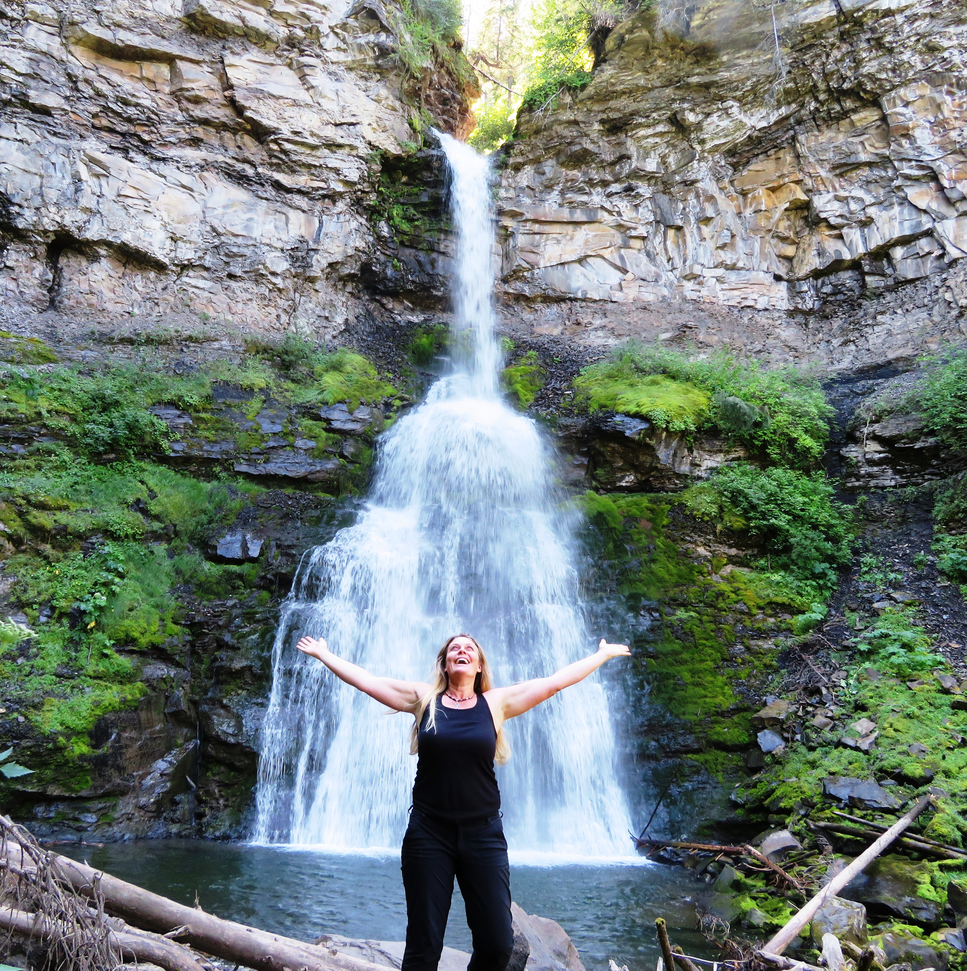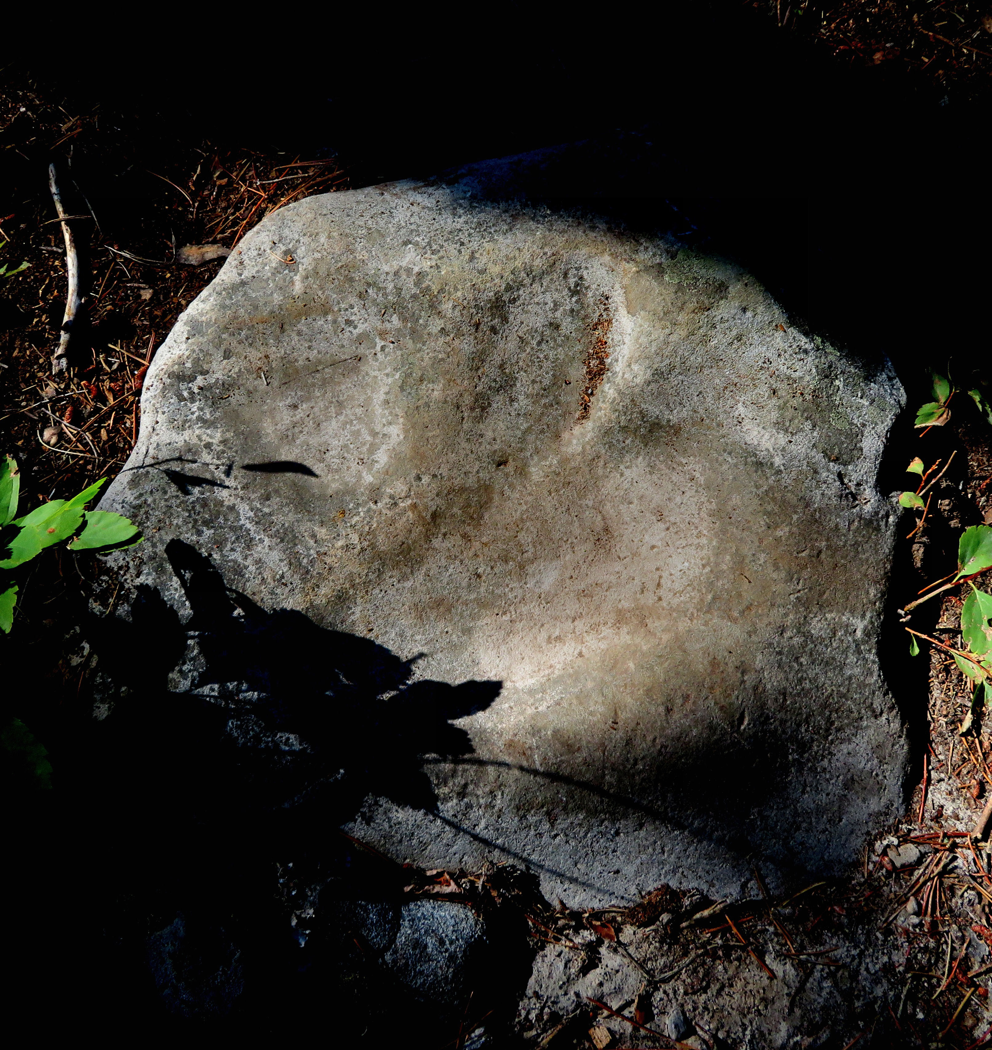

Left: Me posing in front of the falls. Right: A possible dinosaur track I found along the trail.

DID YOU KNOW? A trio of fossilized footprint tracks discovered near Tumbler Ridge, by a local guide in 2011 offer compelling evidence that the beasts were not solitary but travelled in packs

HOW TO GET THERE – To reach Nesbitt’s Knee Falls, head south from Tumbler Ridge on Highway 29 for 13.5 km. Then turn right onto the Murray River Forest Service Road. This is the same road that takes you to Monkman Provincial Park. After 23 km turn left at the natural gas plant. A short way down the road you will come to a fork with a sign. The left fork leads to Nesbitt’s Knee Falls. The trailhead is located on the right 3.5 km up the road.

