swim in the upper and admire the lower barbour falls

Barbour Falls are a great pit stop when you are on your way to visit Kinuseo Falls. A short detour off the main gravel road to Monkman Park takes you to the trailhead for the falls. The hike is a short and easy 2 kilometre return. The upper falls has a trail down to the base of the falls if you want to take a dip in the pool. Farther down the trail is the viewpoint for the lower falls. They are taller and more spectacular but they are not reachable and can only be admired from the trail.
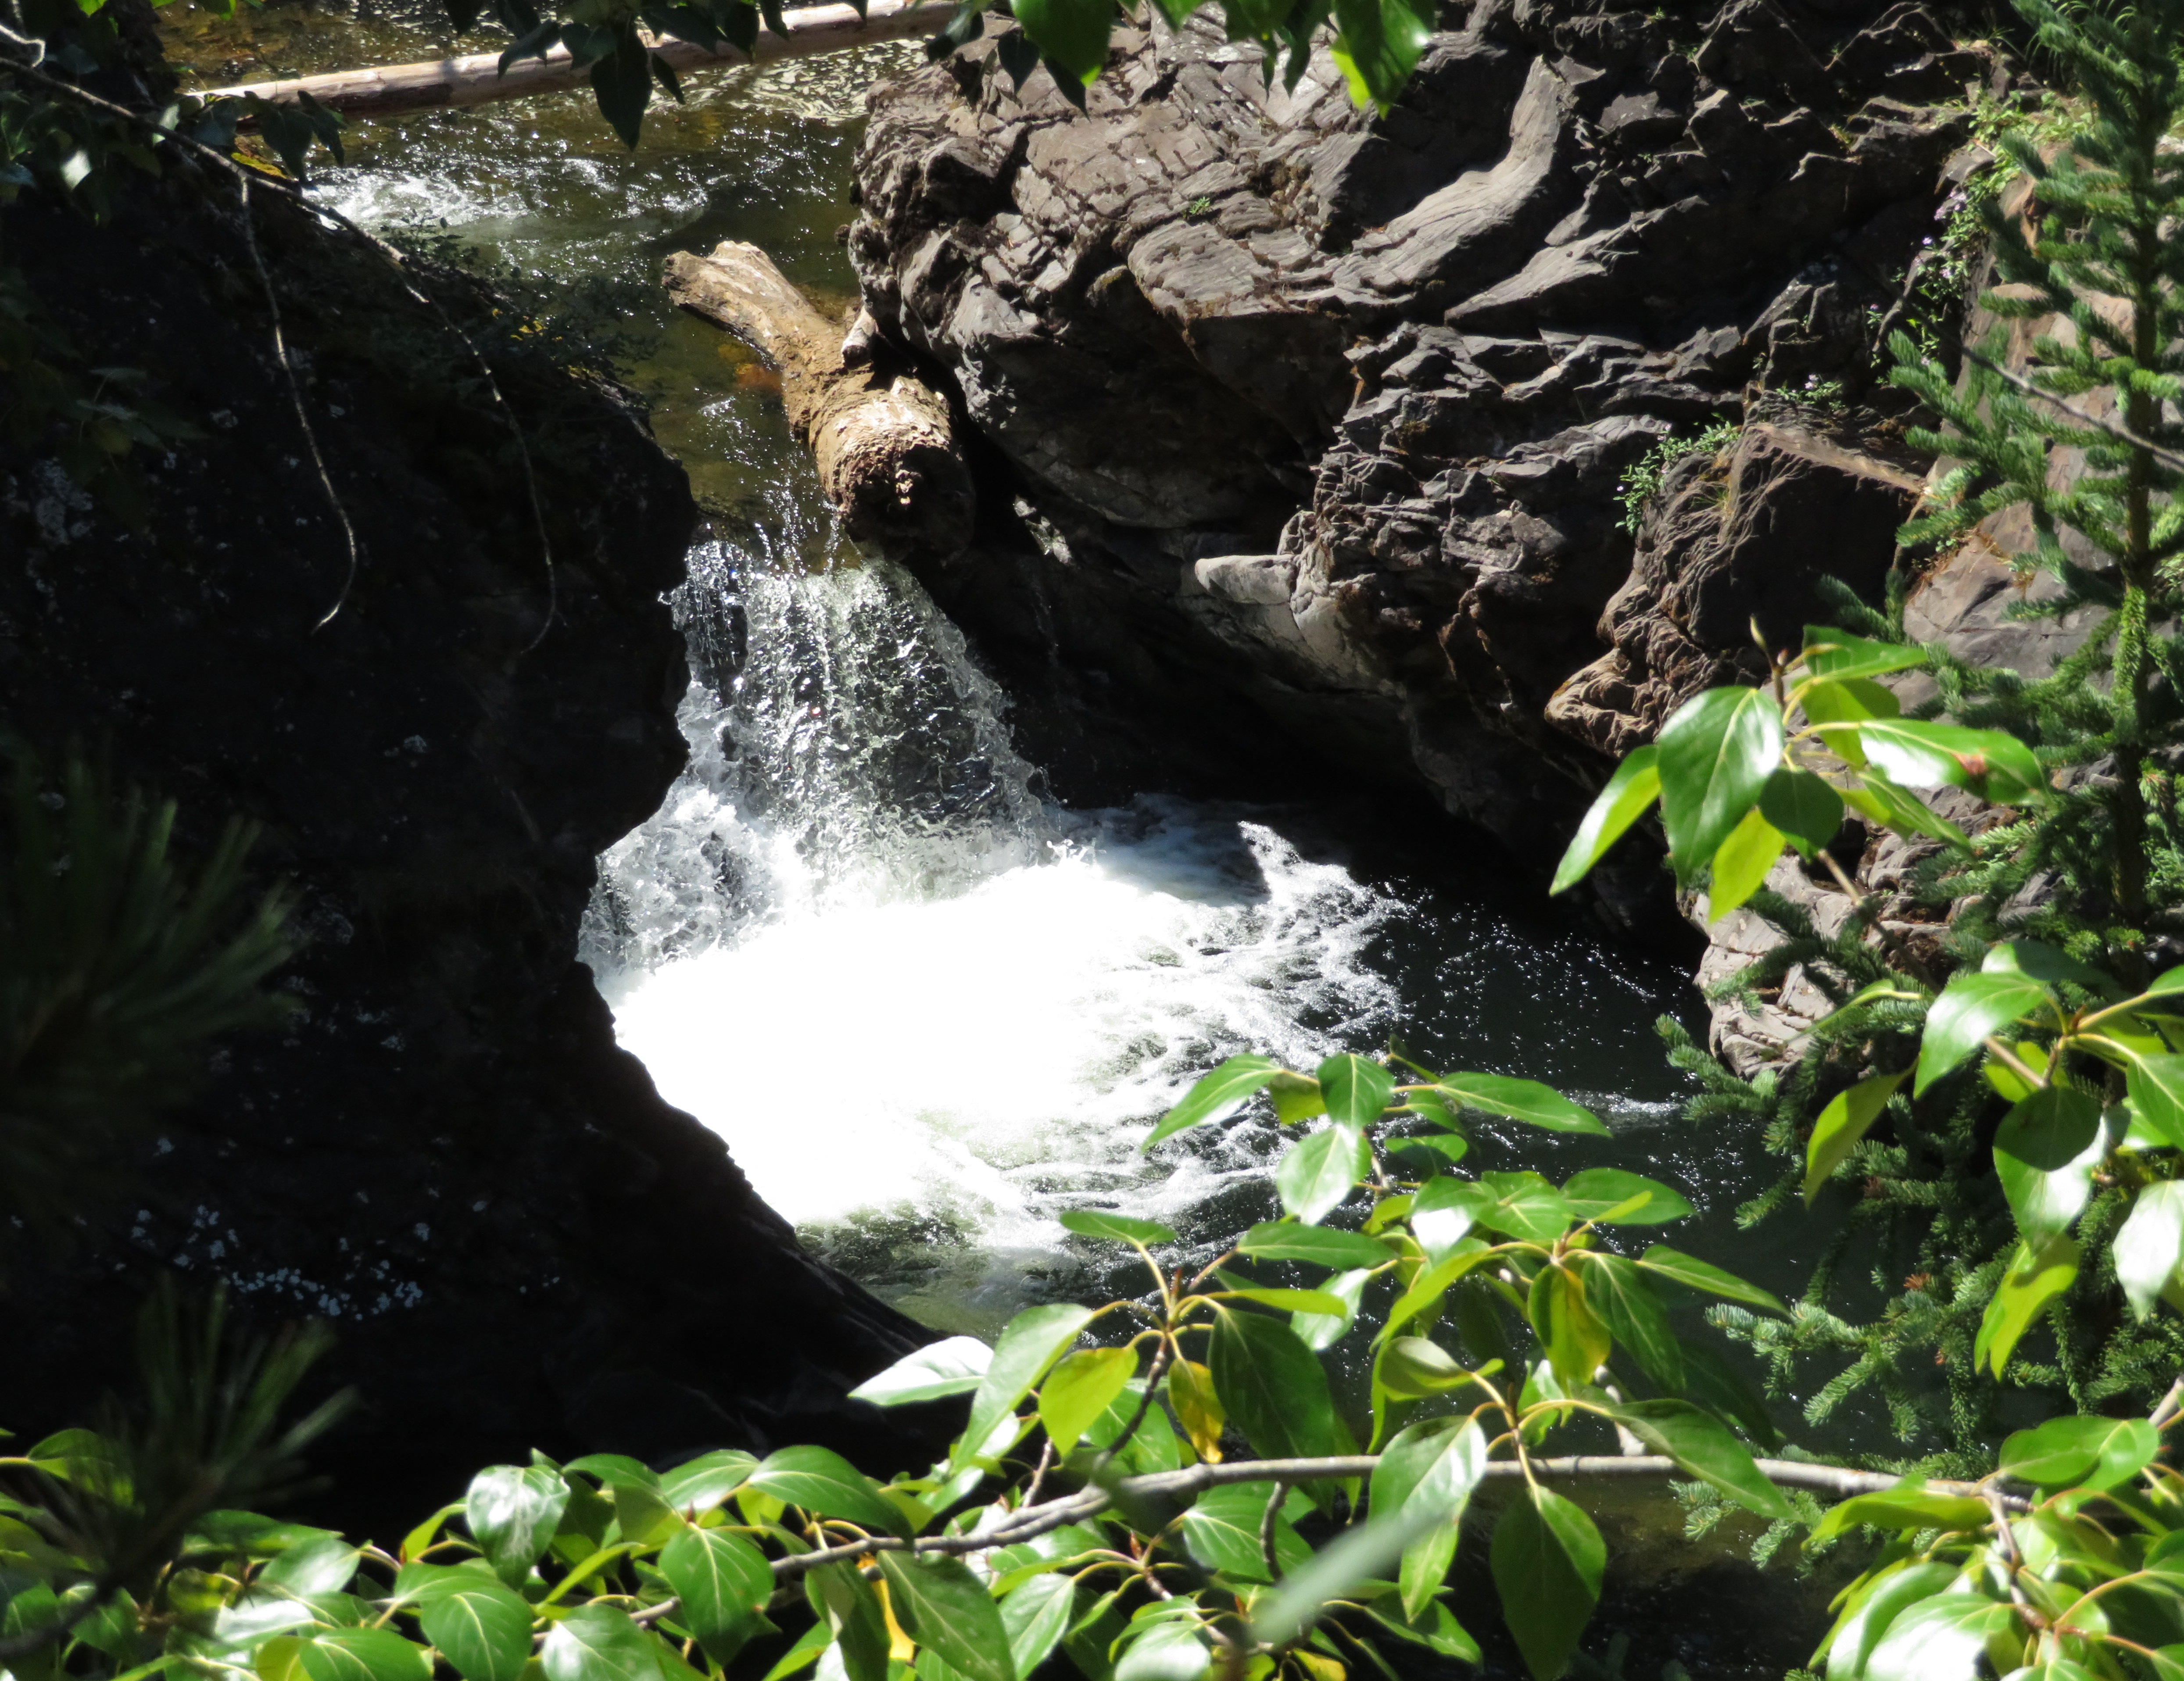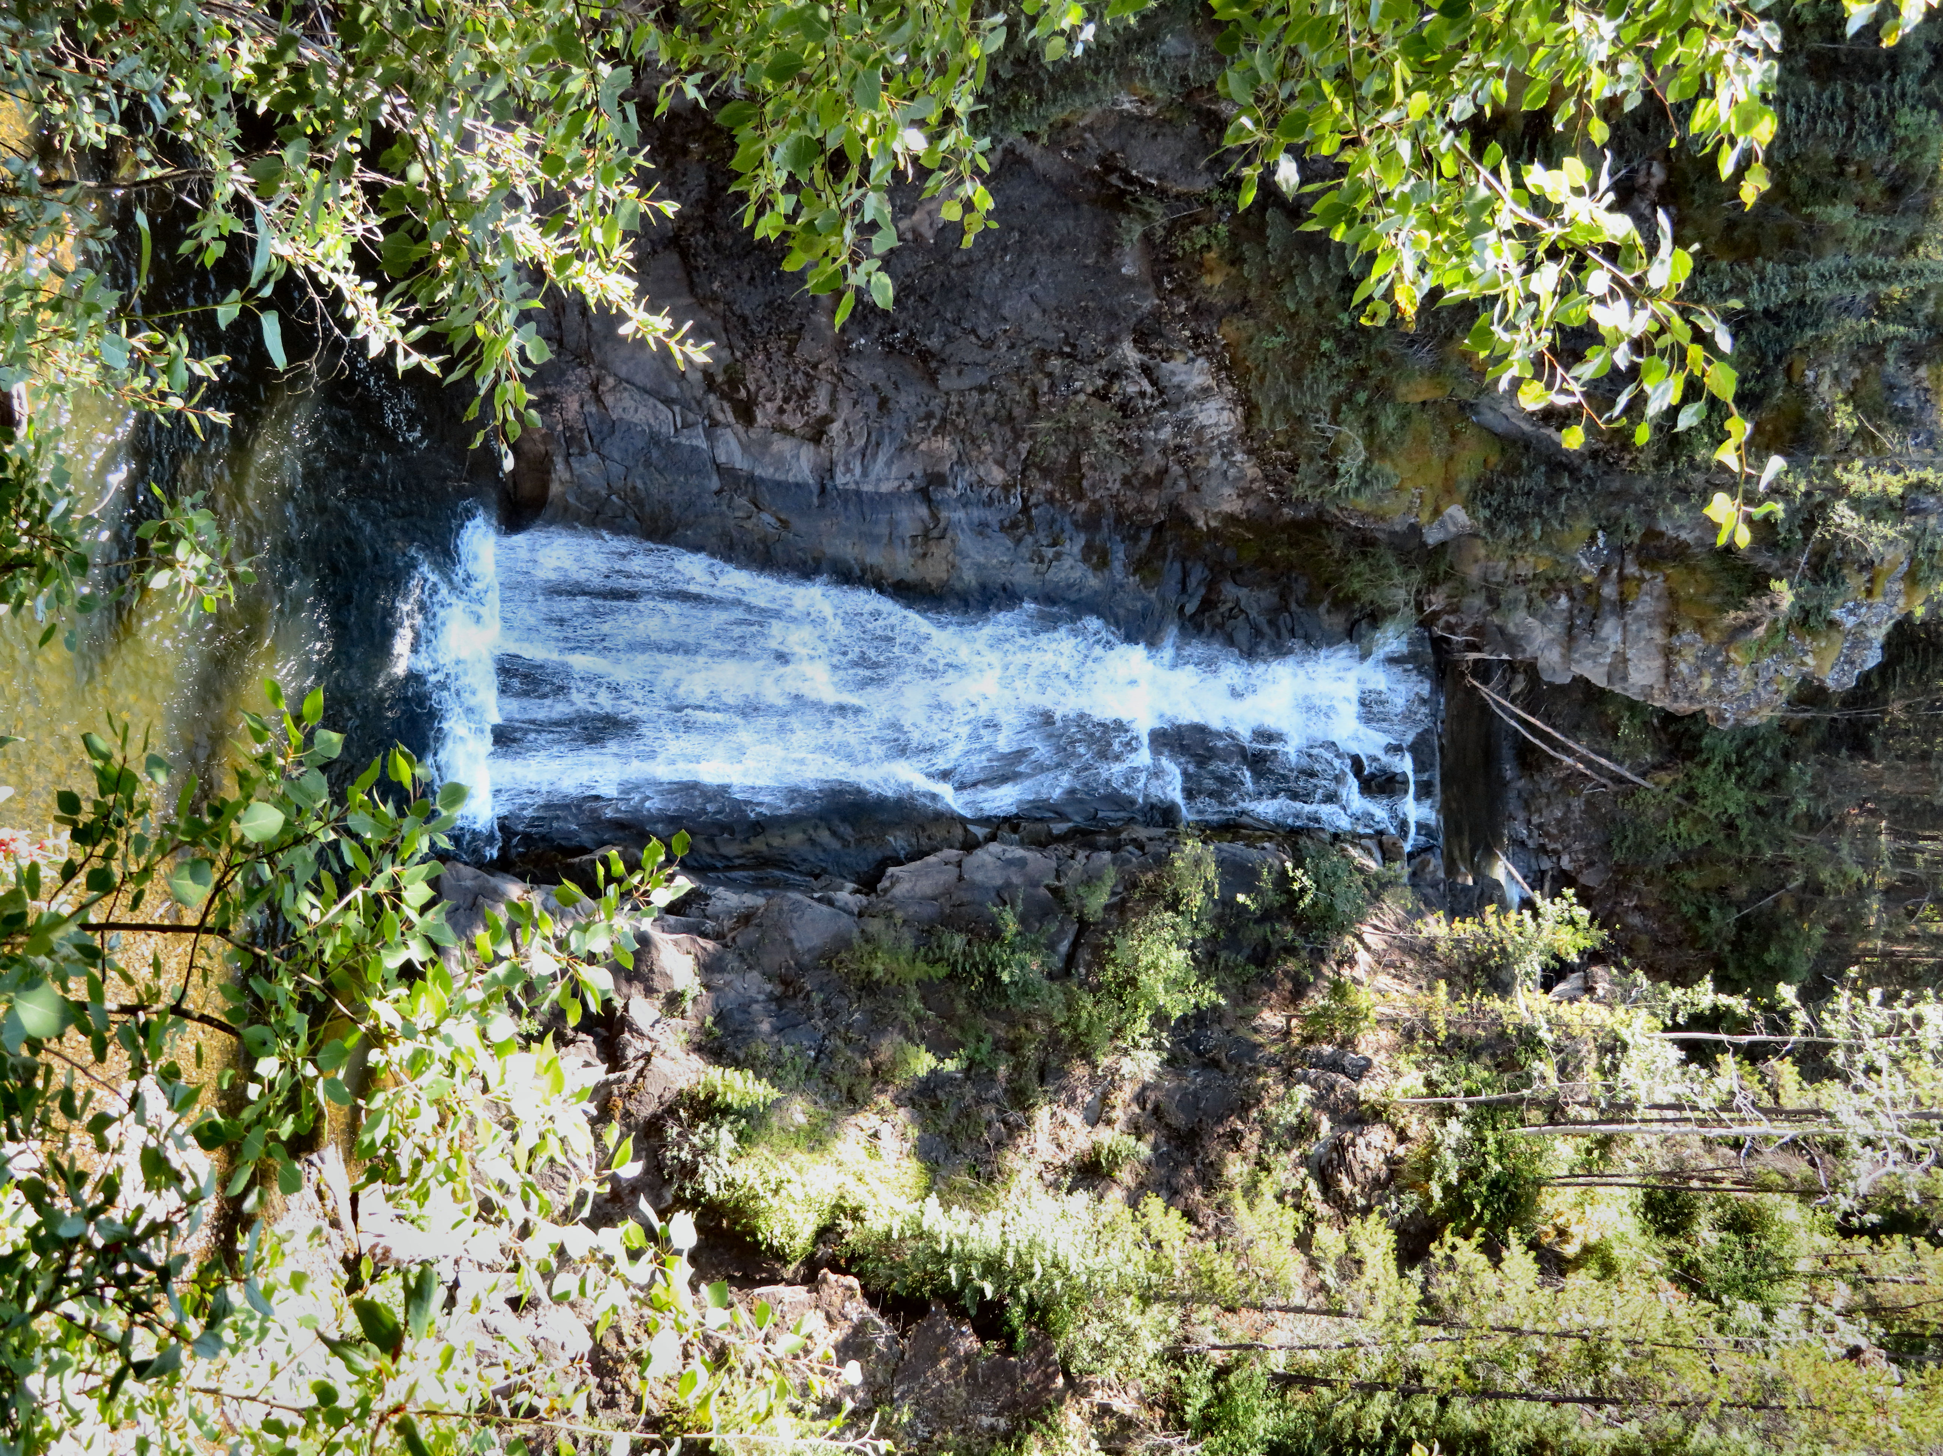

Left: Upper Barbour Falls is a great swimming area. Right: Lower Barbour Falls can be viewed from the trail.

HOW TO GET THERE – To reach Barbour Falls, head south from Tumbler Ridge on Highway 29 for 13.5 km. Then turn right onto the Murray River Forest Service Road. This is the same road that takes you to Monkman Provincial Park. After 23 km turn left at the natural gas plant. A short way down the road you will come to a fork with a sign. The right fork leads to Barbour Falls. The trailhead is located on the left 2.3 km up the road.

