Visit every lookout for the best views of Kinuseo Falls

Kinuseo Falls are one of the most outstanding features in Monkman Provincial Park. The falls measure 60 metres, making them slightly taller than Niagara Falls, although they don’t move the same volume of water as Niagara.
They were originally called Kinoosao Falls (meaning 'fish' in the Cree language) owing to the great numbers of trout both above and below the falls. In fact a number of people were catching fish at the base of the falls during my visit. If you look close at the picture below you can see a guy doing some fly fishing.
Most people only see the falls from the observation deck near the parking lot. From here you can see the falls tumble over the edge. If you follow the trail down you will find a steep trail leading to the base of the falls. From here you can feel the mist of the falls on your face.
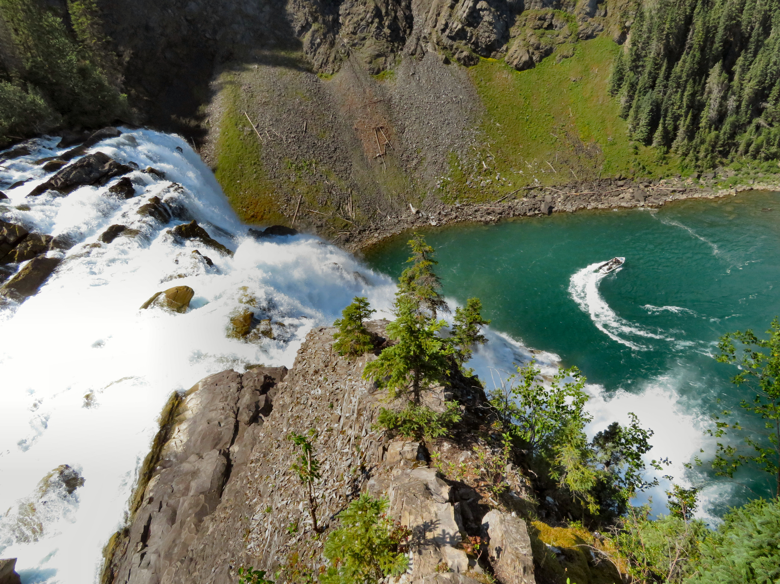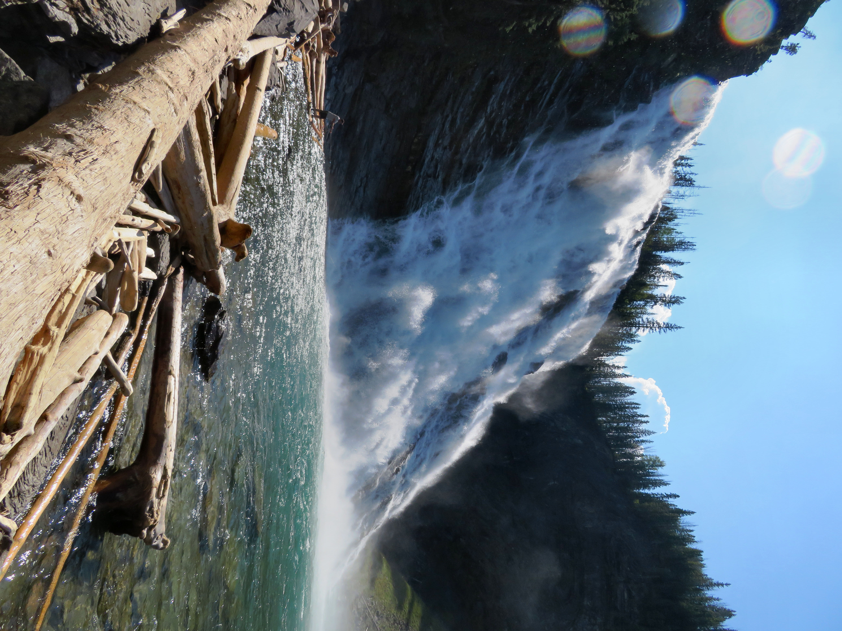

Left: The falls from the top lookout deck located next to the parking area. Right: The falls from the base.

If you head back to the parking lot you will see another trail leading to an upper trail. Follow this trail for 1.5 km and you will get the better views of the falls and the river valley. When you reach the end of the trail you will be rewarded with the most spectacular view from a park bench located on a rocky cliff.
Another way to see the falls is on a Murray Canyon River Boat tour. Take a jet boat on an adrenaline filler ride up the river to the base of the falls. For more information inquire at the visitor center.

HOW TO GET THERE – From Tumbler Ridge drive south on Highway 29 for 13.5 km and then turn right onto the Murray River Forest Service Road. Stay on the main road for 50 km and then watch for a Kinuseo Falls sign and turn right. Follow this road 1km to the parking lot.

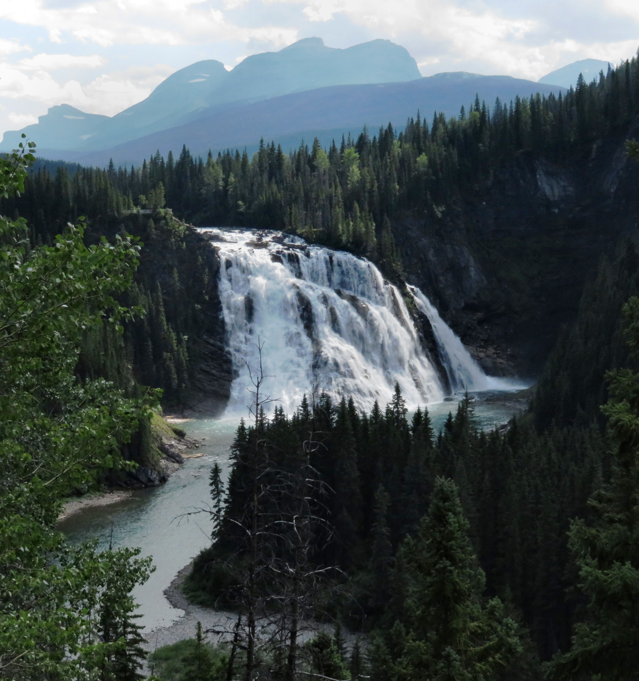

Kinuseo Falls from the trail heading towards the last lookout point.

