Take a Thrilling jump off Bromely Rock

If you are looking for the best place ever for a family picnic, look no further than Bromley Rock Provincial Park. This striking rock bluff is located on the beautiful Similkameen River in a place where the river widens and slows down. A gorgeous white sand beach with a small grove of trees located across the river from the bluff creates a secret oasis.
The day area which is located just off the highway between Hedley and Princeton, has log picnic tables, plenty of parking and outhouses making it the ideal location to spend the day swimming, fishing, building sand castles and, if you are an adrenaline junkie – jumping off the cliff.
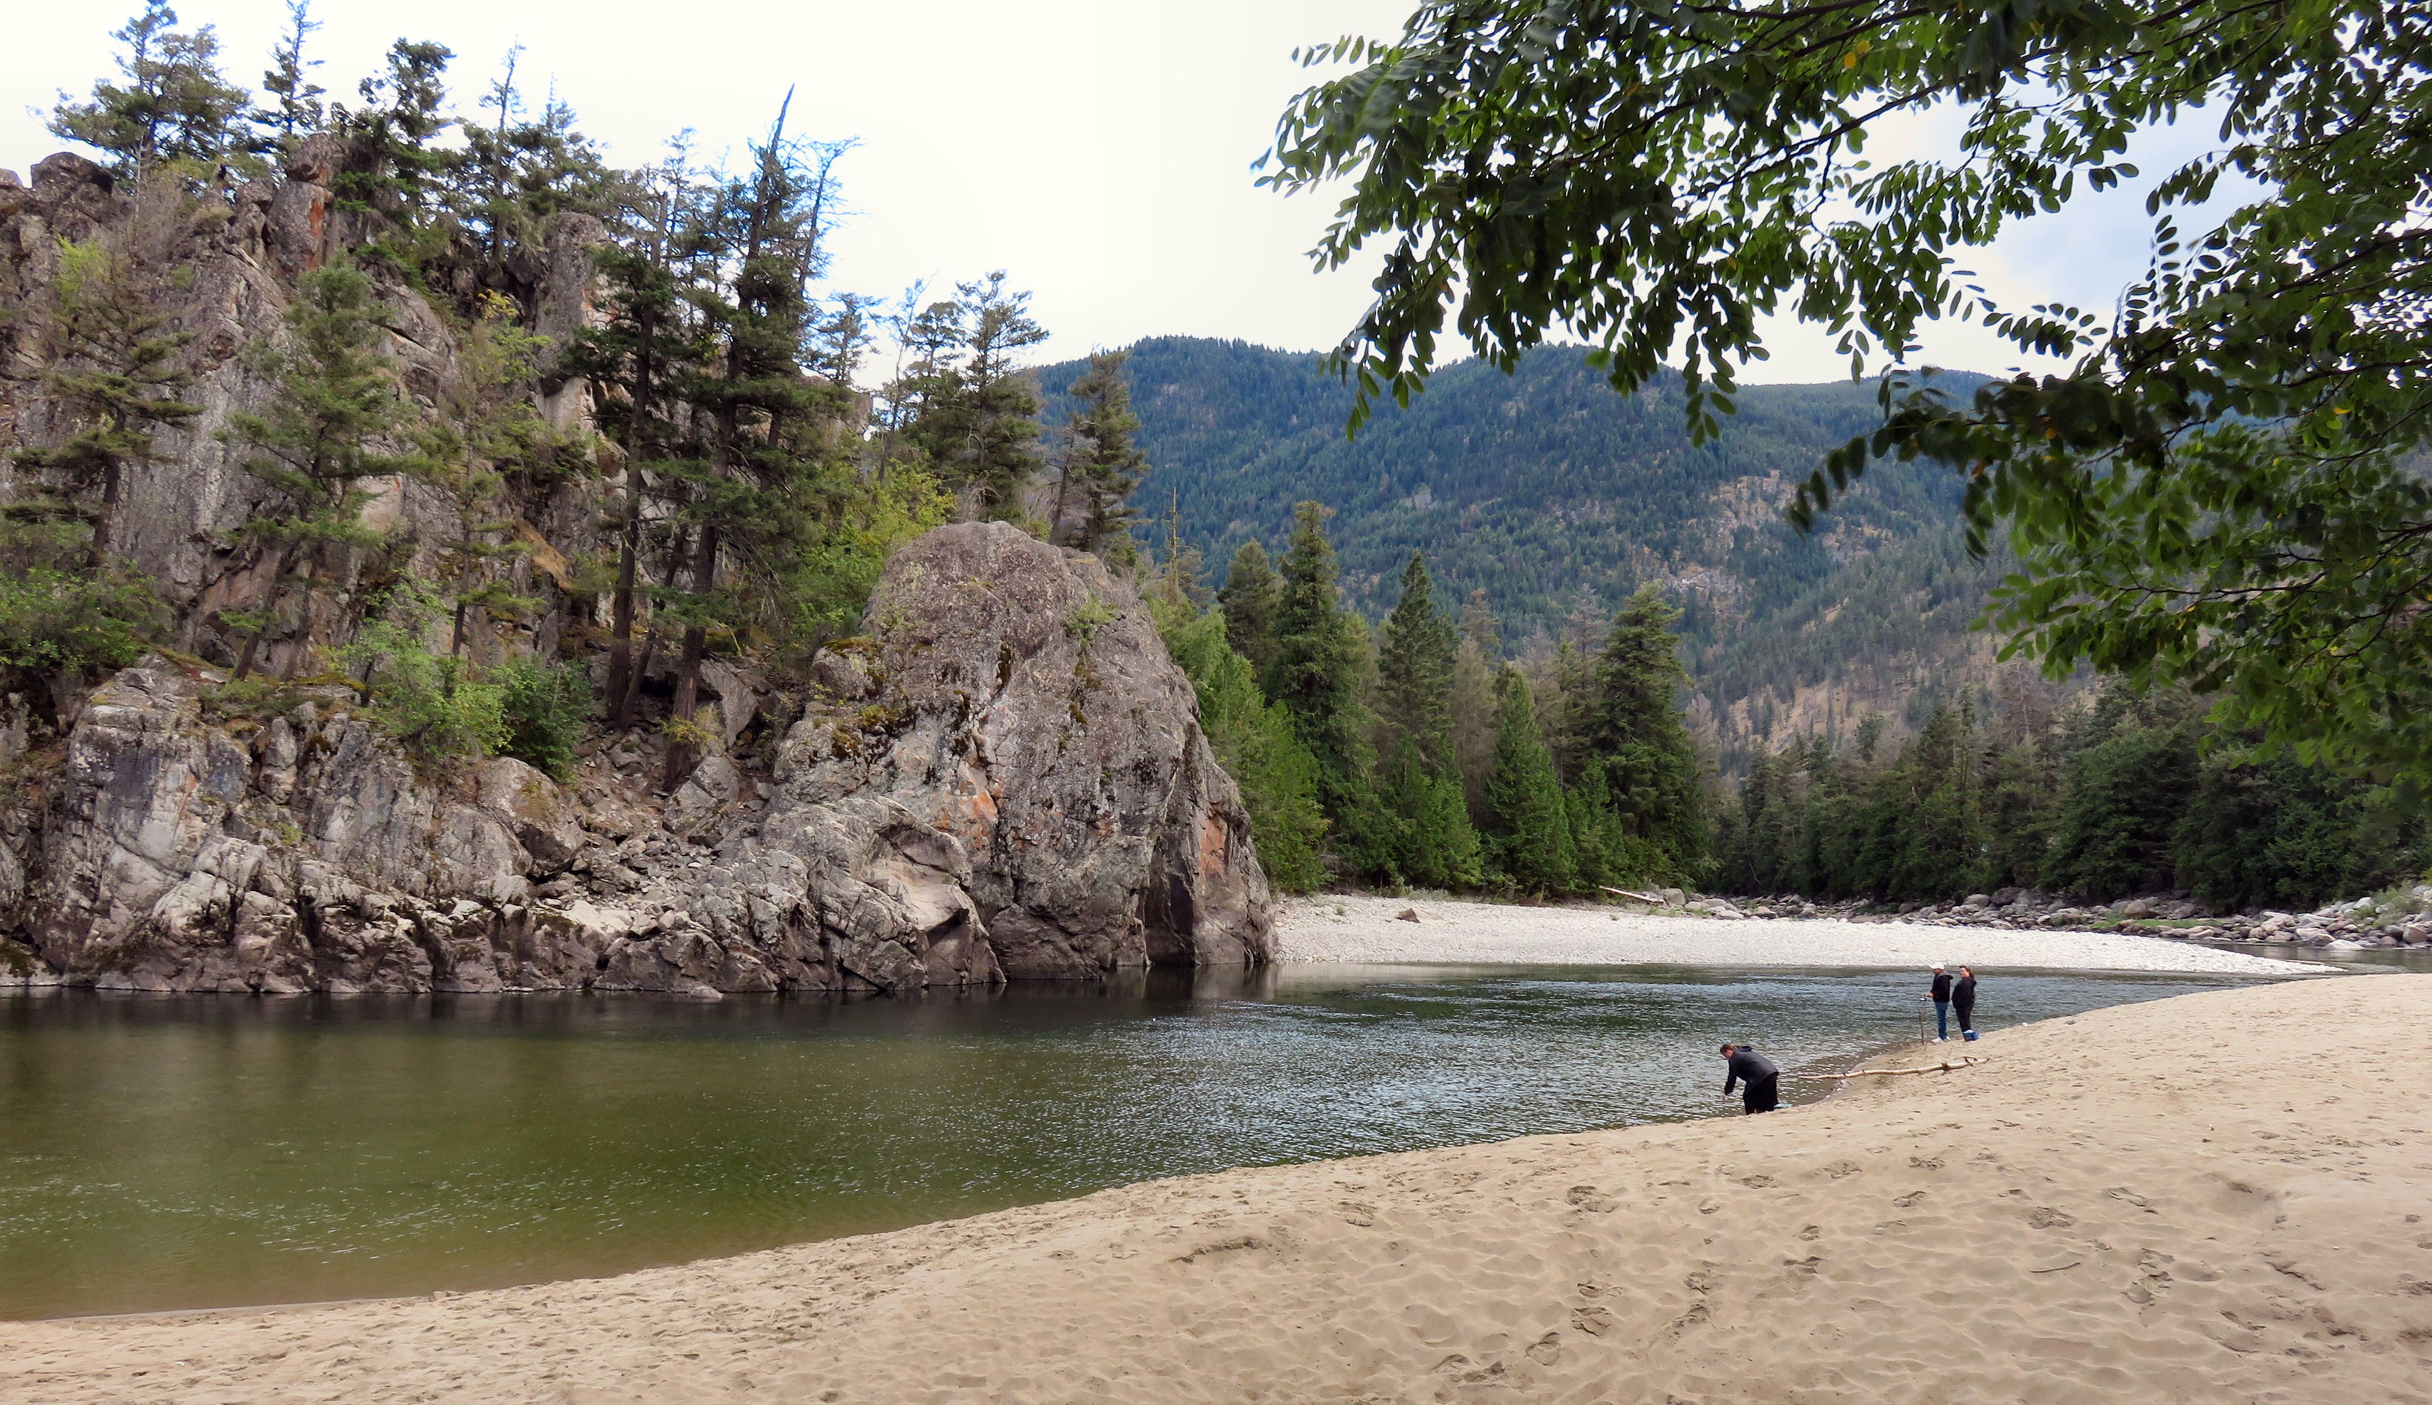

Bromley’s Rock Provincial Park is the perfect place to swim, fish, picnic and play in the sand and cliff jump.

For those of you who would like to stay longer, the park also has a campground. The campsites are available on a first-come-first-served basis. A camping consists of 1-4 persons 16 years or older with a maximum of 8 people including children 15 and younger. One vehicle and trailer are allowed per site. The checkout time is 11:00 am and the maximum allowable stay is 14 days per calendar year. Firewood is also for sale from the park facility operator.

HOW TO GET THERE – The Park is located 21 km east of Princeton, on Hwy #3 on your way to Hedley.

