Tips for Reducing Your Environmental Footprint

When heading out into nature, it is important that we leave it more pristine than we found it so future generations can enjoy the beauty of British Columbia. Here are some tips to help you reduce your environmental footprint.

1. Switch to E-Cigarettes - If you are a smoker please leave your cigarettes at home. Cigarette butts not only litter our trails and shores, they also cause many of the forest fires that devastate our province every summer. E-Cigarettes are a safe and clean alternative.

2. Head out and Spread Out! - If you are heading to a lake where you don't have reservations always have a backup plan. If you get there and it is overcrowded, don't add to the chaos go to a less busy lake for the day and come back another time.

3. Put Your Campfire-In-Can - In order to prevent forest fires many people are bringing along propane campfires which are safer and allowed during campfire bans. My favorite is the campfire in a can, it looks just like a campfire, gives out tons of heat and you can cook on it.

4. Buy a Kayak or Paddleboard - Speedboats and other loud motorized watercraft have no place on our small fishing and paddling lakes. They spread milfoil which ruins the lake for swimmers and they also disrupt spawning areas and other wildlife that make their homes on small quiet lakes. Paddleboards and Kayaks are an affordable, healthy way to stay in shape and connect with nature in an environmentally responsible way.

5. Keep Your Food Secure From Animals - Be sure to bring any food waste with you or dispose in a proper bin as animals get attracted by food and could start to linger in human areas potentially causing harm. And be sure never to feed an animal, getting them used to people food causes them harm in their natural environment.

6. Keep Your Distance From Animals – Wild animals may seem friendly but it is important to keep our distance from them. Even with small animals like birds and bunnies, if you move to get close to them and they move away, don’t follow them as that can stress the animal.

7. Take the Plus One Challenge - Always carry an extra garbage bag in your backpack to carry out any garbage you bring and always look for an extra piece of garbage, cigarette butt or bottle to take with you. Post a picture of the garbage and where you found it online with the hashtag #plusonechallenge and share with others.

8. Don’t Post the Names of Special Places on Social Media – While it is fun to share pictures of the amazing places we visit online with our friends, it is important for us to keep the names of the places secret. Too many "hidden gems" have been exposed through social media and are now overrun by people and being environmentally threatened. When you post your pictures, do not publically post the names and locations of them. If your friends ask, you can private message them, or encourage them to go out exploring and uncover their own hidden gems.

Tips for Staying Safe and Comfortable on the Trail

1. Pack an Emergency Kit – I always hike with a small bag that contains emergency supplies such as candles, a lighter, bandages, scissors, a knife, a variety of medications and a tensor bandage in case I roll my ankle.

2. Bear Bell and Flare - If you are hiking alone, be sure to wear a bear bell so that you make enough noise to scare off any bears. You may also want to get a flare stick. These small sticks can be found at any outdoor shop and when set off they make a loud sound and send out sparks which will scare most wild animals.

3. Water Purifier – Always carry plenty of water with you and also pick up a water purification system be it a filter or the purifying pills so that in case you run out you can make any water you find potable.

4. Tell a Friend – Always tell a friend or family member where you are hiking and how long you expect to be gone. If something happens to you on the trail or you get lost, searchers will at least know where to start looking for you.

5. Hiking Poles – On uphill hikes it is a great idea to bring hiking poles. Whether you prefer using one or two poles, these will help you keep your balance and footing on the downhill parts and prevent you from slipping and falling.

6. Safety in Numbers – It’s always a good idea to hike in groups of two or more. Bears and other wild animals are less likely to prey on a group and there is someone to help you if you get injured.

7. Pick Your Pack – A quality daypack is a must for any serious hiker. It will cost around $90 - $150 at an outdoor shop but it is well worth the investment. Mine has a belt around the waist and the frame offers great back support for those long hikes. I can also carry a lot of water with ease since my load is balanced. I also have pockets on the belt to give me easy access to emergency items such as bug spray and my bear banger.

8. Buy Good Shoes – A quality pair of ankle-supporting hiking shoes can make all the difference on the trail. Go to a specialty shop and get properly fit for a pair of shoes. Unless you great a great sale you will be paying over $100 for them but they will be worth every dollar when you get on the trail.

9. Bring a Compass or GPS – If you plan on doing some off trail bushwhacking it is a good idea to bring and compass and GPS. But don’t just bring the items; learn how to use them properly before you go.

10. Visit Your Outdoor Specialty Store – It’s a great idea to make regular visits to your local outdoor rigging store so you can keep up to date on new back country innovations and pick up a book on surviving in the backcountry. You can never be too prepared.

SUGGESTED ITINERARIES

KOOTENAY COMMERCIAL HOT SPRING CIRCLE ROUTE

The hot springs mentioned in this book are free non-commercial hot springs. There are also a number of resort hot springs throughout BC. Some of them include Radium, Harrison, Canyon, Halcyon, Nakusp, Fairmont and Ainsworth. They offer a variety of amenities including hotels, restaurants, RV and camping. The hot pools are large and well maintained and often offer gorgeous views of the surrounding mountains and lakes. There is a large concentration of them in the Kootenays. This map offers an excellent circle route.
Please note that St. Leon Hot Springs is on private property and is not a resort hot spring. Halfway Hot Spring is included in the book. It is a provincial park with rustic camping.

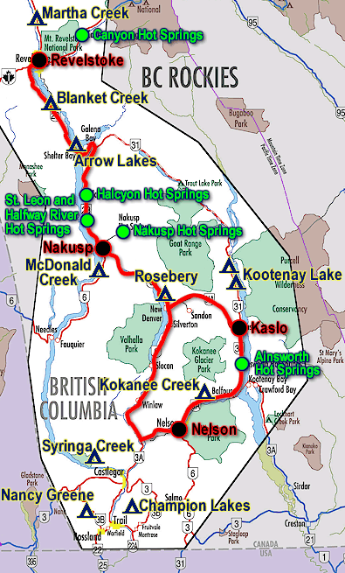

NAKUSP WATERFALLS AND HOTSPRINGS ROUTE
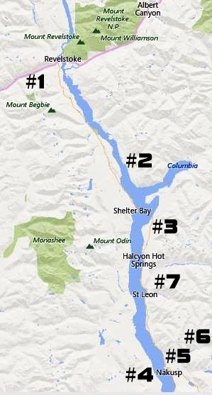

This route can be done as a daytrip from Kamloops.

Stop #1 – Kay Falls (page 7): This gorgeous waterfall is located along the highway and is a 5 minute hike in.

Stop #2 – Sutherland Falls (page 24): This waterfall is located in Blanket Creek Provincial Park a short ways before the ferry terminal. The falls are a 5 minute walk from the parking area.

Ferry from Shelter Bay to Galena Bay
The ferry leaves every hour on the hour from 5am to 12am. The trip takes 20 minutes. There are bathrooms located on the ferry and at the ferry terminal.

Stop #3 – Ione Falls (page 25): This rest stop is located a short distance after the ferry terminal. There are outhouses and picnic tables.

Stop #4 – Lunch Stop at Nakusp: This lively little tourist town is located on the shores of Arrow Lake. There are plenty of funky restaurants and shops to choose from on the main strip.

Stop #5 – Gardner Creek Falls (page 27): These falls are located along the side of the road. You can swim in the pool at the base of the falls.

Stop #6 – Kushanax Falls and Nakusp Hot Springs (page 28): Park at the Nakusp Hot Springs and hike up the trail to see the old hot spring source and a waterfall. You can also take a soak in the hot springs.

Stop #7 – Halfway Hot Springs (page 26): This natural hot spring is located 11 kilometers up a rough dirt road. A vehicle with some clearance is highly recommended. I drove a 2015 Toyota Rav 4 and had no problem.

Ferry from Galena Bay to Shelter Bay
The ferry leaves every hour on the half hour from 5:30am to 12:30am.

YOHO NATIONAL PARK WATERFALL WEEKEND
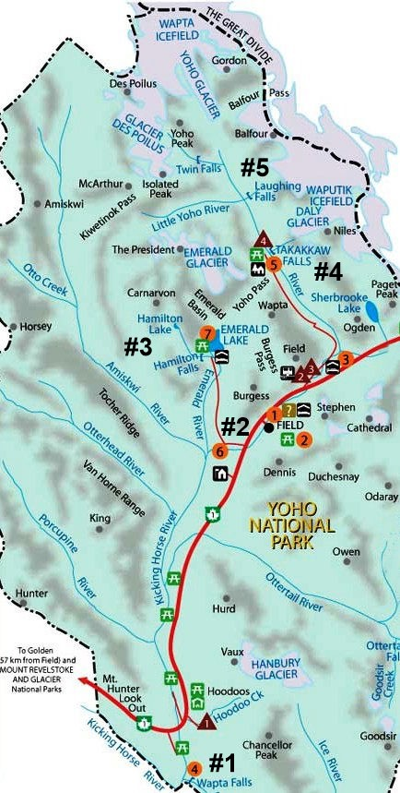

This is a great weekend adventure. I recommend book 2-3 nights in Golden at the Golden Municipal Campground. If you reserve in advance you can get a site with water and power. They have flushing toilets and showers and are located beside the Kicking Horse River.

DAY ONE:
Stop #1 – Wapta Falls (page 10): You will need about 2hours to hours to complete this 5km round trip hike. If you visit late summer when the water is low, you can hike to the top of the hill in front of the falls.

Stop #2 – Natural Bridge (page 11): This is a great pit stop on your way to Emerald Lake. The bridge is located right at the parking lot. If you follow the trail you will find a great little sandy beach downstream.

Stop #3 – Hamilton Falls (page 12): This roundtrip hike is less than 2 km. The trailhead is located in the parking area for Emerald Lake. After the hike you may want to stop for lunch at the Emerald Lake Lodge then explore the lake on a rented canoe. Or, you may want to hike the 10.9km trail around the lake. It is a moderate hike and not very crowded.

DAY TWO
Stop #4 – Takakkaw Falls (page 13): Accessible on a short easy trail from the parking lot, this is one of Canada’s most beautiful waterfalls.

Stop #5 – Twin Falls: The trailhead for Twin Falls is located at the parking lot of Takakkaw Falls. This 18km hike will bring you past Angel Staircase Falls, Point Lace Falls and Laughing Falls. At the end you will find the Twin Falls Tea House and the gorgeous Twin Falls.

TUMBER RIDGE DINOSAUR ADVENTURE
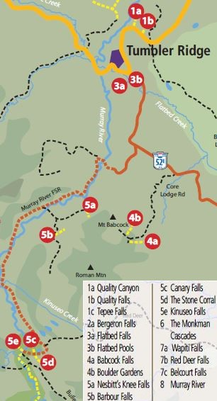

Book 2-3 nights’ accommodations in Tumbler Ridge

DAY ONE:
Stop #1 – Tumbler Ridge Visitor Information Center: The best place to start your adventure is at the visitor information center where you can pick up free maps and trail guides.

Stop #2 – Dinosaur Discovery Gallery: Just down the road from the visitor center is the Dinosaur Discovery Center where you can learn the history of dinosaur discoveries in the area and book an evening dinosaur track tour of the Wolverine site.

Stop #3 – Cabin Pool and Flatbed Falls (pages 51-52): Stop 3a and 3b on the map is where you can see dinosaur tracks beside a swimming hole in Flatbed Creek and then jump off the rocks into Flatbed Falls.

Stop #4 – Quality Falls (page 47): Item 1b on the map, Quality Falls is a short drive from Tumbler Ridge. A 2.5km round trip moderate hike brings you to the swimming hole in front of a waterfall.

DAY TWO:
Stop #1 – Nesbitt’s Knee Falls (page 54): This 3km return hike brings you too the base of the falls, item 5a on the map.

Stop #2 – Barbour Falls (page 55): A 2km return trail takes you to the upper falls and swimming hole and then to a place where you can view the lower falls, item 5b on the map.

Stop #3 – Canary Falls (page 58): This 1km round trip hike takes you to a place to view the falls.

Stop #4 – Kinuseo Falls (page 56): Located 50km up the Murray River Forest Service Road, these falls are the main attraction. There are a number of trails.

SEA TO SKY WHISTLER WATERFALL ROUTE
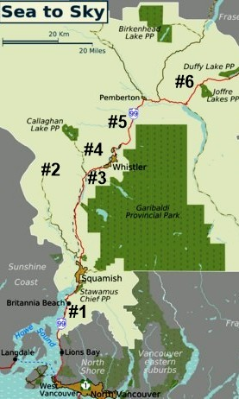

The Sea to Sky Highway to Whistler is a treasure trove of gorgeous waterfalls. I recommend booking a hotel in Squamish for 1-2 nights to fully enjoy the area.

DAY ONE:
Stop #1 – Shannon Falls (page 22): A short hike from the parking lot will bring you to this stunning waterfall. It is located right beside Stawamus Chief Provincial Park. You may want to hike to the top of this mountain for a breathtaking view.

Stop #2 – Ashlu Mine Falls (page 20): The best locations are at the end of a gravel road and this gem in no exception. To get to this waterfall you must drive an hour from Squamish and walk through an abandoned mine shaft. Be sure to have a vehicle with some clearance as the road is rough in areas.

Stop #3 – Brandywine Falls (page 19): A short hike from the parking lot takes you to the viewing platform of these famous falls.

Stop #4 – Alexander Falls (page 18): This is in my opinion the most beautiful of the falls in this area. It is located right at the parking lot.

DAY TWO:
Stop #5 – Nairn Falls (page 17): The best part of these falls is the area by the river. You can explore the interesting rock formations along the shore as the water rushes by.

Stop #6 – Joffre Lakes: This 4-hour round trip hike brings you past multiple waterfalls and three aquamarine lakes.

Note – Keystone Falls and Pebble Creek Hot Springs are located at 50.668178,-123.455064 on Lillooet Forest Service Rd about an hour from Whistler.

KOOTENAY HOT SPRING WATERFALL ROUTE
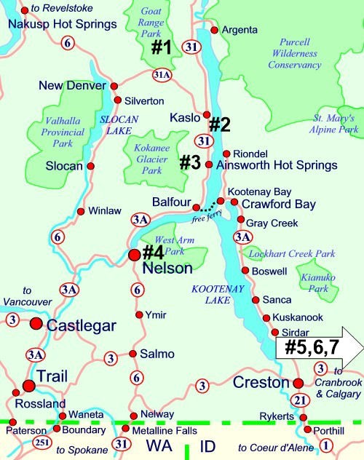

The Kootenay’s are a great area to find beautiful waterfalls and soothing hot springs.

DAY ONE:
Stop #1 – Wilson Creek Falls (page 29): A drive up a gravel road and a 1 hour round trip hike will bring you to the base of these incredible falls.

Stop #2 – Fletcher Falls (page 30): Located near the tiny town of Kaslo, these falls are a short hike from the parking area and located near a great swimming beach.

Stop #3 – Canyon Falls (page 31): If you come in late August you can watch the salmon spawning in the creek before taking a short hike to the falls.

Stop #4 – Cottonwood Falls: These falls are located right in Nelson at 199 Carbonate Street in Cottonwood Falls Park. There is also a Japanese Garden making it a great place for a picnic.

DAY TWO:
Stop #5 – Marysville Falls (page 34): Located right in the scenic town of Kimberly, a short hike takes you through the unique rock formations of the creek bed to a large waterfall.

Stop #6 – Lussier Hot Springs (page 36): A drive up a dusty gravel road and a short hike from the parking area rewards you with a soak in a natural spring located next to a river.

Stop #7 – Silver Springs (page 32): Jump off a cliff into the refreshing turquoise waters of Silver Spring then take the hiking trail to visit the other lakes.

Note – Near Sparwood you can hike to the Fording Mountain (Sulphur) Warm Springs. Visit the Tourist Information Center for directions.

