After you visit kay Falls check out KaY-2 falls

The Revelstoke area is a waterfall chasers heaven. Countless named and unnamed waterfalls tumble down the surrounding mountains. Kay Falls is a well known waterfall that can be seen from the highway. But did you know that just past this gorgeous waterfall is another little known fall I call Kay-2?
I had heard about these falls from a Facebook post. The next trip I took to Revelstoke I decided to find them. Unlike Kay Falls, they cannot be seen from the parking lot. I hiked a little ways into the forest and could hear the rush of water. I crossed the stream and made my way to a clearing where I got a fantastic view of Kay—2. While they are not as stunning a Kay Falls, they are exciting to find.
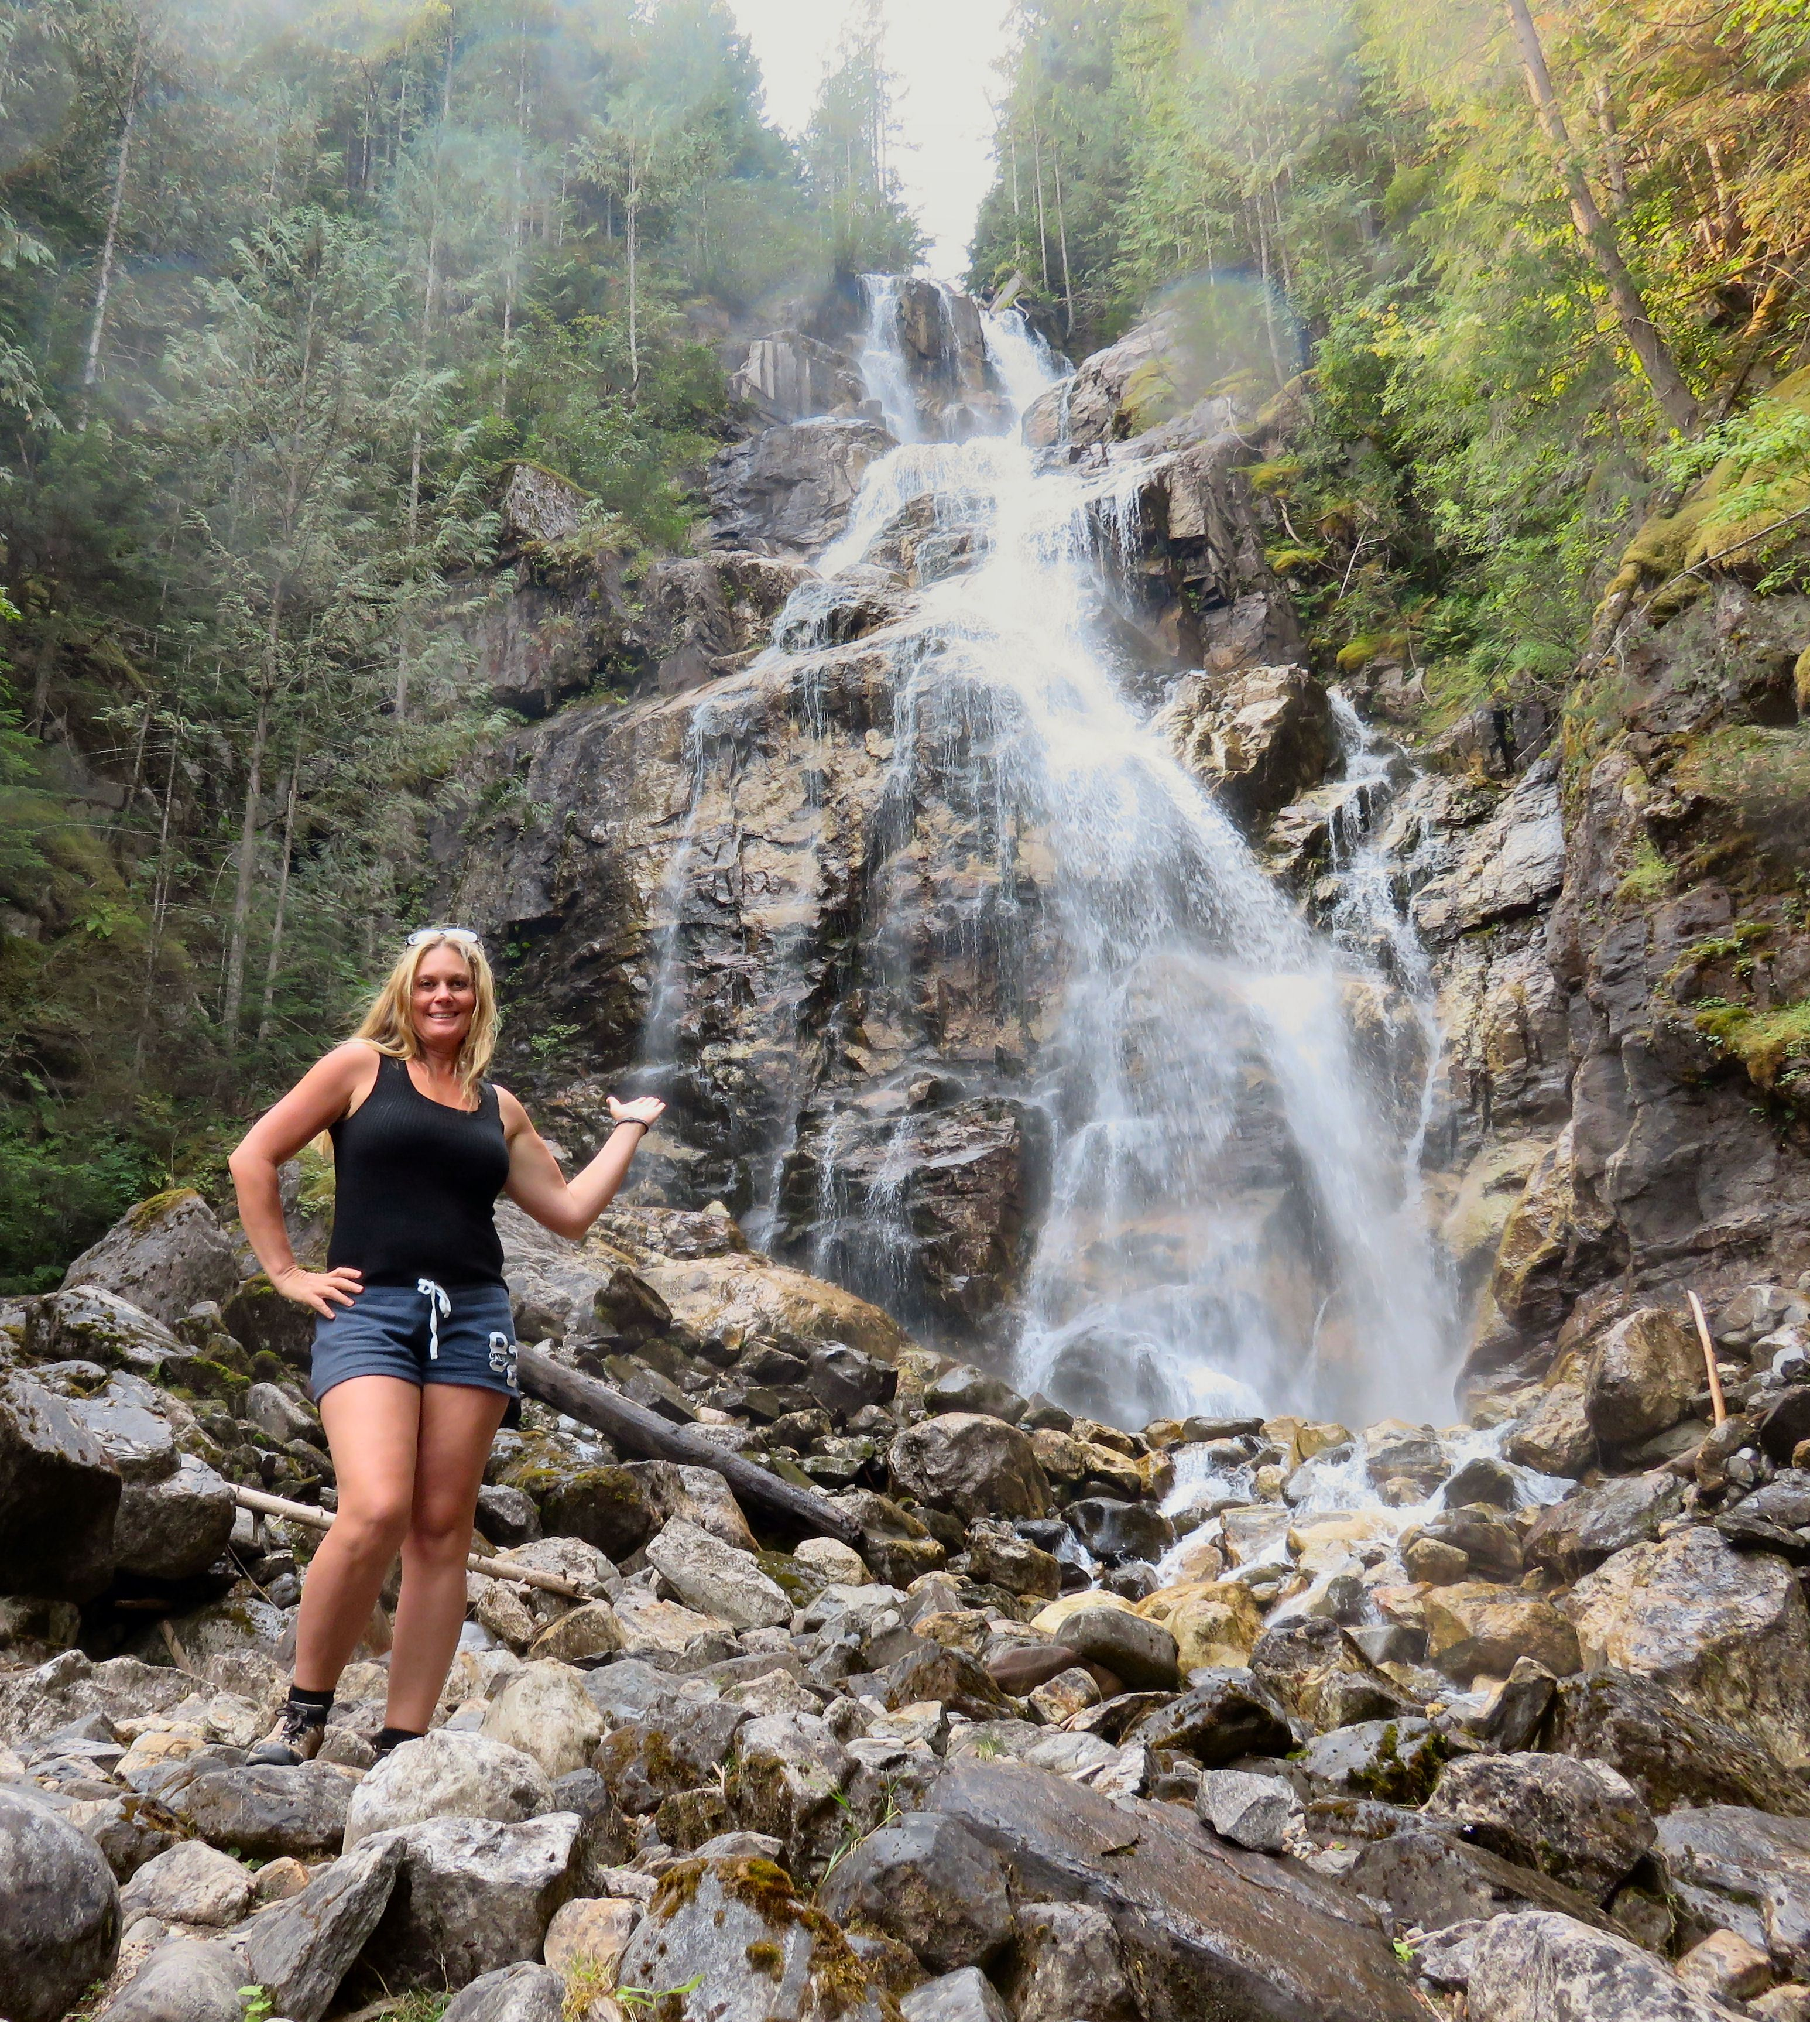

Kay Falls can be seen from the highway near Revelstoke.

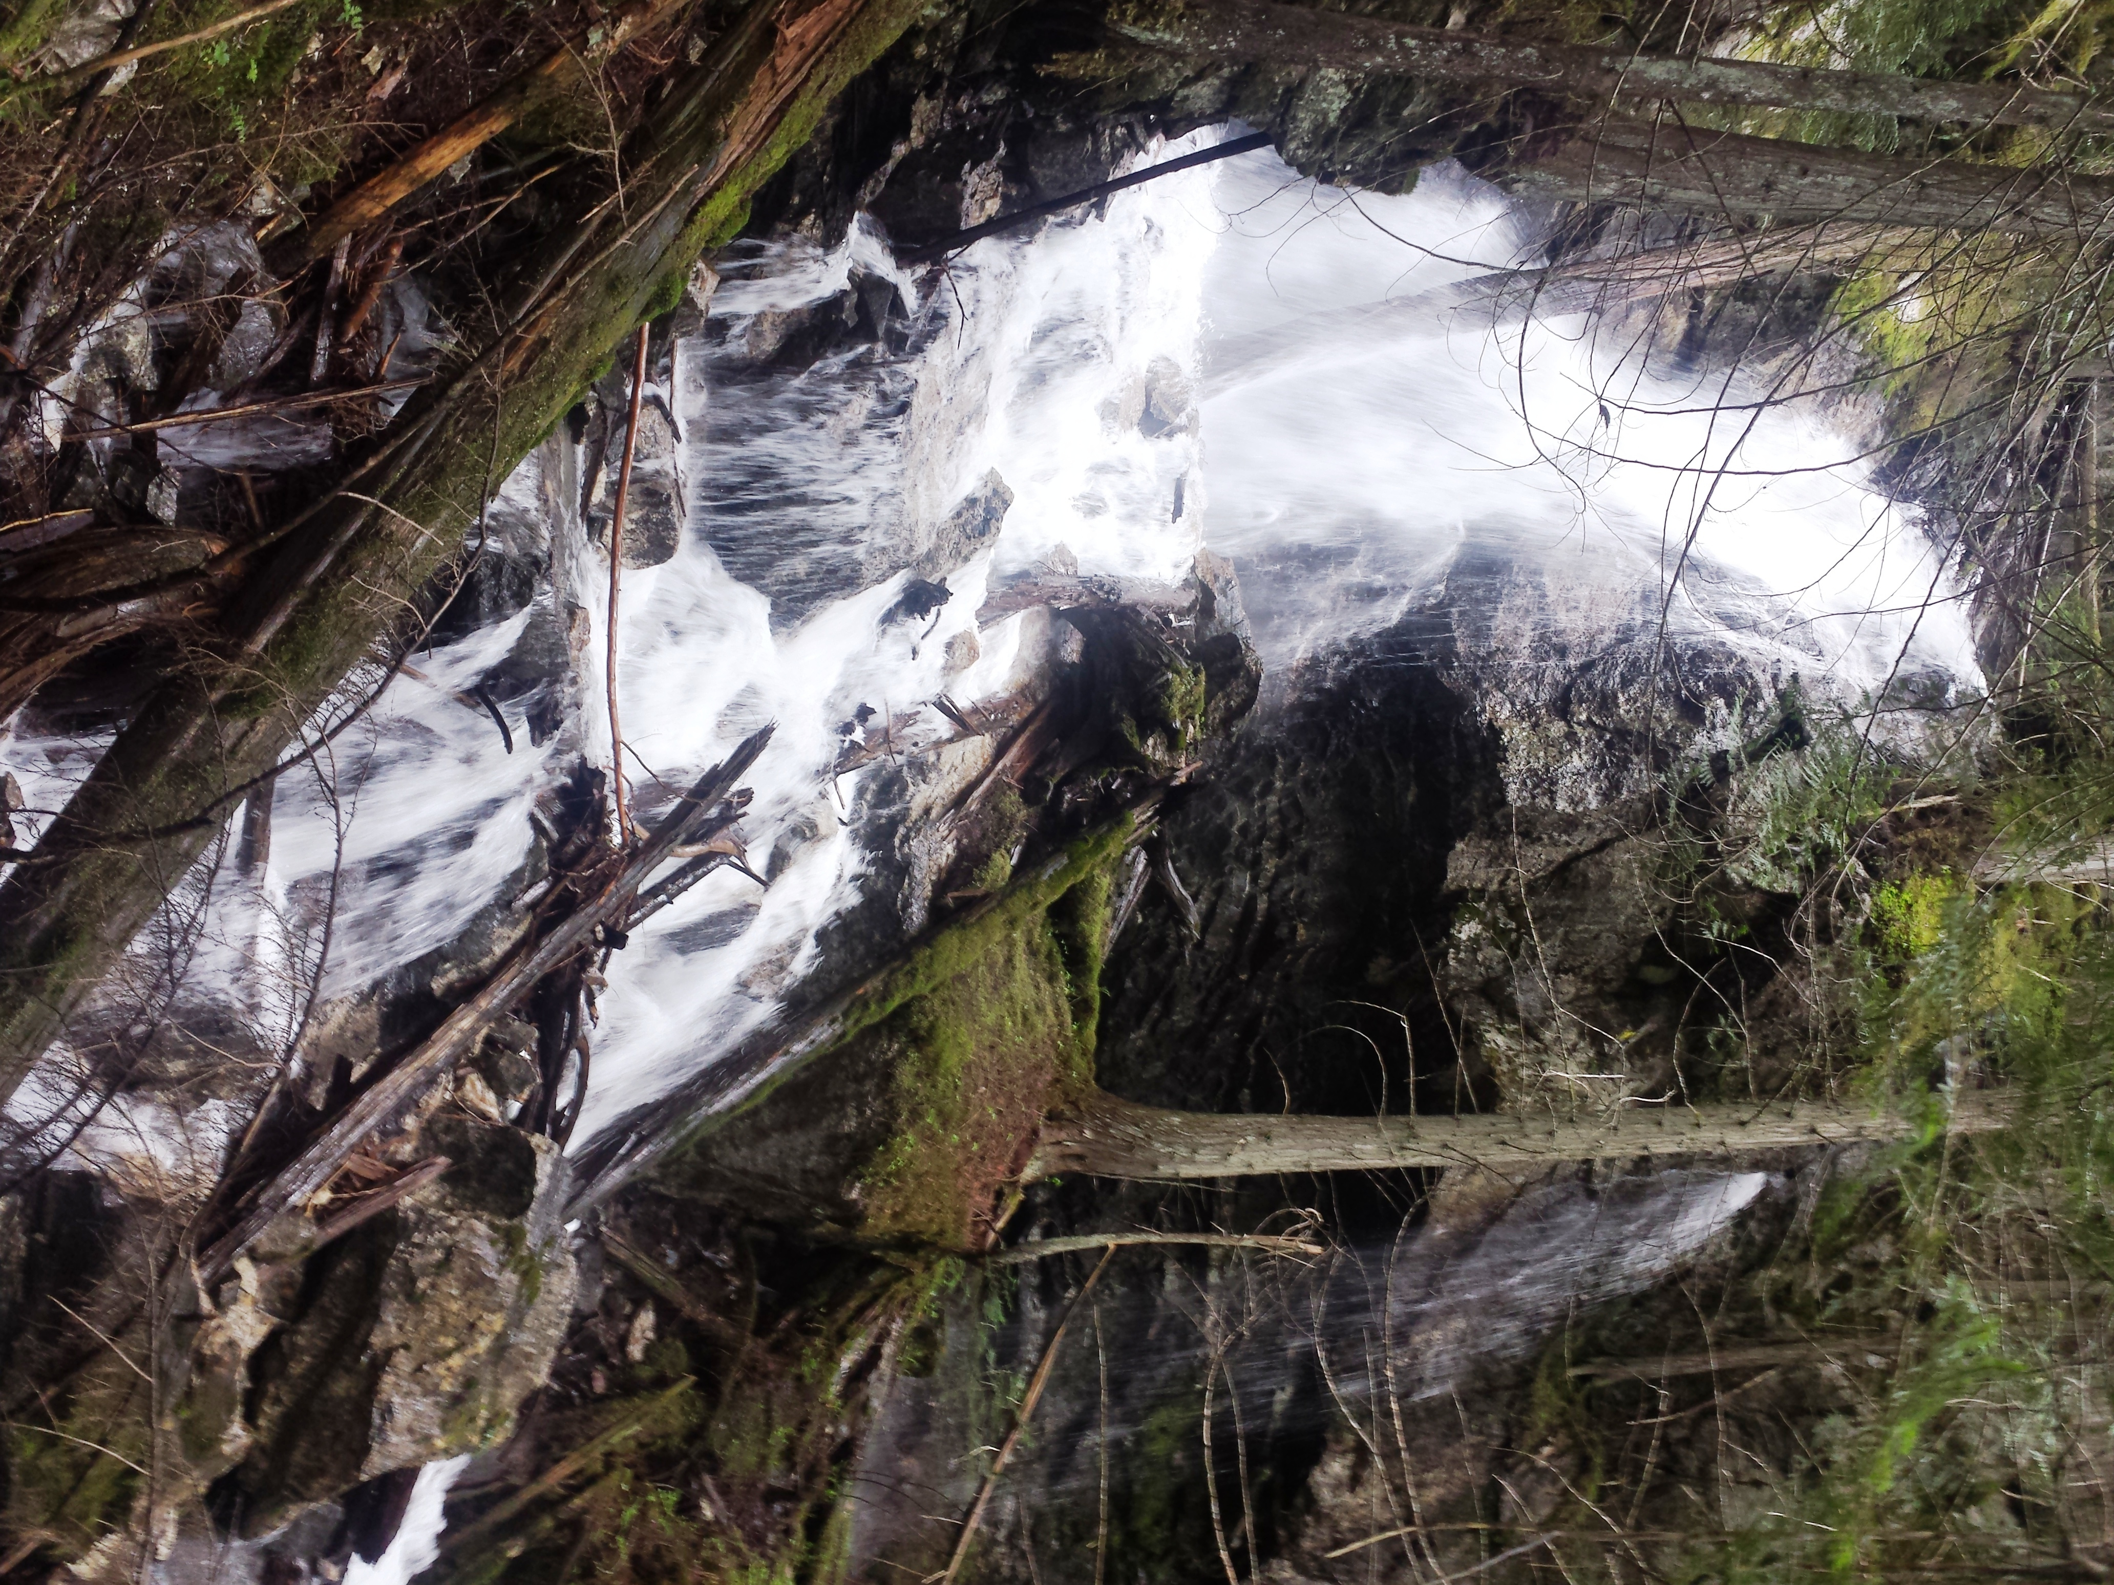

Kay-2 Falls are just up the road from Kay Falls.

HOW TO GET THERE – From Kamloops drive past the Crazy Creek Suspension Bridge towards Revelstoke. Watch on the right for a concrete wall. If you arrive at a large rock on your left or at Noah’s Ark, you have travelled too far. Park at the concrete wall and look for the trailhead. The falls are a 5 minute walk up the trail.
Just past Kay Falls and just before the Enchanted Forest, you will see a creek with a tiny waterfall. Follow it up the hill for a few minutes and you will see Kay-2 Falls.

