Become Bear Aware at bear creek falls

I am not sure if there are a lot of bears that frequent these falls hence the name, but just in case, make sure that you are prepared when you hike to these falls. This includes hiking in groups of 2 or more when possible, wearing a bear bell when hiking alone and bringing along bear spray or bear bangers in case of emergency. If you should encounter a bear remain calm and keep your distance, tell it to go away and raise your arms to look larger. If he seems threatening shoot a bear banger off to his side to scare him and if he gets too close give him a shot of bear spray in the face.
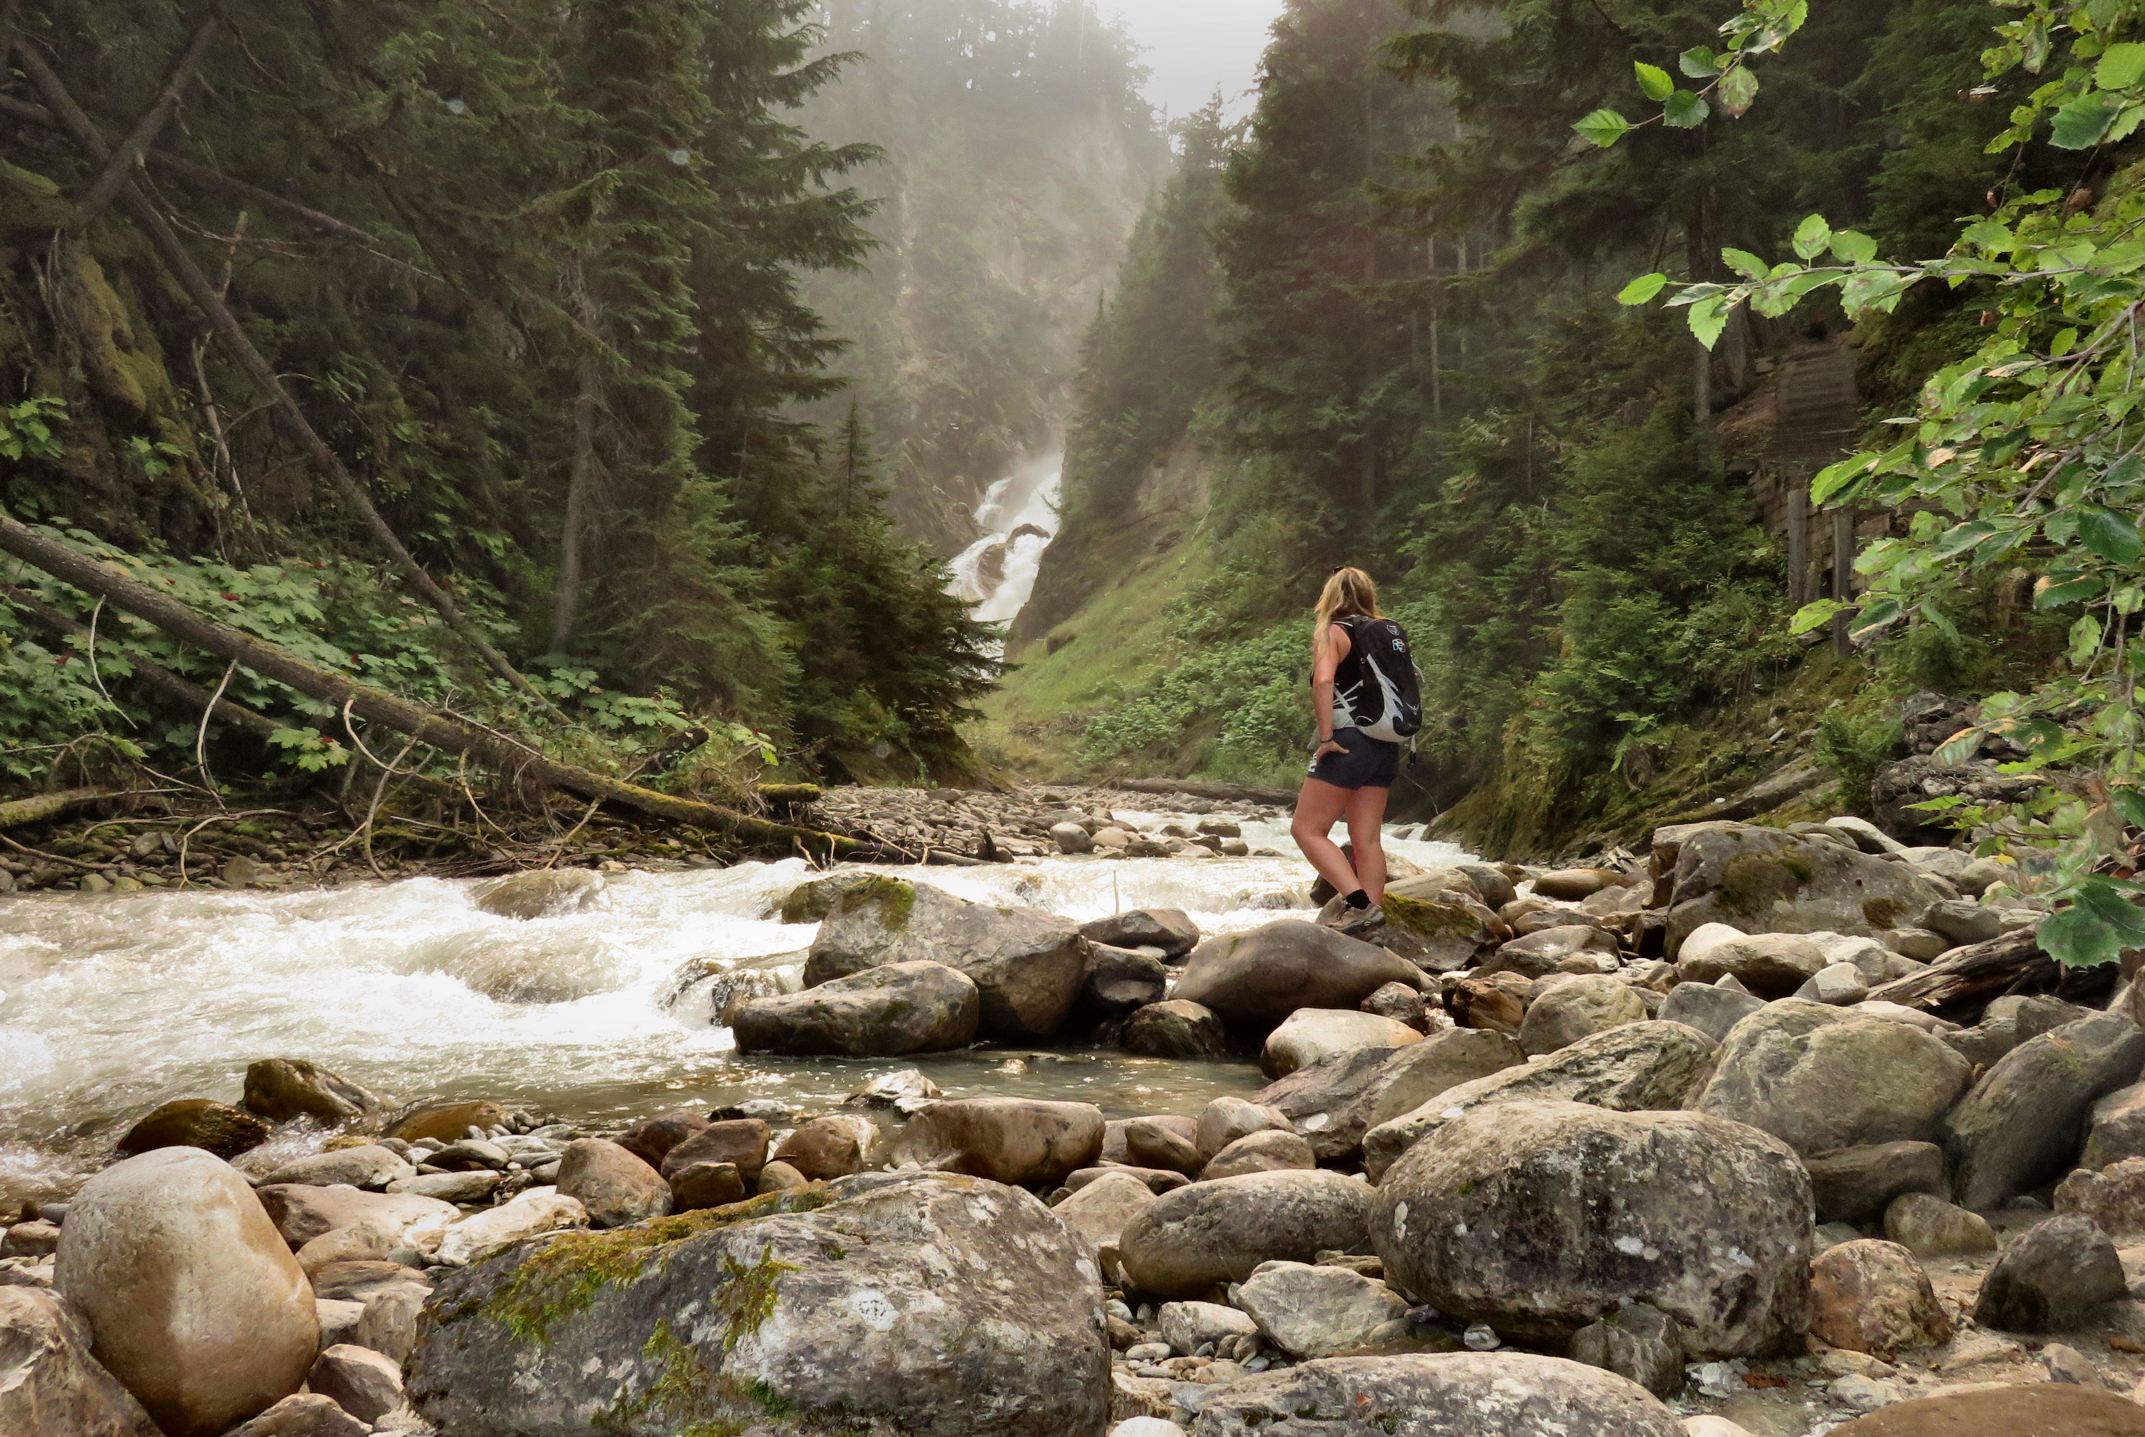

Teresa admires Bear Creek Falls from the rocky shores of Bear Creek.

Hopefully you won’t see any bears on this one kilometre round trip downhill hike to the Bear Creek Falls. The trail is well-maintained and wide, it is an easy hike with a number of steps and steep incline to contend with. The best place to photograph the falls is downstream as they have a large spray.

HOW TO GET THERE – Bear Creek Falls is located in Glacier National Park. From Revelstoke drive past the Roger’s Pass Visitors Center and keep an eye on the right hand side for the sign.

