Experience the wonder of wapta falls

If you are visiting Yoho National Park, Wapta Falls is a must-see and well worth the 2.3 kilometre hike in. It is the largest waterfall of the Kicking Horse River, at about 30 metres high and 150 metres wide, with an average flow that can reach up to 254 cubic metres per second.
Wapta Falls was the location of the 1858 historical event that gave the Kicking Horse River its name. It was here where Palliser Expedition member James Hector was kicked in the chest while trying to recover a runaway horse. Believing he was dead the other expedition members began digging his grave. Thankfully a blink of Hector's eye saved him from being buried alive.
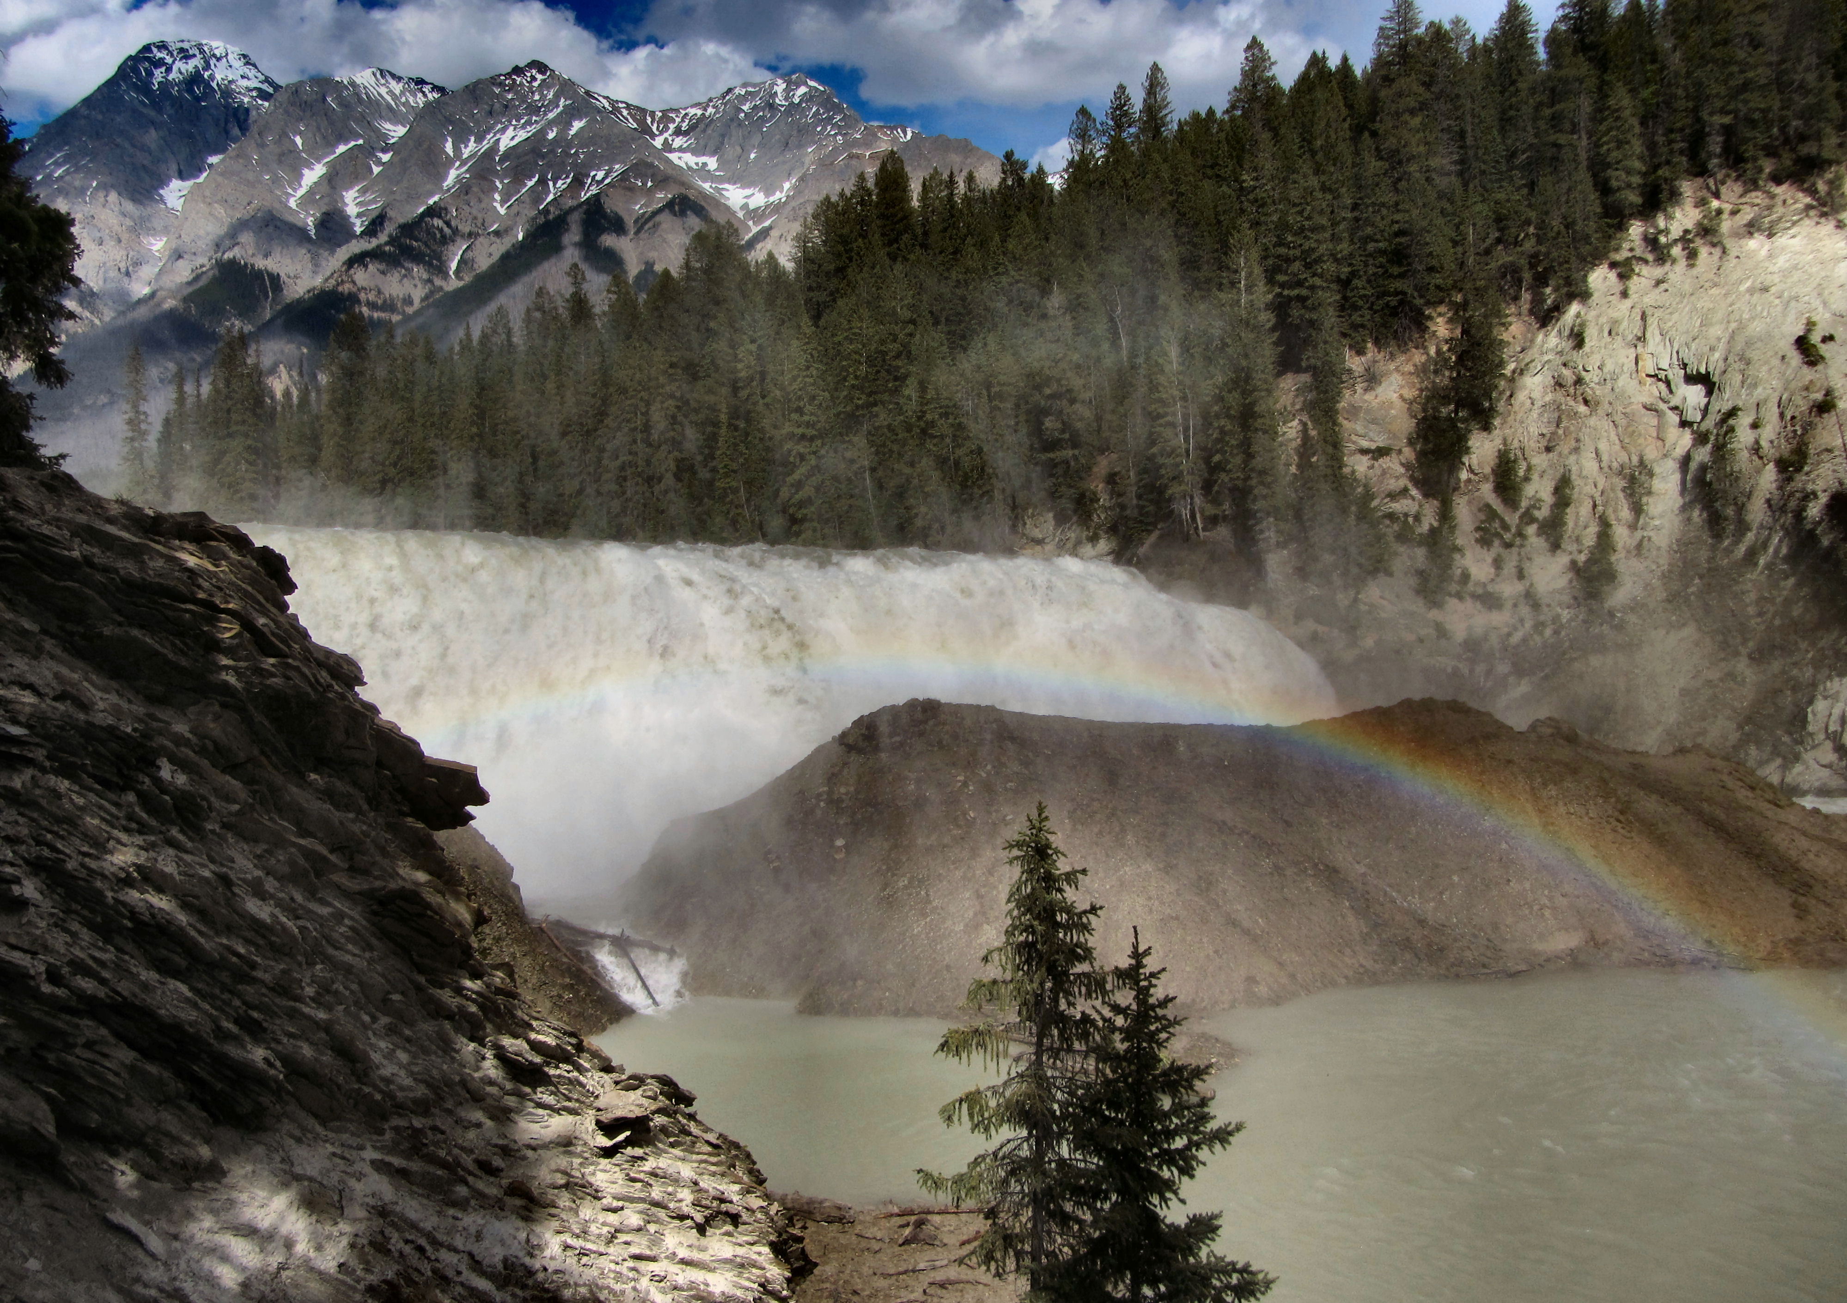

A beautiful rainbow spans across Wapta Falls.

He recovered and pushed on with the expedition which proceeded to make the first recorded passage of the Big Hill leading up into the Bow Valley from the present day location of Field.
This event inspired expedition members to name the river The Kicking Horse.

HOW TO GET THERE – Wapta Falls can be found near the west end gate of Yoho National Park. Take the Wapta Falls trail turnoff, turn right and drive 1.8 kilometres on a gravel road to the parking area at the trailhead. Note: The trailhead is not marked for westbound traffic as there is no left turn lane here so it is easy to miss. It’s a 5km round trip.

